Supply List for Grade 7

- 1 pack of multi-color highlighters (yellow, pink, blue, green, orange)
- Amazon has BIC Brite Liner Highlighters 5 count pack of assorted
colors for $1.99)- For ELA
- 1 package of plastic forks and spoons
- 1 Pencil box or bag
- Pencils (bring in only 2- 3 and replenish as needed) &1 pack number 2 pencils- For ELA
- Extra erasers
- Highlighters (bring in 1 or 2 and refill as needed throughout the year)
- Scissors
- Glue stick
- Colored pencils (at least 8 colors)
- Markers (at least eight colors)
- Optional: Sharpies for use in Art Class
- Ruler
- Cloth book covers, 2 large and 1 small
- Headphones or earbuds for Chromebooks
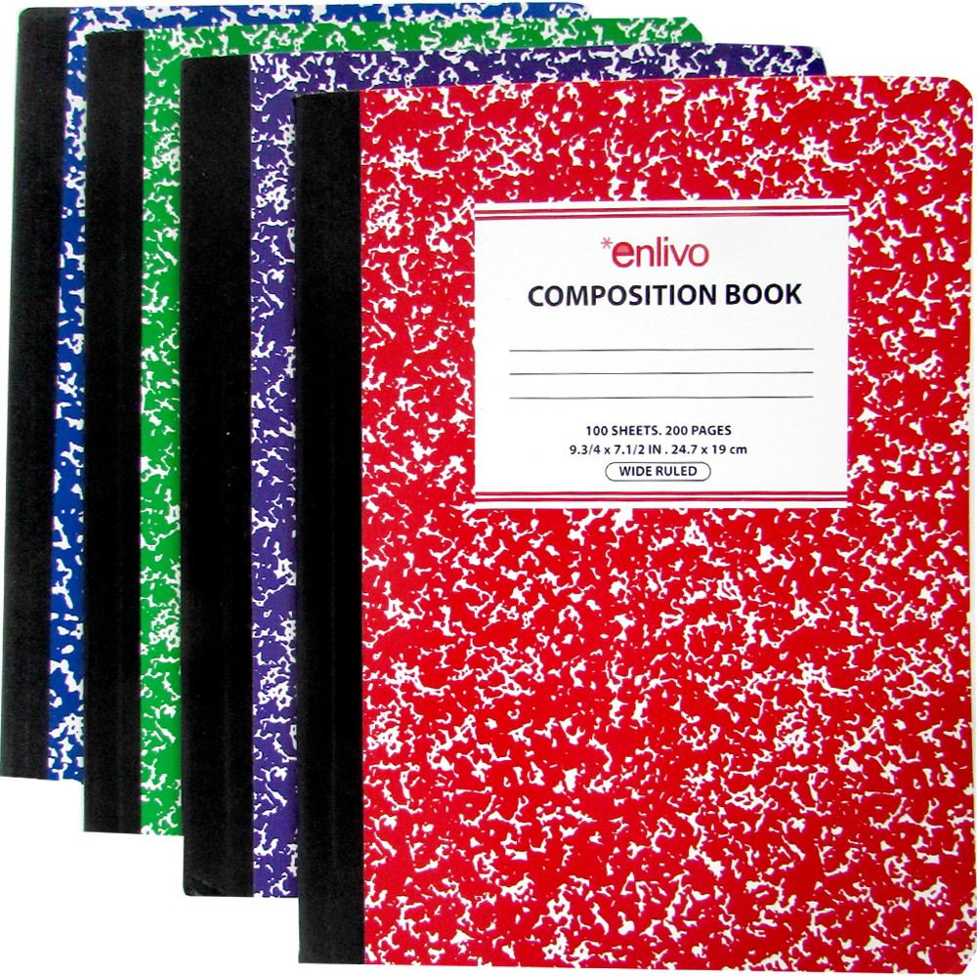
- Calculator optional
- Novel for independent reading (on going)
- 1 pack of black pens- For ELA
- 1 pack of notecards- For ELA
- 1 package loose leaf notebook paper-3 hole punched- For ELA
- 1 pack of 3 hole punched white printer paper- For ELA

Notebooks and Folder(s):
- 6 Composition notebooks (Labeled: Science, Religion, English, Reading, Math, and French; also be sure to write your name on the front of each)
- 1 2-Subject notebook labeled for Social Studies
- 1 1 Inch 3 ring binder for Reading & 1- 2 inch 3-ring binder- For ELA
- Expandable Accordion File Folder for organizing papers from each class. (As an alternative you may use a binder with vinyl pocket folders for each subject, but an accordion file folder is more compact and secure. You should have one folder or section of your accordion file labeled “Homework” where all assigned work should be kept and a section for each subject.)
• 2 - 1 subject notebooks- For ELA

