
Mrs. McAllister’s
Kindergarten Supply List

SCHOOL SUPPLIES

- “Crayola” Crayons- 24 count - 2 packs
- “Elmer’s” Glue Sticks- 6
- Plastic folder (this will go back and forth to school and home each day)
- Child Scissors
- Water color paints
- 1 plastic pencil box – small, hard plastic (no handles)
- 1 pkg of thin “Expo” dry erase markers
- 1 pkg of “Ticonderoga “ pencils
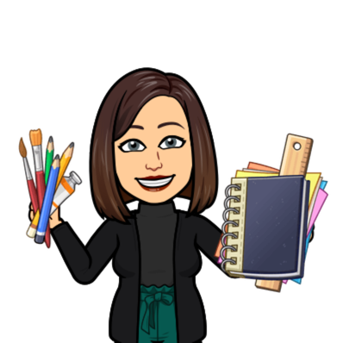
- 1 old (clean) sock for dry erase board eraser
- 1 pair of wired headphones for computer class (please put in a large ziploc bag labeled with your child’s name)

CLASSROOM SUPPLIES

- Cardstock – 1 pkg -If your last name begins with A-D, please bring white cardstock. If your last name begins with E-O please bring colored card stock If your last name begins with P-Z, please bring black cardstock

Thank you in advance for your contributions to our classroom and our school!

