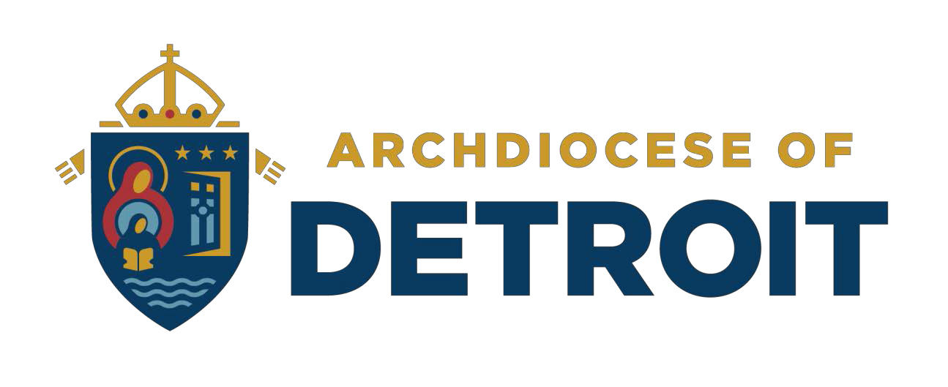

St Clare of Montefalco School
Catholic Identity Program Effectiveness Surveys Report

Contents
Appendices 3
Appendix A: Demographic Data 3
Respondents - School Connection 3
Community Members – Breakdown 4
Gender 5
Race 6
Ethnicity 7
Religious Affiliation 8
Age 9
Respondents - Parish Affiliation 9
Appendix B: NCEA Standards 10
Most Important Standard of a Catholic School 10
Mission and Catholic Identity 12
Academic Excellence 19
Governance and Leadership 26
Operational Vitality 32
Appendix C: Communication Preferences 38
Appendix D: Advertising Preferences 38
Appendix E: Enrichment and Extracurriculars 38
Other Extracurricular Suggestions 43
Appendix F: Faculty/Staff Profile 43

Appendices

Appendix A: Demographic Data

Respondents - School Connection

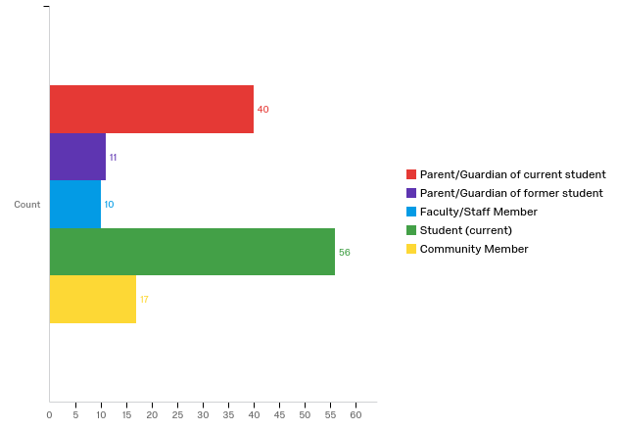

Respondent School Connection | % | Count
Parent/ Guardian of current student | 30% | 40
Parent/ Guardian of former student | 8% | 11
Faculty/ Staff Member | 7% | 10
Student (current) | 42% | 56
Community Member | 13% | 17
Total | 100% | 134

Community Members – Breakdown

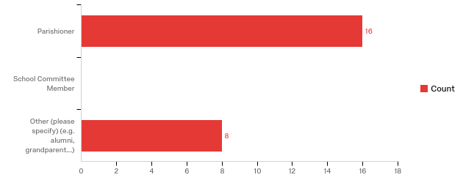

 | % | Count
Parishioner | 67% | 16
School Committee Member | 0% | 0
Other (please specify) (e.g. alumni, grandparent...) | 33% | 8
Total | 100% | 24

Other (Text Answers)
My comments are determined by my age All my children went to this school and my grandchildren I firmly believe in a catholic education and I feel the school is an important part of the Archdiocese plea to evangelize
alumni
parent of alumnae
alumni
alumni
Alumni
Coach, Volunteer
Parish Council

Gender
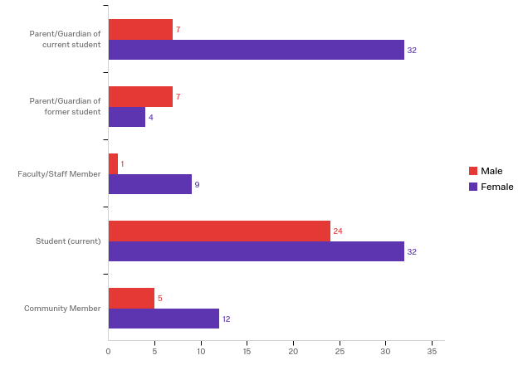

Respondent Type |  | Male |  | Female |  | Total
Parent/ Guardian of current student | 18% |  | 7 | 82% | 32 | 39
Parent/ Guardian of former student | 64% |  | 7 | 36% | 4 | 11
Faculty/ Staff Member | 10% |  | 1 | 90% | 9 | 10
Student (current) | 43% |  | 24 | 57% | 32 | 56
Community Member | 29% |  | 5 | 71% | 12 | 17

Race
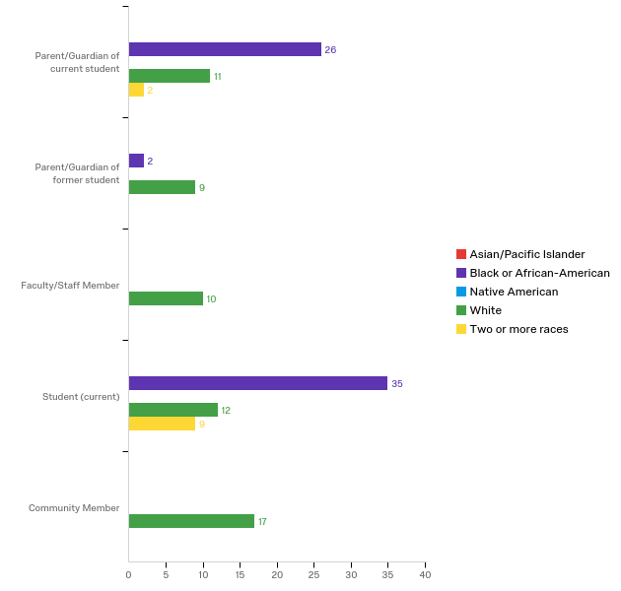

Respondent Type | Asian/Pacific Islander |  | Black or African- American |  | Native American |  | White |  |  | Two or more races |  | Total
Parent/ Guardian of current student | 0% | 0 | 67% | 26 | 0% | 0 | 28% | 11 |  | 5% | 2 | 39
Parent/ Guardian of former student | 0% | 0 | 18% | 2 | 0% | 0 | 82% |  | 9 | 0% | 0 | 11
Faculty/ Staff Member | 0% | 0 | 0% | 0 | 0% | 0 | 100% | 10 |  | 0% | 0 | 10
Student (current) | 0% | 0 | 63% | 35 | 0% | 0 | 21% | 12 |  | 16% | 9 | 56
Community Member | 0% | 0 | 0% | 0 | 0% | 0 | 100% | 17 |  | 0% | 0 | 17

Ethnicity

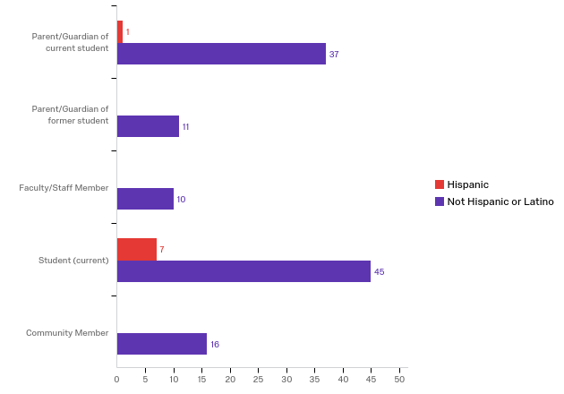

Respondent Type | Hispanic |  | Not Hispanic or Latino |  | Total
Parent/ Guardian of current student | 3% | 1 | 97% | 37 | 38
Parent/ Guardian of former student | 0% | 0 | 100% | 11 | 11
Faculty/ Staff Member | 0% | 0 | 100% | 10 | 10
Student (current) | 13% | 7 | 87% | 45 | 52
Community Member | 0% | 0 | 100% | 16 | 16

Religious Affiliation

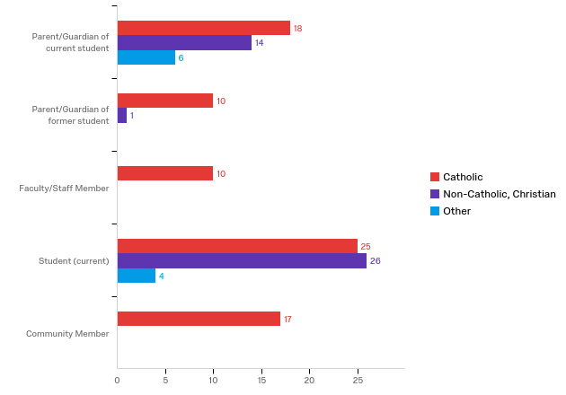

Respondent Type | Catholic |  | Non-Catholic, Christian |  | Other |  | Total
Parent/ Guardian of current student | 47% | 18 | 37% | 14 | 16% | 6 | 38
Parent/ Guardian of former student | 91% | 10 | 9% | 1 | 0% | 0 | 11
Faculty/ Staff Member | 100% | 10 | 0% | 0 | 0% | 0 | 10
Student (current) | 45% | 25 | 47% | 26 | 7% | 4 | 55
Community Member | 100% | 17 | 0% | 0 | 0% | 0 | 17

Age

Respondent Type | Under 12 years old |  | 12-17  years old |  | 18-24  years old |  | 25-34  years old |  | 35-44  years old |  | 45-54  years old |  | 55-64  years old |  | 65-74  years old |  | 75 years or older |  | Total
Parent/ Guardian of current student | 5% | 2 | 5% | 2 | 0% | 0 | 13% | 5 | 45% | 17 | 32% | 12 | 0% | 0 | 0% | 0 | 0% | 0 | 38
Parent/ Guardian of former student | 0% | 0 | 18% | 2 | 0% | 0 | 0% | 0 | 0% | 0 | 9% | 1 | 45% | 5 | 18% | 2 | 9% | 1 | 11
Faculty/ Staff Member | 0% | 0 | 0% | 0 | 0% | 0 | 10% | 1 | 0% | 0 | 0% | 0 | 80% | 8 | 0% | 0 | 10% | 1 | 10
Student (current) | 41% | 23 | 57% | 32 | 0% | 0 | 0% | 0 | 2% | 1 | 0% | 0 | 0% | 0 | 0% | 0 | 0% | 0 | 56
Community Member | 0% | 0 | 0% | 0 | 0% | 0 | 24% | 4 | 6% | 1 | 12% | 2 | 35% | 6 | 12% | 2 | 12% | 2 | 17

Respondents - Parish Affiliation

Parish Affiliation | Parent/ Guardian of current student |  | Parent/ Guardian of former student |  | Faculty/ Staff Member |  | Student (current) |  |  | Community Member
St. Edith Parish - Livonia | 0% | 0 | 0% | 0 | 0% | 0 | 0% |  | 0 | 6% | 1
St. Paul on the Lake Parish - Grosse Pointe Farms | 0% | 0 | 0% | 0 | 0% | 0 | 4% |  | 1 | 0% | 0
St. Charles Borromeo Parish - Newport | 0% | 0 | 0% | 0 | 0% | 0 | 4% |  | 1 | 0% | 0
St. Philomena Parish - Detroit | 0% | 0 | 0% | 0 | 11% | 1 | 0% |  | 0 | 0% | 0
St. Ambrose Parish - Grosse Pointe Park | 0% | 0 | 10% | 1 | 0% | 0 | 0% |  | 0 | 0% | 0
St. Augustine and St. Monica Parish - Detroit | 6% | 1 | 0% | 0 | 0% | 0 | 0% |  | 0 | 0% | 0
Our Lady Star of the Sea Parish - Grosse Pointe Woods | 6% | 1 | 0% | 0 | 0% | 0 | 0% |  | 0 | 0% | 0
Sacred Heart Parish - Detroit | 6% | 1 | 0% | 0 | 0% | 0 | 4% |  | 1 | 0% | 0
St. Clare of Montefalco Parish - Grosse Pointe Park | 83% | 15 | 90% | 9 | 89% | 8 | 88% | 22 |  | 94% | 16
Total |  | 18 |  | 10 |  | 9 |  | 25 |  |  | 17

Appendix B: NCEA Standards

Most Important Standard of a Catholic School
Connection to School | Most Important Standard |  |  | Least Important Standard
Parent/Guardian of current student | Academic Excellence | Mission and Catholic Identity | Governance and Leadership | Operational Vitality
Parent/Guardian of former student | Mission and Catholic Identity | Academic Excellence | Governance and Leadership | Operational Vitality
Faculty/Staff Member | Mission and Catholic Identity | Academic Excellence | Governance and Leadership | Operational Vitality
Student (current) | Academic Excellence | Mission and Catholic Identity | Governance and Leadership | Operational Vitality
Community Member | Mission and Catholic Identity | Academic Excellence | Governance and Leadership | Operational Vitality

All Respondents Combined

Operational Vitality
50%

48%
4%
19%
27%
38%
11%
3%
4%
23%
45%
28%
44%
21%
16%
19%

Academic Excellence

Governance and Mission

Mission and Catholic Identity

0% 10% 20% 30% 40% 50% 60% 70% 80% 90% 100%

 | Mission and Catholic  Identity | Governance and Mission | Academic Excellence | Operational Vitality
1st Choice | 44% | 4% | 48% | 4%
2nd Choice | 21% | 23% | 38% | 19%
3rd Choice | 16% | 45% | 11% | 27%
4th Choice | 19% | 28% | 3% | 50%

Operational Vitality
Community Member
Academic Excellence Governance and Mission
0% 7%

0%
7%

29%
29%
21%

14%

50%

43%

64%

Mission and Catholic Identity

Operational Vitality

0% 7%
4%
36%
29%

28%

64%

Academic Excellence Governance and Mission
Student (current)

4% 13%
2%
24%

24%

33%
44%
50%

Mission and Catholic Identity

Operational Vitality
Faculty/Staff Member

15%
15%
0% 10%
10%
26%

26%
48%
44%

80%

Academic Excellence

Governance and Mission

0%
10% 20%
20%
30% 40%
30%

50%
1st Choice 2nd Choice 3rd Choice
4th Choice

Mission and Catholic Identity

Operational Vitality Academic Excellence Governance and Mission
Parent/Guardian of former
student
Mission and Catholic Identity
0% 10%
0% 10%

0% 10%
0%

10%
10%
10%

20%

30%
40% 50%

40% 50%

40%
40%

60%

70%

Operational Vitality
Parent/Guardian of current
student
Academic Excellence Governance and Mission
8%14%

3%
3%
6%

31%

36%

25%

47%

58%

Mission and Catholic Identity
28%
28%
25%
25%
22%
42%

0% 20% 40% 60% 80% 100%

Mission and Catholic Identity
Mission and Catholic Identity - General
Questions

Visibly Catholic environment

15%
4%
5%

24%
53%

Religious Education 9%
2%
2%

27%
60%

Private school setting

11%
2%
3%

20%
64%

Mission-driven 8%
2%
2%

29%
60%

Faith formation opportunities for all 5%
2%
2%

23%
68%

Curriculum based on Gospel Values
1%
2%

16%

28%
53%

Catholic Identity

11%
3%
5%

21%
59%

0% 10% 20% 30% 40% 50% 60% 70% 80% 90% 100%

 | Catholic Identity | Curriculum  based on Gospel Values | Faith  formation opportuniti es for all | Mission- driven | Private school setting | Religious Education | Visibly  Catholic environme nt
Very Important (5) | 59% | 53% | 68% | 60% | 64% | 60% | 53%
4 | 21% | 28% | 23% | 29% | 20% | 27% | 24%
3 | 11% | 16% | 5% | 8% | 11% | 9% | 15%
2 | 3% | 1% | 2% | 2% | 2% | 2% | 4%
Not Important (1) | 5% | 2% | 2% | 2% | 3% | 2% | 5%

Students

How important are each of the following with regard to the quality of your school experience at this school?

Religion curriculum 8%
2%
4%

20%
61%

Mass attendance 6%
2%

18%
65%

4%

Get to talk about God

12%
2%
2%
2%
80%

Community Service Projects

12%
0%
6%

25%
53%

Catholic Schools Week

14%
6%
0%
6%
73%

0% 10% 20% 30% 40% 50% 60% 70% 80% 90% 100%

Very Important (5) 4 3 2 Not Important (1)

Grades 5-8 Survey Questions

10. In our school, adults take time to pray together.
22%
22%
15%
10%

32%

45%

9. The principal, teachers, and staff serve as role models of faith and service to students
22%
16%
6%

8. In our school, adults do service on behalf of the poor and those in need.

7. Our school provides opportunities outside the classroom for students to do service on behalf of the
poor and those in need.
10%

9%
7%
9%

6%
6%
4%

24%

39%
37%

59%

71%

6. Our school provides opportunities outside the
classroom for students to develop their faith and participate in Mass, sacraments and prayer.

5. In all subjects, teachers help students think about how Gospel values and Catholic beliefs can help to
make the world a better place.
15%
6%
2%
6%

15%
8%

23%

40%

4. Religion class in our school is very important, and is taught by knowledgeable teachers.
13%

8%
8%
4%

27%

53%

86%

3. Our school's mission statement clearly says that we are a Catholic school.

2. Our school's mission affects everything we do.

- Everyone in the school community - the principal, teachers and staff, students, and parents - knows
and understands the school's mission.
12%
2%
0%
0%

16%
10%
0%

12%
2%
4%

29%

29%

45%

53%

0% 10% 20% 30% 40% 50% 60% 70% 80% 90% 100%

Strongly Agree (5) 4 3 2 Strongly Disagree (1)

Faculty/Staff

Faculty/Staff Survey Questions

13. Every adult in the school supports the faith life of the school community.

12. Our school provides opportunities for adult members of the school community to participate in
service activities for social justice. 0%
  - Our school helps parents/guardians support the faith life of their child.

10. Our school provides opportunities for faith 0% formation for parents/guardians and other adult
members of the school community.

9. Our school provides opportunities for faith formation for faculty and staff. 0%

8. Administrators, faculty, and staff serve as role models of faith and service to students. 0%
0%
0%
7. Our school provides opportunities outside the classroom for students to participate in service
activities for social justice.
    - Our school provides opportunities outside the classroom for students' faith formation and
participation in retreats, prayer, Mass, sacraments,… 0%
      - In all subjects, teachers help students think
critically and ethically about the world around them, 0% using the lens of Gospel values and Catholic… 0%
        - Our school provides an academically rigorous Catholic religion program, taught by qualified
teachers. 0%

3. Our school mission clearly expresses a 0% commitment to Catholic identity. 0%
0%
          - Everything we do in our school is guided and directed by our mission. 0%
0%
            - Everyone in the school community - administrators, faculty, staff, students,
parents/guardians, alums, and supporters - knows… 0%
0%

10%
10%

10%
10%

10%
10%

10%

10%
10%

10%
10%

10%

10%
10%

10%

10%
10%

20%
20%
20%

20%
20%
20%

20%

20%
20%
20%
20%

20%

20%
30%

30%

30%

30%

40%

40%

40%

40%
40%

40%
40%

50%

50%

60%

60%

80%

80%

90%

0% 10% 20% 30% 40% 50% 60% 70% 80% 90% 100%

Strongly Agree (5) 4 3 2 Strongly Disagree (1)

Factors that influenced my decision to work at this school

Catholic environment
80%
20%
0%

0%

0%

0% 10% 20% 30% 40% 50% 60% 70% 80% 90% 100%

Strongly Agree (5) 4 3 2 Strongly Disagree (1)

Parents/Community

Considered leaving this school because of these factors

Lack of Catholic education
6%

0% 10% 20% 30% 40% 50% 60% 70% 80% 90% 100%

% of respondents

Importance in decision to send your child(ren) to this school

Catholic identity
39%
24%

24%
3%
6%

0% 10% 20% 30% 40% 50% 60% 70% 80% 90% 100%

Very Important (5) 4 3 2 Not Important (1)

Satisfied with how often your child(ren) attends Mass while in school?

No 6%

Yes
94%

0% 10% 20% 30% 40% 50% 60% 70% 80% 90% 100%

Parent/Community Survey Questions

13. Every adult in the school supports the faith

18%
22%
45%

life of the school community.

12. Our school provides opportunities for adult
10%
4%

20%

45%

members of the school community to
participate in service activities for social justice.

11. Our school helps parents/guardians support the faith life of their child.

10. Our school provides opportunities for faith formation for parents/guardians and other adult members of the school community.

9. Our school provides opportunities for faith
18%
12%
6%

17%
2%
0%

14%
6%
2%

27%

30%

28%

54%

48%

56%

formation for faculty and staff. 9% 0%
7%
8. Administrators, faculty, and staff serve as role
models of faith and service to students. 9% 4%
0%
7. Our school provides opportunities outside the classroom for students to participate in service
activities for social justice. 2%
2%
6. Our school provides opportunities outside the

23%

25%
19%

23%

64%

53%

60%

classroom for students' faith formation and
participation in retreats, prayer, Mass,…
5. In all subjects, teachers help students think
13%
0%
3%

30%

54%

critically and ethically about the world around 9% them, using the lens of Gospel values and… 6%
2%
- Our school provides an academically rigorous
Catholic religion program, taught by qualified 9%
teachers. 4%
4%
3. Our school mission clearly expresses a
7%

28%

28%

56%

65%

commitment to Catholic identity. 0%
0%
  - Everything we do in our school is guided and
directed by our mission. 6% 6%
2%
    - Everyone in the school community - administrators, faculty, staff, students, 9%
parents/guardians, alums, and supporters -… 2%
2%

30%

33%

57%

54%

0% 10% 20% 30% 40% 50% 60% 70% 80% 90%100%

Strongly Agree (5) 4 3 2 Strongly Disagree (1)

Academic Excellence

Academic Excellence - General Questions

Student : teacher ratio

Special needs education

Small class sizes

Physical Education programs

Music/Art/ Language programs

Empowering learning environment

Effective, school-wide assessment methods

11%
1%
2%

11%
2%
6%

11%
2%
6%

4%
0%
2%

3%
2%
4%

5%
2%
0%

11%
4%
2%

23%

27%

19%

27%

25%

17%

33%

36%

51%

50%

52%
61%

60%

65%

66%

76%

Community service opportunities

Academic excellence
8%
4%
1%

17%
2%
1%
0%

80%

0% 10% 20% 30% 40% 50% 60% 70% 80% 90% 100%

 | Academi c excellenc e | Commun ity service opportu nities | Effective,  school- wide assessm ent methods | Empowe ring learning environ ment | Music/Ar  t/ Languag e program s | Physical Educatio n program s | Small class sizes | Special needs educatio n | Student : teacher ratio
Very Important (5) | 80% | 52% | 50% | 76% | 66% | 65% | 60% | 51% | 61%
4 | 17% | 36% | 33% | 17% | 25% | 27% | 19% | 27% | 23%
3 | 2% | 8% | 11% | 5% | 3% | 4% | 11% | 11% | 11%
2 | 1% | 4% | 4% | 2% | 2% | 0% | 2% | 2% | 1%
Not Important (1) | 0% | 1% | 2% | 0% | 4% | 2% | 6% | 6% | 2%

Students

How important is the following with regard to the quality of your school experience at this school?

Teachers

10%
2%
2%
80%

Safe learning environment

Religion curriculum
6%

16%
6%
0%
0%

20%
8%

61%

78%

Math curriculum

Field trips
2%
4%

2%
2%
2%

0%
12%

26%

68%

80%

Extracurricular activities
8%
0%

10%
8%

76%

4%
2%

English language arts curriculum 6%
2%
2%

21%

36%

48%

54%

Elective course offerings

Community Service Projects
10%
2%
4%

12%
0%

25%

53%

6%
0% 10% 20% 30% 40% 50% 60% 70% 80% 90% 100%

Very Important (5) 4 3 2 Not Important (1)

Grades 5-8 Survey Questions

25. Our school invites parents to be involved in the school.

24. Our school offers programs and activities (such as sports, drama, clubs, or band) for students to
develop their gifts and talents.

23. Our school offers guidance and resources (such as counselors, tutors and special teachers) to help
students be successful.

8%
4%
4%

6%
4%
2%
0%

14%
2%

25%

27%

49%
59%

88%

22. At our school, teachers find many different ways
8%

13%

33%

42%

to see how much students have learned.

21. At our school, teachers use student work and student test results to improve how they teach.
6%
6%

15%
2%
7%

26%

23%

40%

50%

20. At our school, student work is graded fairly.
17%
6%
15%

62%

19. At our school, teachers work together to help
each other become better teachers.

18. At our school, teachers use many different approaches in their classrooms to meet the different
needs of all students.

17. Our teachers do a good job of helping all students learn.

16. In our classes, students spend most of the time
5%
3%
8%

6%
8%
8%

4%
10%
6%
23%

29%

20%

31%

49%

47%

61%

solving problems, discussing ideas, creating their
own work, reading, writing, speaking, and…

15. Our school prepares students to use and judge media and technology.

14. Our school prepares students for the best high schools.
14%
2%
6%

4%
4%
8%

20%
2%
6%
4%

28%

56%

69%

0% 10% 20% 30% 40% 50% 60% 70% 80% 90% 100%

Strongly Agree (5) 4 3 2 Strongly Disagree (1)

Faculty/Staff

Faculty/Staff Survey Questions

34. Our school provides opportunities for parents/guardians to be involved in the education of their
children.
33. Our school provides enriching programs for students to develop their gifts and talents and enhance their
creative, artistic, social/emotional, physical, and…
32. Our school provides programs and services that help students successfully complete the school program (for
example, guidance and resource programs).
31. Our school communicates how well students are achieving in comparison to similar students locally and/or
nationally.
- Teachers vary the types of assessments they use to monitor individual and class-wide student learning.
  - Our school uses the results of standardized and teacher-developed assessments to improve the
curriculum and increase learning.
28. Our school uses standardized and teacher-developed assessments to document student learning and report the
outcome to parents/guardians.

10%
10%
0%

0%
10%

10%

10%

11%
0%
11%

10%
0%

0%
10%
10%

20%
20%

20%
20%
20%
20%
20%
20%

20%
20%

20%
30%

30%

30%

33%

50%

50%

44%

50%

60%

27. At our school, all administrators, faculty and staff engage in ongoing professional development.
26. At our school, teachers collaborate systematically and regularly in order to increase student achievement and
improve teaching effectiveness.
25. At our school, teachers use different teaching approaches to meet the diverse needs of all students.

24. Teachers use effective instruction to deliver the curriculum.
23. Curriculum and instruction in our school prepares

0%
0%

0%
0%
10%

0%
0%
11%

10%
0%
0%

20%
40%
40%

40%

33%

30%

30%

50%

56%

60%

students to be capable and critical users of media and technology.
22. In classes in our school, students spend most of the time solving problems, discussing ideas, creating their own work, reading, writing, speaking, and researching.
21. Our school has a clearly articulated rigorous curriculum infused with Gospel values, that prepare
students for life and work.

10%
0%

10%
10%
0%

0%
10%
20%

20%

30%

30%
40%

40%

50%

0% 10% 20% 30% 40% 50% 60% 70% 80% 90% 100%

Strongly Agree (5) 4 3 2 Strongly Disagree (1)

Factors that influenced my decision to work at this school

Student : teacher ratio
60%
20%
10%

10%
0%
40%
50%
0%
10%
0%

0%
10%
60%
10%
20%

School's reputation

Professional development opportunities

0% 20% 40% 60% 80% 100%

Strongly Agree (5) 4 3 2 Strongly Disagree (1)

Parents/Community

Considered leaving this school because of
these factors

Too small class sizes
0%

0%
18%
3%

Too large class sizes

Quality of teachers and staff

Lack of Special Education services

0% 10% 20% 30% 40% 50% 60% 70% 80% 90% 100%

% of respondents

Importance in decision to send your child(ren) to this school

34%
16%
19%
3%
19%
70%
21%
6%
0%
0%
64%
24%
6%
0%
3%

Non-standardized testing

Academic reputation

Private school setting

0% 10% 20% 30% 40% 50% 60% 70% 80% 90% 100%

Very Important (5) 4 3 2 Not Important (1)

Parent/Community Survey Questions

34. Our school provides opportunities for parents/guardians to be involved in the education of
their children.
33. Our school provides enriching programs for students to develop their gifts and talents and enhance their creative, artistic, social/emotional, physical, and…
32. Our school provides programs and services that help students successfully complete the school

11%
2%
0%

9%
8%
2%

10%

26%

27%

35%
53%

55%

51%

program (for example, guidance and resource…
31. Our school communicates how well students are achieving in comparison to similar students locally
6%
6%

11%
6%

21%

45%

and/or nationally.

  - Teachers vary the types of assessments they use to monitor individual and class-wide student learning.

29. Our school uses the results of standardized and
17%
21%
18%
5%
3%
23%

54%

64%

teacher-developed assessments to improve the
curriculum and increase learning.
28. Our school uses standardized and teacher- developed assessments to document student learning
and report the outcome to parents/guardians.

27. At our school, all administrators, faculty and staff engage in ongoing professional development.

26. At our school, teachers collaborate systematically and regularly in order to increase student achievement
and improve teaching effectiveness.

25. At our school, teachers use different teaching approaches to meet the diverse needs of all students.

24. Teachers use effective instruction to deliver the curriculum.

23. Curriculum and instruction in our school prepares students to be capable and critical users of media and
11%
2%
0%

12%
0%
4%

13%
3%
3%

7%
7%
2%

10%
8%
0%

13%
4%
0%

6%
15%

27%

28%

23%

30%

31%

31%

58%

55%

61%

52%

52%

48%

technology.
22. In classes in our school, students spend most of the time solving problems, discussing ideas, creating their own work, reading, writing, speaking, and researching.
21. Our school has a clearly articulated rigorous
0%
18%
16%
8%
2%

36%

56%

49%

curriculum infused with Gospel values, that prepare 5%
9%

students for life and work.
0%
0% 20% 40% 60% 80% 100%

Strongly Agree (5) 4 3 2 Strongly Disagree (1)

Governance and Leadership
Governance and Leadership - General Questions

Quality of faculty/ staff

14%
5%
3%
1%
77%

Positive learning environment

10%
4%
1%
1%
85%

Nurturing learning environment

12%
2%
1%
2%
82%

Leadership of the School Board

12%
2%
2%

35%
47%

Leadership of the principal

14%
7%
9%

22%
47%

Leadership of faculty/ staff 2%
5%
2%

17%
73%

Diversity of students

14%
2%
5%

22%
57%

Diversity of faculty 4% 3%
3%

17%
73%

0% 10% 20% 30% 40% 50% 60% 70% 80% 90% 100%

 | Diversity of faculty | Diversity of students | Leadershi  p of faculty/ staff | Leadershi p of the principal | Leadershi  p of the School Board | Nurturing  learning environm ent | Positive  learning environm ent | Quality of faculty/ staff
Very Important (5) | 73% | 57% | 73% | 47% | 47% | 82% | 85% | 77%
4 | 17% | 22% | 17% | 22% | 35% | 12% | 10% | 14%
3 | 4% | 14% | 2% | 14% | 12% | 2% | 4% | 5%
2 | 3% | 2% | 5% | 7% | 2% | 1% | 1% | 3%
Not Important (1) | 3% | 5% | 2% | 9% | 2% | 2% | 1% | 1%

Students

How important is the following with regard to the quality of your school experience at this school?

Uniforms School rules

6%

8%
2%6%
22%
12% 18%

20%

16%

35%

64%

78%

Safe learning environment
0% 6%
0%

0% 10% 20% 30% 40% 50% 60% 70% 80% 90% 100%

Very Important (5) 4 3 2 Not Important (1)

Grades 5-8 Survey Questions

13. The principal finds ways to help teachers, staff, students, and parents work together in striving for
excellence in all aspects of the school.
32%

12. The principal involves everyone in the school community to make sure that everything we do
furthers the school's mission and vision.

11. The principal makes sure that we have a successful school.

0% 10% 20% 30% 40% 50% 60% 70% 80% 90% 100%
36%
11%
6%
15%
27%
31%
29%
6%
6%
43%
37%
6%
8%
6%

Strongly Agree (5) 4 3 2 Strongly Disagree (1)

Faculty/Staff

Faculty/Staff Survey Questions

- Our school has a strong culture of collaboration on all levels within the school to advance excellence.

10%
10%
10%
20%

50%

  - Our school administration takes responsibility
for the development and oversight of school 0% programs, personnel, and school operations. 0%
20%

20%

60%

18. Our school administration involves all members of the school community to ensure a school culture
that embodies the mission and vision.

0%
10%
0%
20%

70%

17. Our school administration has authority to realize and implement the school's mission and
vision.

10%
0%

20%

30%
40%

16. Our school administration effectively carries out its responsibilities in the areas of faith formation
and instructional leadership. 0%
20%

20%

20%

40%

15. A person or group (such as a pastor or a board), in collaboration with the school administration,
takes responsibility for monitoring that the school is faithful to its mission, academically excellent and sound in its business decisions.

10%
0%
10%
30%

50%

14. There is a person or group (such as a pastor or a board) who collaborates with the school
administration to make or recommend decisions for the success of the school.

0%
0%
10%

40%
50%

0% 10% 20% 30% 40% 50% 60% 70% 80% 90% 100%

Strongly Agree (5) 4 3 2 Strongly Disagree (1)

Factors that influenced my decision to work at this school

School's leadership
30%
50%
0%
10%

10%
30%

30%
0%
20%
10%

Flexible work environment

0% 20% 40% 60% 80% 100%

Strongly Agree (5) 4 3 2 Strongly Disagree (1)

Parents/Community

Considered leaving this school because of
these factors

Quality of leadership
12%
6%

Bullying

0% 10% 20% 30% 40% 50% 60% 70% 80% 90% 100%

% of respondents

Importance in decision to send your child(ren) to this school

Private school setting
64%
24%
6%
0%
3%

0% 10% 20% 30% 40% 50% 60% 70% 80% 90% 100%

Very Important (5) 4 3 2 Not Important (1)

Parent/Community Survey Questions

  - Our school has a strong culture of collaboration on all levels within the school to advance excellence.

25%
9%
4%
6%
57%

19. Our school administration takes responsibility for
the development and oversight of school programs, 7% personnel, and school operations. 4%
0%

26%
63%

18. Our school administration involves all members of the school community to ensure a school culture that
embodies the mission and vision.

10%
4%

29%
51%

6%

17. Our school administration has authority to realize
and implement the school's mission and vision. 4%
4%
0%

25%
67%

16. Our school administration effectively carries out its responsibilities in the areas of faith formation and 8%
instructional leadership. 4%
2%

29%
57%

15. A person or group (such as a pastor or a board), in collaboration with the school administration, takes
responsibility for monitoring that the school is faithful to its mission, academically excellent and sound in its business decisions.

16%
6%
4%
0%
74%

14. There is a person or group (such as a pastor or a board) who collaborates with the school
administration to make or recommend decisions for the success of the school.

15%
11%
0%
0%
74%

0% 10% 20% 30% 40% 50% 60% 70% 80% 90% 100%

Strongly Agree (5) 4 3 2 Strongly Disagree (1)

Operational Vitality

Operational Vitality - General Questions

Safety
89%
7%
1%
2%
0%
66%
22%
8%
3%
1%
60%
27%
7%
2%
2%
57%
35%
8%
0%
1%

Current/updated technology

Affordability

Accessible buildings/facilities

0% 10% 20% 30% 40% 50% 60% 70% 80% 90% 100%

 | Accessible  buildings/facilities | Affordability | Current/updated  technology | Safety
Very Important (5) | 57% | 60% | 66% | 89%
4 | 35% | 27% | 22% | 7%
3 | 8% | 7% | 8% | 1%
2 | 0% | 2% | 3% | 2%
Not Important (1) | 1% | 2% | 1% | 0%

Students

How important is the following with regard to the quality of your school experience at this school?

Safe learning environment
78%
16%
6%
0%

0%

0% 20% 40% 60% 80% 100%

Very Important (5) 4 3 2 Not Important (1)

Grades 5-8 Survey Questions

31%
33%
15%
6%
15%
46%
28%
12%
8%
6%
46%
23%
21%
10%
0%

28. Our school does a good job of attracting new students to our school.

27. Our school uses different ways to keep parents/guardians informed about all that is
happening in our school.

26. Our school provides the space, equipment and technology we need to learn.

0% 10% 20% 30% 40% 50% 60% 70% 80% 90% 100%

Strongly Agree (5) 4 3 2 Strongly Disagree (1)

Faculty/Staff

Faculty/Staff Survey Questions

42. Our school has an institutional advancement plan, based on our mission, which uses current and effective strategies for communications, marketing,
enrollment management, and development.
10%

10%

20%
20%

40%

41. Our school's facilities, equipment, and technology management plans are designed to
enhance teaching and learning.

10%
0%
20%

20%

50%

- Our school maintains and shares a technology management plan.

10%
0%
20%

30%

40%

39. Our school maintains and shares plans for managing facilities and equipment.
10%

10%

20%

30%

30%

- Our school treats all personnel with consistency,
fairness, and justice. 0% 0%

20%

30%
50%

37. Our school leaders take responsibility for ensuring that the financial plans and budgets are
implemented using best practices.

10%
20%

20%
20%

30%

36. Our school consistently shares its financial plan with the school community.
10%
10%

10%

30%

40%

35. Our school's financial plan is the result of a collaborative process including expert advisors.
10%

0%

20%

30%

40%

0% 10% 20% 30% 40% 50% 60% 70% 80% 90% 100%

Strongly Agree (5) 4 3 2 Strongly Disagree (1)

Factors that influenced my decision to work at this school

School's reputation
40%
50%
0%
10%
0%
30%

30%
0%
20%
10%
10%
0%
40%
20%
30%

Flexible work environment

Benefits and pay

0% 10% 20% 30% 40% 50% 60% 70% 80% 90% 100%

Strongly Agree (5) 4 3 2 Strongly Disagree (1)

Parents/Community

Considered leaving this school because of
these factors

Transportation / Bus Service
0%
30%

Cost

0% 10% 20% 30% 40% 50% 60% 70% 80% 90% 100%

% of respondents

Importance in decision to send your child(ren) to this school

45%

18%

Tuition
15%

3%

12%

12%

0%

Transportation / Bus Service 3%

3%

42%

0% 10% 20% 30% 40% 50% 60% 70% 80% 90% 100%

Very Important (5) 4 3 2 Not Important (1)

Parent/Community Survey Questions

42. Our school has an institutional advancement plan, based on our mission,
which uses current and effective strategies for communications, marketing, enrollment management, and development.

13%
10%
10%

25%
43%

- Our school's facilities, equipment, and technology management plans are designed to
enhance teaching and learning.

11%
7%
5%

27%
50%

40. Our school maintains and shares a technology management plan.

18%
7%
9%

29%
38%

- Our school maintains and shares plans for managing facilities and equipment.

20%
18%
14%
5%
43%

38. Our school treats all personnel with consistency, fairness, and justice. 4%
2%
2%

28%
64%

37. Our school leaders take responsibility for
ensuring that the financial plans and budgets 7% are implemented using best practices. 2%
2%

36%
52%

36. Our school consistently shares its financial plan with the school community.

17%
23%
10%
17%
33%

35. Our school's financial plan is the result of a collaborative process including expert advisors.

11%
3%

24%
54%

8%

0% 10% 20% 30% 40% 50% 60% 70% 80% 90%100%

Strongly Agree (5) 4 3 2 Strongly Disagree (1)

Appendix C: Communication Preferences

 | Email | In person | Newsletter | Phone call | Social media | Text message | U.S. Mail | Total
Parent/Guardian of current student | 89% | 0% | 0% | 0% | 0% | 11% | 0% | 37
Parent/Guardian of former student | 80% | 0% | 10% | 0% | 10% | 0% | 0% | 10
Faculty/Staff Member | 70% | 0% | 10% | 0% | 20% | 0% | 0% | 10
Student (current) | 31% | 24% | 8% | 10% | 14% | 6% | 4% | 49
Community Member | 38% | 6% | 38% | 0% | 13% | 0% | 0% | 16

Appendix D: Advertising Preferences

Parent/ Guardian

Brochures/ pamphlets/ fliers

Church

Door to door

Fliers Newspape r

Phone Promo items

Radio School events

Social medi a

Televisio n

U.S.
Mail
Wor d of mou th

of current student Faculty/ Staff Member
12% 7% 3% 5% 5% 5% 3% 7% 15% 13% 2% 7% 17%

0% 0% 0% 0% 0% 0% 0% 0% 0% 0% 0% 0% 0%

Appendix E: Enrichment and Extracurriculars

Students: Importance of Extracurricular Activities in their Academic Experience
Very Important (5) |  | 4 | 3 | 2 | Not Important (1)
Student (current) | 37 | 5 | 4 | 2 | 1

Importance of Student Enrichment and Extracurricular Opportunities

Sports
Community Member

Boy/Girl Scouts, Cub Scouts

Academics/Arts

Sports
Student (current)

Boy/Girl Scouts, Cub Scouts

Academics/Arts

Sports
Faculty/Staff Member

Boy/Girl Scouts, Cub Scouts

Academics/Arts

Sports
Parent/Guardian of
former student

Boy/Girl Scouts, Cub Scouts

Academics/Arts

Sports
Parent/Guardian of
current student

Boy/Girl Scouts, Cub Scouts

Academics/Arts

0% 10% 20% 30% 40% 50% 60% 70% 80% 90% 100%

Very Important (5) 4 3 2 Not Important (1)

Want Athletic Extracurriculars at Your School?

Volleyball Track/Cross Country
Community Member
Soccer Lacrosse Football Basketball Baseball/Softball
Volleyball Track/Cross Country
Student (current)
Soccer Lacrosse Football Basketball Baseball/Softball
Volleyball Track/Cross Country
Faculty/Staff Member
Soccer Lacrosse Football Basketball Baseball/Softball
Parent/Guardian of current Parent/Guardian of former
Volleyball Track/Cross Country
Soccer Lacrosse Football Basketball Baseball/Softball
student
Volleyball Track/Cross Country
Soccer Lacrosse Football Basketball Baseball/Softball
student
0% 10% 20% 30% 40% 50% 60% 70% 80% 90% 100%

Yes No

Preferred Enrichment Extracurriculars

Field Trips
Community Member

Drama/Theatre

Chess

Boy/Girl Scouts, Cub Scouts

Art

Field Trips

Drama/Theatre
Student (current)

Chess

Boy/Girl Scouts, Cub Scouts

Art

Field Trips
Faculty/Staff Member

Drama/Theatre

Chess

Boy/Girl Scouts, Cub Scouts

Art

Field Trips
Parent/Guardian of former
student

Drama/Theatre

Chess

Boy/Girl Scouts, Cub Scouts

Art

Field Trips
Parent/Guardian of
current student

Drama/Theatre

Chess

Boy/Girl Scouts, Cub Scouts

Art

0% 10% 20% 30% 40% 50% 60% 70% 80% 90% 100%

Yes No

Preferred Enrichment Extracurriculars

Reading Club
Community Member

One-on-one tutoring

Music/Instruments

Math Club

Homework Club

Reading Club

One-on-one tutoring
Student (current)

Music/Instruments

Math Club

Homework Club

Reading Club
Faculty/Staff Member

One-on-one tutoring

Music/Instruments

Math Club

Homework Club

Reading Club
Parent/Guardian of current Parent/Guardian of former

One-on-one tutoring

Music/Instruments
student

Math Club

Homework Club

Reading Club

One-on-one tutoring

Music/Instruments
student

Math Club

Homework Club

0% 10% 20% 30% 40% 50% 60% 70% 80% 90% 100%

Yes No

Other Extracurricular Suggestions
Other - Parent/Guardian
Robotics or Innovators | tennis, golf, baseket ball for pre k to 3 | Craft club/knitting
Hockey | Computer club
Other – Faculty/Staff
Robotics coding club | Tech club, LEGOs | Forensics
Other - Student
boxing/wrestling | flag football | sewing
Hockey | student founded clubs | cheerleading
rugby | community for kids | Sewing club
swimming team
Other – Community Member
we already have most of these at St. Clare and more like spelling bee and debate | Choir

Appendix F: Faculty/Staff Profile

How long have you been employed at this school?
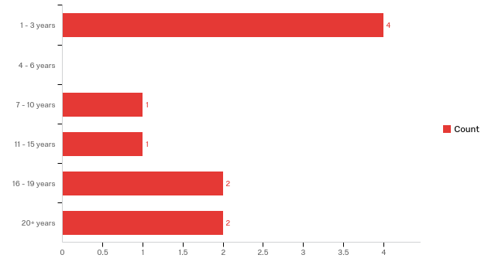

Answer | % | Count
1 - 3 years | 40% | 4
4 - 6 years | 0% | 0
7 - 10 years | 10% | 1
11 - 15 years | 10% | 1
16 - 19 years | 20% | 2
20+ years | 20% | 2
Total | 100% | 17

Have you been previously employed at another Catholic school within the Archdiocese of Detroit?
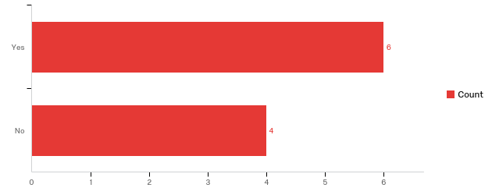

Answer | % | Count
Yes | 60% | 6
No | 40% | 4
Total | 100% | 10

Have you been previously employed at another public, private, or charter school?
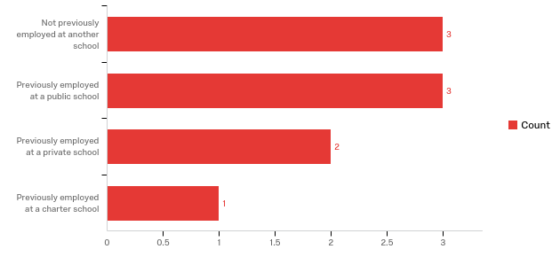

Answer | % | Count
Not previously employed at another school | 33% | 3
Previously employed at a public school | 33% | 3
Previously employed at a private school | 22% | 2
Previously employed at a charter school | 11% | 1
Total | 100% | 9

Did you attend this school?
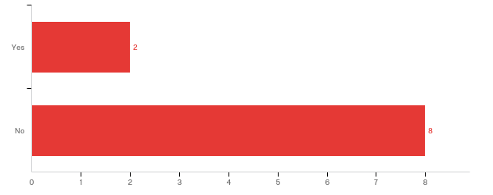

Answer | % | Count
Yes | 20% | 2
No | 80% | 8
Total | 100% | 10

Did you attend another Catholic School?

Answer
% | Count
60% | 6
40% | 4
100% | 10

Yes No Total

Do you have children currently attending this school?
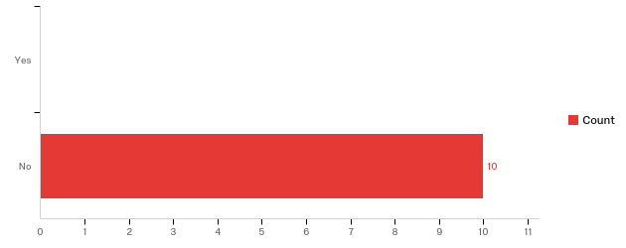

Answer | % | Count
Yes | 0% | 0
No | 100% | 10
Total | 100% | 10

Do you have children currently attending a different Catholic School in the Archdiocese of Detroit?

Answer | % | Count
Yes | 0% | 0
No | 100% | 10
Total | 100% | 10

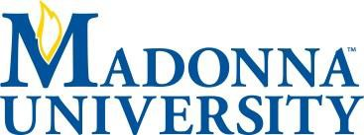

Report data from the Catholic School Effectiveness Survey administered through a partnership between Madonna University and the University of Detroit Mercy.

Developed by the Center for Catholic School Effectiveness, School of Education, Loyola University Chicago In partnership with the Roche Center for Catholic Education, Lynch School of Education, Boston College (2012)

