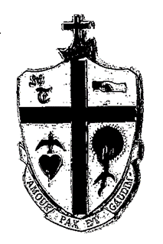 M.O.S.T
MEN OF SAINT TERESA OF AVILA
CATHOLIC CHURCH

George T. Wade Scholarship
For Continuing Education

PURPOSE: To Assist and Aid in Furthering the Educational Goals of a registered member of Saint
Teresa of Avila Catholic Church.

WHO CAN APPLY: Any Registered Member of STA Catholic Church Ages 19 and Older who
is not a previous winner of the George T. Wade scholarship.

HOW TO APPLY: Applicant Must Submit a 500 Word, Double-Spaced, Typed Essay on One of the
Following Subjects:

- How can Saint Teresa of Avila increase participation in church services and church activities during the pandemic?
- Do you feel that it is important to attend Mass physically or virtually?
- How has the pandemic affected your faith and/or religious participation?

Also included with the essay, applicant must submit proof of acceptance at an accredited institute of higher learning.

CRITERIA FOR SELECTION: (Award of scholarship will be based on :)

- Quality (distinguishing attributes, excellence and strength)
- Grammatical Accuracy (conformity to rules of grammar)
- Sincerity (honesty and earnest devotion)

Awardees will receive up to $1,000.00 credit payable to the educational institution. Non awardees will receive a letter of acknowledgement.
See Reverse Side for Instructions

Instructions:

Any registered member of Saint Teresa of Avila Catholic Church, 19 years old or older who is not a previous awardees of the George T. Wade scholarship should submit application for scholarship on or before Sunday November 14, 2021
To:
Paul M. Washington: (pmwashi@hotmail.com) Tony Yorkshire: tyorkies1@verizon.net or Michael Howard: (howard012155@gmail.com)

Or Mail or bring to:

STA Parish Life Center
(MOST George T. Wade Scholarship
1401 V Street, S.E.
Washington, D.C. 20020

The recipient of the Scholarship will be notified and will be announced
At the 9:30 am Sunday Mass

Good Luck!
May Our Good Lord Continue to Bless You and your educational goals

