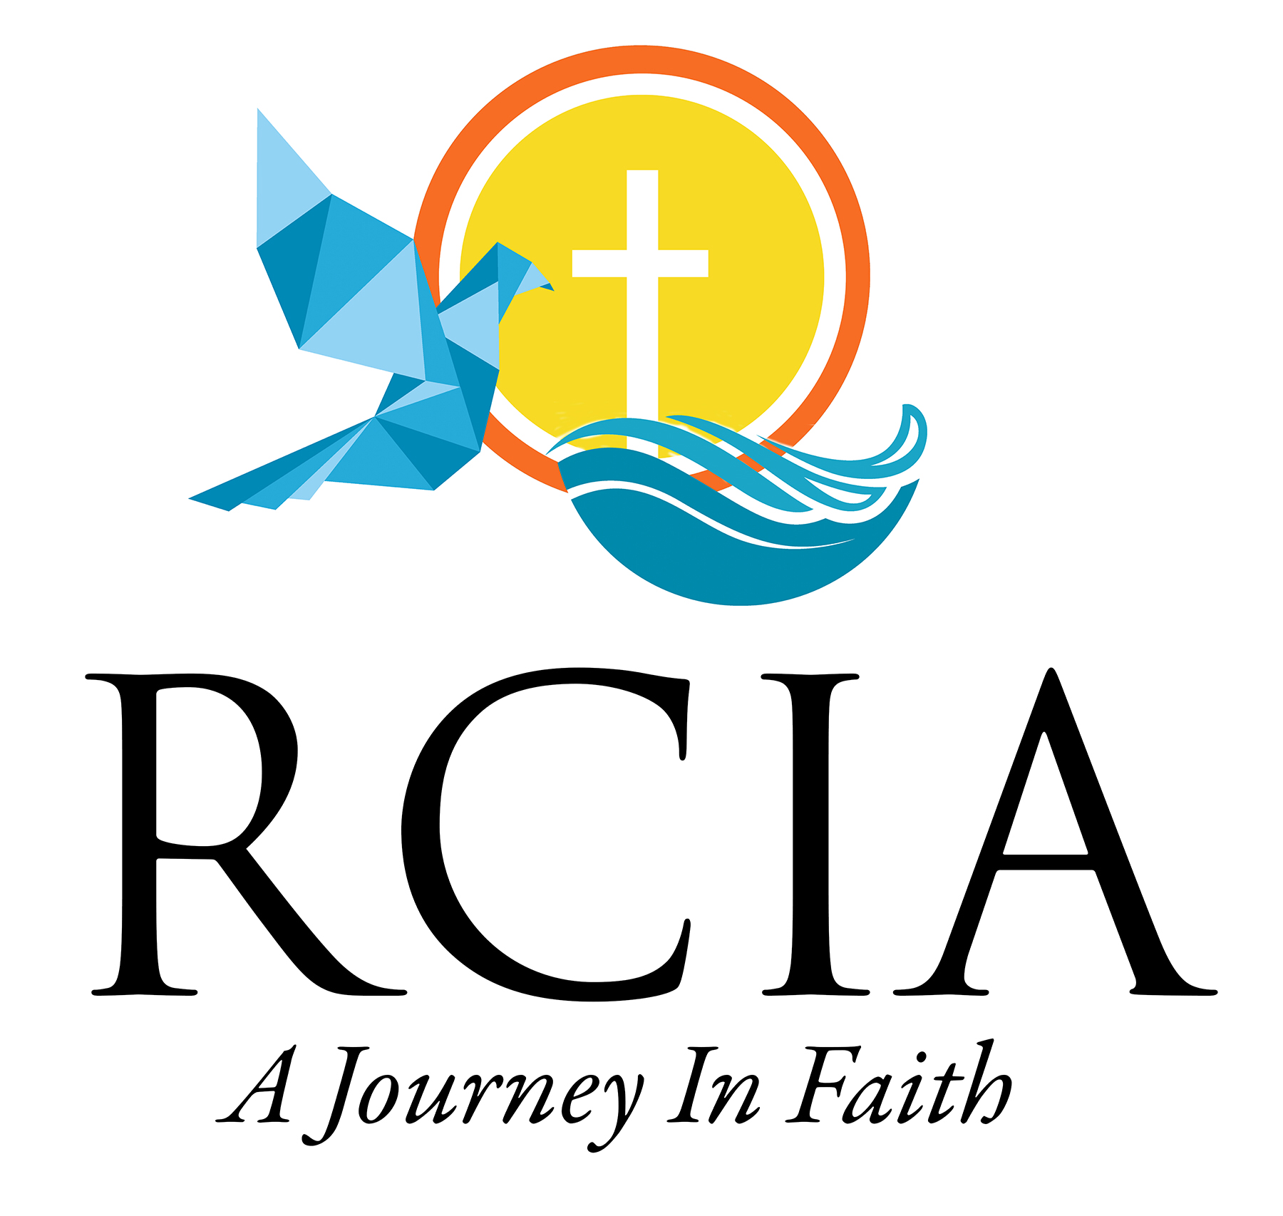
Our Lady of the Miraculous Medal
820 North Garfield Avenue, Montebello, CA 90640
Phone: 562.879.9478
Roy Ramirez, Director
Email: olmmrcia@gmail.com

RITE OF CHRISTIAN INITIATION FOR ADULTS
CLASS REGISTRATION FORM

Adults entering this program must be at least 18 years old and in need of Baptism, Holy Communion and Confirmation
or have been baptized but are seeking Holy Communion and Confirmation.
Due to the pandemic, a member of the RCIA Team will contact you regarding class start dates and times for the 2020-2021 season.
Please provide a copy of your Birth or Baptismal Certificate with this application.
Fees: $100.00 (non-refundable)

I am seeking: Baptism: _______ Communion: _______ Confirmation: _______ Conversion: _______ Information only:_________

Name: ______________________________________________________________________________________________________
Please print

Address: ____________________________________________________________________________________________________

City: __________________________________________________ Zip code: _________________________________________

Home Phone: ___________________________________ Cell Phone: _______________________________________________

Best Time to Call: _______________________ E-mail address: ___________________________________________________

Father’s Name: ___________________________________Mother’s Maiden Name: _______________________________________
Please print Please print

Check, if you have been Baptized:_____ Where:_______________________________________City/Country:__________________

Marital Status: ______ Single _____ Married before Catholic Priest or Deacon _____Civilly Married _____Widowed. _____Divorced

Home Parish: ________________________________________________ City: __________________________________________

Parish Envelope Number: ____________ (For OLMM Parishioners Only)

———————————————————————————————————————————————————————————-
For Office use only: Please review the below information for correctness. I understand this information will
be on my official certificate as listed. If you approve, please sign below.
Rec. Payment: ________ /________
_____________________________
Bapt/Birth Certi:_______ NAME:______________________________________________________________________
Godparent Form: ______
Page #: ______________ GODPARENT/SPONSOR:________________________________________________________
Book #: ______________
GODPARENT:_________________________________________________________________

Robe size: _____Ft_____In. SIGNATURE: ______________________________CERTIFICATE RECV’D: (Initial)____________

Revised: 06/2019

