Nativity BVM School

Martha Montiforte, Child Nutrition Supervisor
Nativity BVM School will be participating in USDA’s National School Lunch Program for SY 23-24.
Lunch will be offered to all students enrolled in our school for $3.50. Free and Reduced Meal Benefit Applications are available to you at any time and can be found in the school office or school cafeteria. Each family will receive an application in their child’s backpack the first day of school. Please remember you only need to complete 1 application per FAMILY!! You do not need to complete an application for each child. Kindly return the completed application as soon as possible. You are not required to complete an application but we hope you do! Income levels change each year. You may be eligible!!
We are happy to serve a hot nutritious meal to all Adults and students NOT enrolled in our school for $4.50.
We will maintain the nutrition standards of the National School Lunch Program which includes a strong emphasis on providing fruits and vegetables, milk, whole grains and sensible calorie and sodium levels. The National School Lunch Program provides flexibility for schools to further customize their meal service design to fit their local needs.
Nutrition is a cornerstone of learning and Nativity BVM School is proud to participate in this program to ensure the nutritional needs of every child are fulfilled; enabling our students to attain their greatest potential.
If you have questions or concerns please call Martha Montiforte, Child Nutrition Supervisor at 228-432-2269
This institution is an equal opportunity provider.
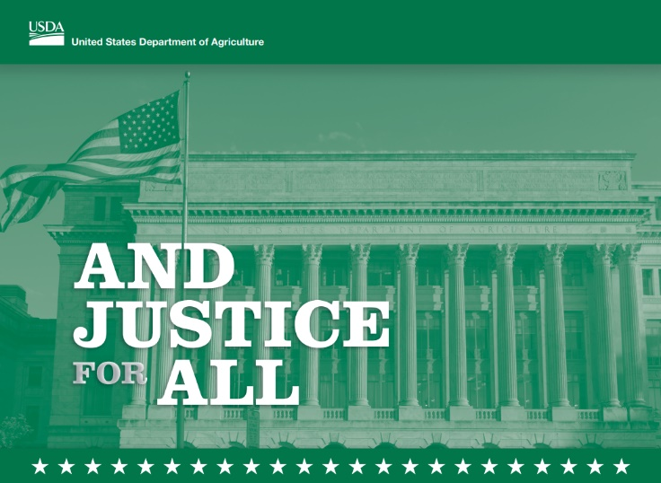
Please see full Non-Discrimination Statement below
USDA Non-Discrimination Statement

In accordance with federal civil rights law and U.S. Department of Agriculture (USDA) civil rights regulations and policies, this institution is prohibited from discriminating on the basis of race, color, national origin, sex (including gender identity and sexual orientation), disability, age, or reprisal or retaliation for prior civil rights activity.
Program information may be made available in languages other than English. Persons with disabilities who require alternative means of communication to obtain program information (e.g., Braille, large print, audiotape, American Sign Language), should contact the responsible state or local agency that administers the program or USDA’s TARGET Center at (202) 720-2600 (voice and TTY) or contact USDA through the Federal Relay Service at (800) 877-8339.
To file a program discrimination complaint, a Complainant should complete a Form AD-3027, USDA Program Discrimination Complaint Form which can be obtained online at: https://www.usda.gov/sites/default/files/documents/USDA-OASCR%20P-Complaint-Form-0508-0002-508-11-28-17Fax2Mail.pdf, from any USDA office, by calling (866) 632-9992, or by writing a letter addressed to USDA. The letter must contain the complainant’s name, address, telephone number, and a written description of the alleged discriminatory action in sufficient detail to inform the Assistant Secretary for Civil Rights (ASCR) about the nature and date of an alleged civil rights violation. The completed AD-3027 form or letter must be submitted to USDA by:
- mail:
U.S. Department of Agriculture
Office of the Assistant Secretary for Civil Rights
1400 Independence Avenue, SW
Washington, D.C. 20250-9410; or
- fax:
(833) 256-1665 or (202) 690-7442; or
- email:
Program.Intake@usda.gov

This institution is an equal opportunity provider.

