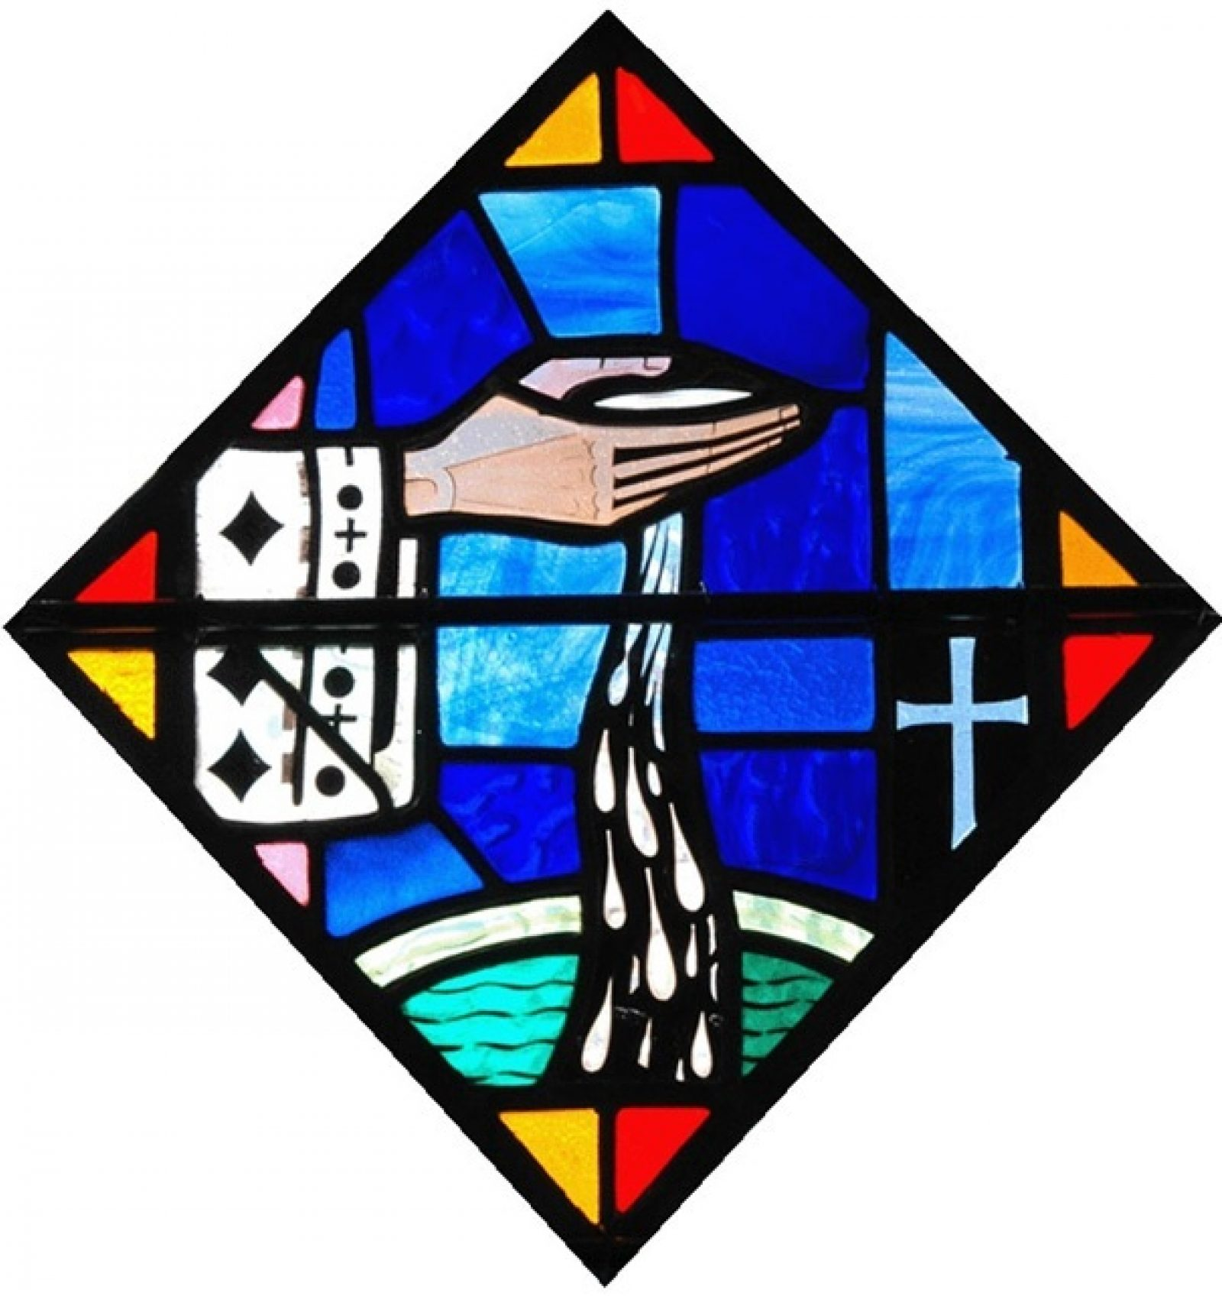
St. Stephen Catholic Church
Baptism
&
Baptism Preparation Class
Schedule 2026

January
- January 11 & 25 at 12:45 pm in Church
Baptism Class – January 4

February
- February 8 & 22 at 12:45 pm in Church
Baptism Class – February 1
March
- March 8 & 22 at 12:45 pm in Church

Baptisms are celebrated twice a month
Location: Church
Time: Following the 11:30 am Mass

Baptism Preparation Classes are held at the Family Life Center, Rooms 10 & 11 once a month beginning at 11:00 – 1:00 pm

- Baptism Class – March 1

April
- April 19 & 26 at 12:45 pm in Church
- Baptism Class – April 12

May
- May 10 & 31 at 12:45 pm in Church
Baptism Class – May 3

June
- June 14 & 28 at 12:45 pm in Church
Baptism Class – June 7

July
- July 12 & 26 at 12:45 pm in Church
Baptism Class – July 5

August
- August 9 & 23 at 12:45 pm in Church
Baptism Class – August 2

September
- September 13 & 27 at 12:45 pm in Church
Baptism Class – September 6

October
- October 11 & 25 at 12:45 pm in Church
Baptism Class – October 4

November
- November 8 & 22 at 12:45 pm in Church
Baptism Class – November 1

December
- December 13 at 12:45 pm in Church
Baptism Class – December 6

