# **St. Stephen Catholic Church Summer Youth Program 2025**

* **Edge Middle School Youth Group**
* **Life Teen High School Youth Group**

**EDGE Middle School Youth Group**

**Saturday – FLC - 5:30 pm - 8:00 PM**

**June**

7 - EDGE Night

**July**

19 - EDGE Night

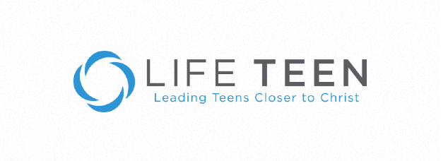

**Life Teen Youth Group**

**Sunday – FLC – 6:30 pm – 8:30 pm**

**June**

1- LIFE Night

8 - LIFE Night

22 - LIFE Night

**July**

13 - LIFE Night

20 - LIFE Night

27 - LIFE Night