Service Opportunity for Candidates for Adult Confirmation

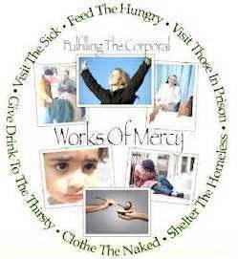
“For I was hungry and you gave me food. I was thirsty and you gave me drink. I was a stranger and you welcomed me. I was naked and you clothed me. O was sick and you visited me. I was in prison and you came to me…..Truly, I say to you, as you did it to one of the least of these my brethren, you did it to me.” [Matthew 25:35-36, 40]

As fully initiated Catholics, our faith mandates that we love our neighbor as ourselves. That love is manifested by our acts of mercy toward others. By our 6th lesson in preparation for your celebration of Confirmation, you are asked to identify and perform a “corporal work of mercy.” Sample activities are listed below; however, you might select another one if you can explain and defend how it is a corporal work of mercy.
Feed the hungry/Give drink to the thirsty:
- Help in a soup kitchen.
- Help deliver meals to the needy or elderly.
Shelter the homeless:
- Help at a home or facility for the elderly.
- Work at a construction site for a charity housing project.
- Clean house for a home-bound person.
- Collect items for victims of a recent disaster.
- Provide rent for someone threatened with eviction.
Clothe the naked:
- Assist at a charity center to sort clothes and other items.
- Collect items for newborns at a crisis pregnancy center.
Visit the sick:
- Visit a home-bound person or one in the hospital.
- Sponsor a person who needs medical care beyond his means.
- Take someone to a medical appointment.
Visit the imprisoned:
- Accompany a deacon involved in prison ministry.
Bury the dead:
- Weed a Catholic cemetery.
- Bring food to a family in mourning.

During lesson #6, you will share with the class the details of your chosen corporal work of mercy: what you did, what the reaction by others was, how you felt, and how this activity brought you closer to Christ.

