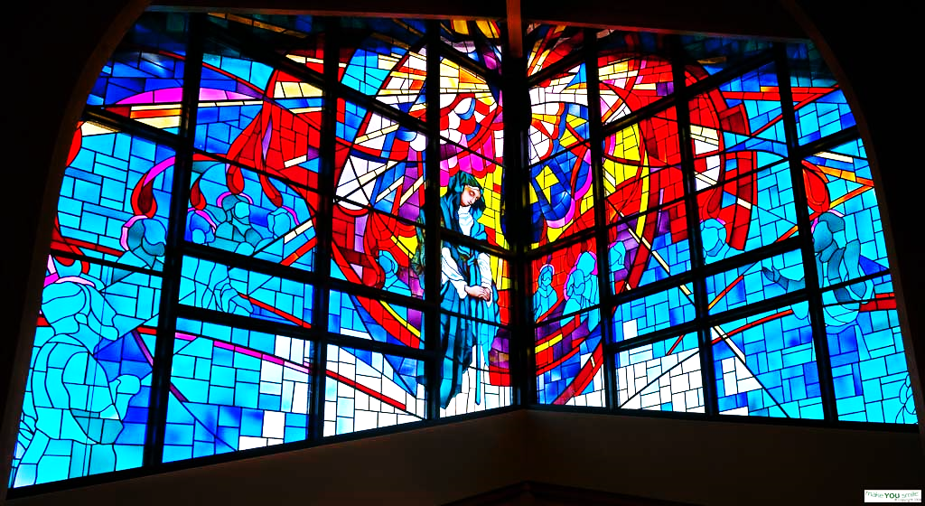

ST. LAURENCE CATHOLIC CHURCH

40th Anniversary Novena

1985 – 2025

Heavenly Father,

We give you all the honor, glory and praise for 40 years of learning, growing, serving and uniting us as a parish family. As we come together and pray this special novena in celebration of the past 40 years, let us be filled with the Holy Spirit, strengthened and renewed in our commitment to God and one another, serving as a light to Sugar Land and the whole world.

In the name of Jesus Christ, we ask that you bless the families that came before us, our own families and our parish family for generations to come, and may we, the people of St. Laurence Catholic Church, continue to be centered in the love of Christ and live to glorify God in all that we do.

Amen.

-

DAILY INTENTION

OF OUR PARISH FAMILY

Day 1

*Let us pray:* For the Holy Spirit to fall afresh on each one of us, our parish and all our ministries.

Day 2

*Let us pray:* For our priests, deacons and all those in religious life or formation.

Day 3

*Let us pray:* For marriages, families, friends and all those the Lord has entrusted to our care.

Day 4

*Let us pray:* For those who have left the Church or who are struggling in their faith.

Day 5

*Let us pray:* For those who are suffering and experiencing hardships in life whether physical, emotional or spiritual.

Day 6

*Let us pray:* For the strength and courage to live out our Catholic faith in our everyday life.

Day 7

*Let us pray:* That we may be instruments of peace,

hope and charity within our parish and the

communities that surround us.

Day 8

*Let us pray:* For past, present and future generations

of St. Laurence Catholic Church to be blessed by God

with an abundance of graces.

Day 9

*Let us pray:* For the courage to step out in faith and invite others to join us at Mass or get involved in the many ministries that make up our parish life.

NOVENA

ST. LAURENCE CATHOLIC CHURCH

In the name of the Father, and the Son, and the Holy Spirit. Amen.

LET US PRAY

*(Insert the daily intention of our parish family here. On each of the nine days, we will pray together for a different intention.)*

THE UNITY PRAYER

My adorable Jesus, may our feet journey together. May our hands gather in unity. May our hearts beat in unison. May our souls be in harmony. May our thoughts be as one. May our ears listen to the silence together. May our glances profoundly penetrate each other. May our lips pray together to gain mercy from the Eternal Father. Amen

*(Mention your personal intentions here.)*

MEMORARE TO THE HOLY FAMILY

Remember, O most beloved and gracious Jesus, Mary and Joseph, that never was it known that anyone who fled to thy protection, implored thy help, or sought thy intercession was left unaided. Inspired by this confidence, I fly unto thee, O Beloved Jesus, Mary and Joseph; to thee do I come, before thee I stand, sinful and sorrowful. O Beloved Jesus, Mary and Joseph, despise not my petitions, but in thy mercy hear and answer me. Amen

St. Laurence, *pray for us.*

Fr. Laurence Connelly, *pray for us as we pray for you.*

Fr. John Weyer, *pray for us as we pray for you.*

Fr. Drew Wood, *pray for us as we pray for you.*

Our Father…

Hail Mary…

Glory Be…

In the name of the Father, and the Son, and the Holy Spirit. Amen.

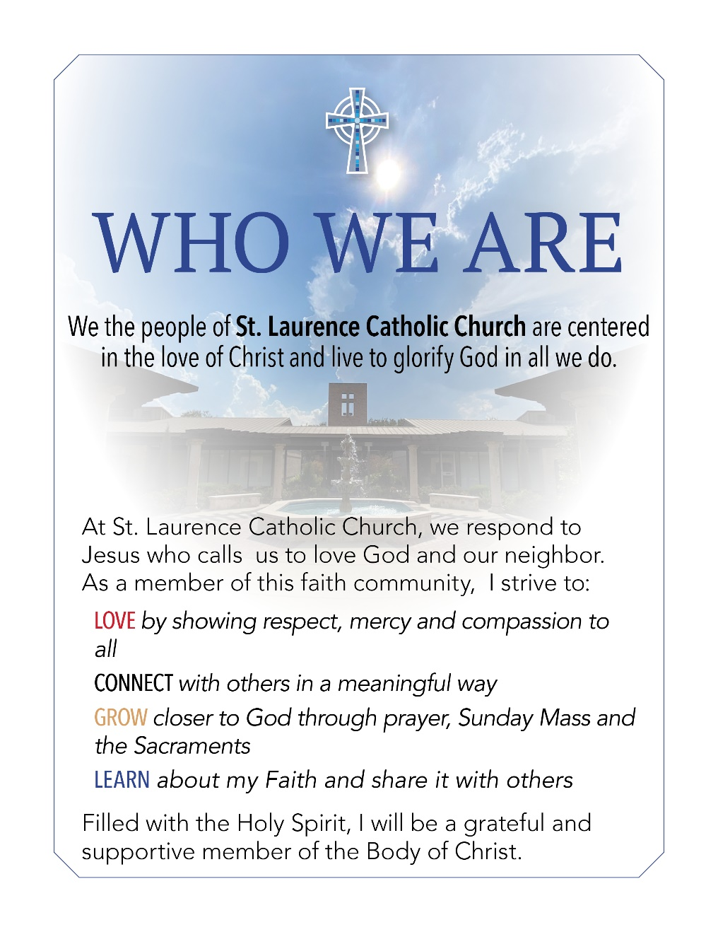

St. Laurence Catholic Church

3100 Sweetwater Boulevard

Sugar Land, Texas 77479

281-980-9812

stlaurence.org

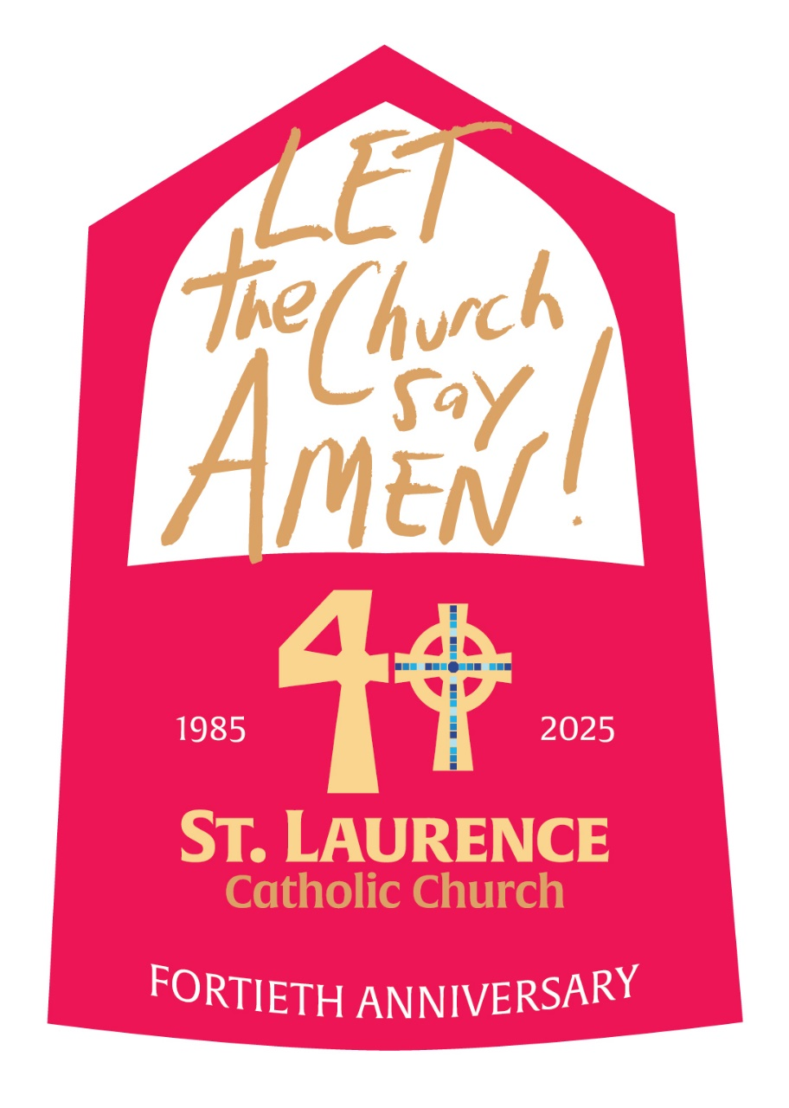

NOVENA

ST. LAURENCE CATHOLIC CHURCH

1985 – 2025