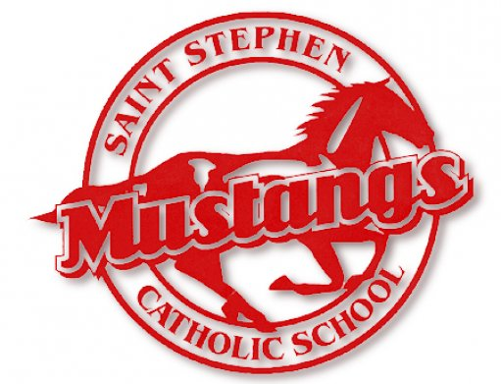

**St. Stephen Basketball Camp**

When:

July 14th-18th

Where:

Family Life Center—St. Stephen School Campus

9:00am-3:00pm (Lunch not provided)

Camp Cost:

$175 per week (Cash, checks payable to St Stephen Catholic School, or billed to FACTS)

T-shirt included

Registration:

Grades 3rd-8th for 2025-26 school year

Open to St Stephen students and parishioners

Registration and Fee due to the school office by June 19 to assure camp t-shirt size

Walk up registrations will be accepted on the first day of camp

Camp Includes:  
Fundamental Instruction

Teamwork & Character Development

Game Situations & Strategy

Skill Contests & Games

**Coach Green is excited to continue the tradition of our summer basketball camp in the St. Stephen FLC. This will be the 10th year of basketball camp.**

**See you on the court Mustangs!**

**St. Stephen Catholic School - 10424 Saint Stephen Circle, Riverview, FL 33569**