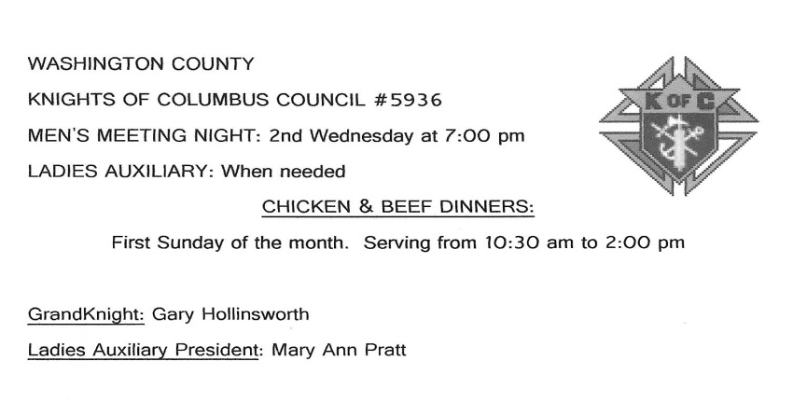

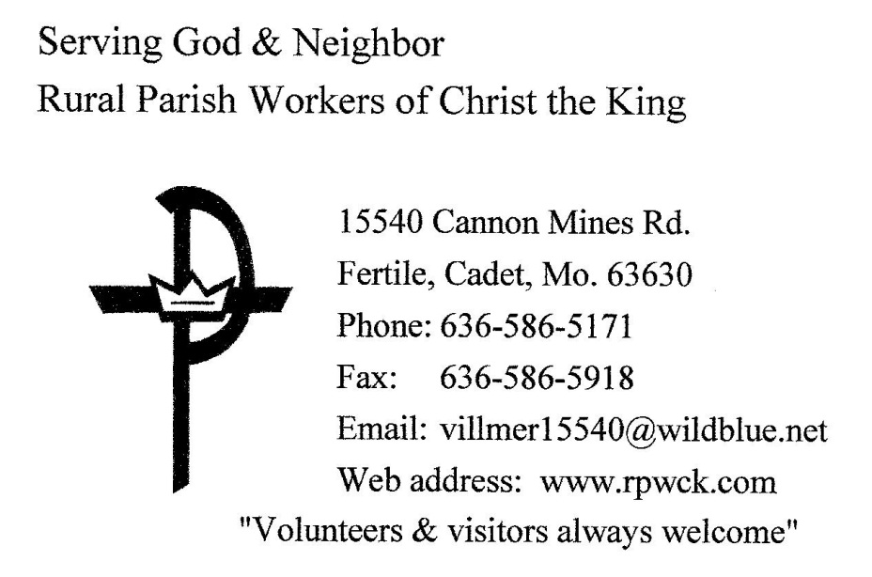





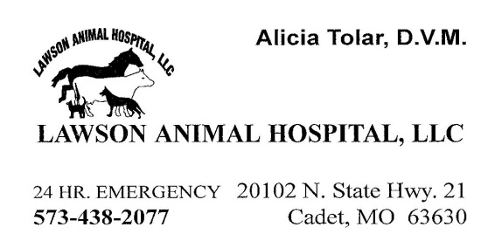





BLACKBIRD CAFÉ

512 EAST HIGH STREET ** POTOSI, MO 63664

Wednesday thru Friday: 8 am to 3 pm

Saturday: 8 am to 2 pm

573-324-7772 ** 573-271-7089

“Come on in and enjoy a delicious home-cooked meal.”

Pat Koch, Owner

Order your Holiday Pies and Cakes early!

We also do Cookies and Candy!



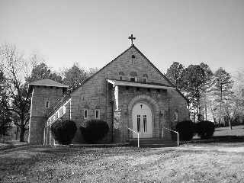



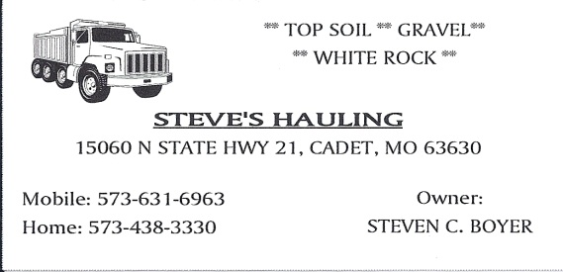



**Looking for God?...**

***“Come To Your Senses!”***

**Inspiring and Uplifting**

**Reflections on God**

[**www.reflections-on-god.com**](http://www.reflections-on-god.com)

**by**

**Dave Politte**



**

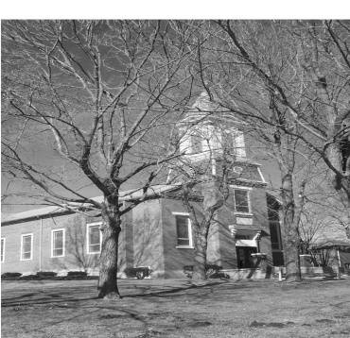

ST. JOACHIM CATHOLIC CHURCH

10120 Crest Rd

Old Mines, Mo. 63630

ST. JOSEPH CATHOLIC CHURCH

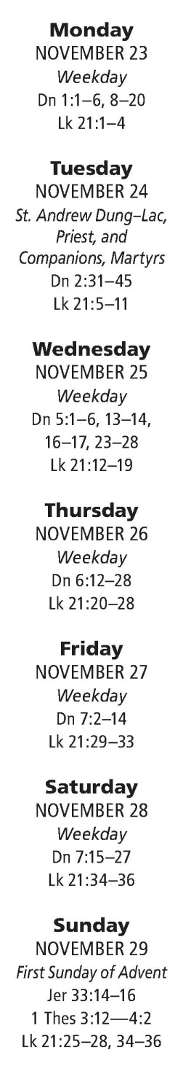TIFF, MO

STAFF

Rev. Anthony A. Dattilo, Pastor

Carmen Litton, Principal

Joyce Politte, DRE

Mary Ann Pratt, Parish Secretary

Vicki Thurmond, Parish Bookkeeper

Laura Villmer, School Secretary

Reuben Lawson, Parish Council President

Office Hours / Telephone Numbers

Rectory: 438-6181 / FAX 438-3685

Office Hours: 7:00 am – 3:00 pm (M-F)

School: 438-3973 / FAX 438-3161

Rural Parish Workers: 636-586-5171

Reuben Lawson, PC President: 438-6446

SUNDAY MASS SCHEDULE:

Saturday evening at 4:00 pm & 6:30 pm at Tiff

Sunday morning at 8:00 am & 10:00 am

WEEKDAY MASS SCHEDULE:

8:00 am – Mon., Wed., Thurs., Fri.

8:15 am – Tuesday - Perpetual Help Devotions

& Rosary before the 7:45 am

CONFESSIONS: Saturday at 3:00-3:45 pm or

by appointment.

HOLY DAY SCHEDULE: Please check the

Bulletin inside for Mass times.

FOOD DRIVE of non-perishable foods for the

St. Vincent de Paul Society Food Pantry on the

1st Sunday of each month. Please bring your items

and put in the box by the side door of the Church.

THANK YOU!

E-Mail & Web Sites:

*MISSION STATEMENT: We, the Parish Family of St. Joachim & St. Joseph, of the Archdiocese of St. Louis, are a people with a heritage of faith. Encouraged by the Tradition of Christian hospitality, caring, and love towards neighbor, we are committed to continue to support each other on our pilgrim journey to the Father. In response to God’s Word, we strive through a sacramental life to bring all to a fuller understanding of God’s love by praying, teaching, and by witnessing to Christ, in the service of one another.*

Parish – stjoachimparish@hotmail.com

School – stjoachimschool@yahoo.com

Parish Web Site – http://stjoachim.org

School Web Site – http://stjoachimschool.com

Rural Parish Workers Web Site – <http://rpwck.com>

NOVEMBER 22, 2015

OUR LORD JESUS CHRIST,

KING OF THE UNIVERSE

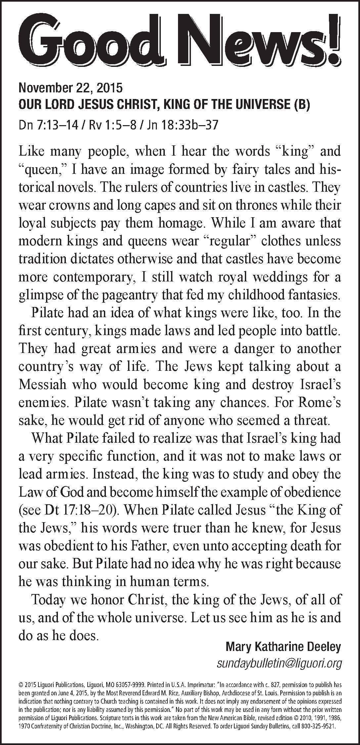

**MASS INTENTIONS**

**November 22, 2015 – Our Lord Jesus Christ, King of the Universe**

Monday, Nov. 23

8:00 am – Georgeanne Wall Cash

Tuesday, Nov. 24

7:45 am – Rosary & Perpetual Help Devotions

8:15 am – Dale Missey

**Wednesday, Nov. 25**

8:00 am – Joan Young

Thursday, Nov. 26 – Thanksgiving Day

9:00 am – Parish Family

9:00 am – (TIFF) Ronnie Politte

Friday, Nov. 27

8:00 am – Stanley Pratt

**Saturday, Nov. 28**

4:00 pm – Veronica A. Boyer

6:30 pm (TIFF) – Dennis P. Coleman

Sunday, November 29

8:00 am – Tim & Tom Wilson

10:00 am – Parish Family

**EUCHARISTIC ADORATION**: Dec. 4, 2015 (9 am- until 5:45 pm)

**NURSING HOME:** Dec. 4, 2015 @ Potosi Manor 10:00 am

## **LITURGICAL APPOINTMENTS FOR NOVEMBER 28th& 29th:**

## **EXTRAORDINARY MINISTER OF HOLY COMMUNION:**

4:00 pm –John Z Coleman, Carolyn Politte, Faye Merseal, Angie Rulo, Volunteer Needed

6:30 pm (Tiff) – Richard & Rae Govero

8:00 am - Jackie O’Hanlon, Mary Ann Pratt, Robert Ross, Ed Politte, Cody Ross

10:00 am – Al & Ima Veach, David & Monica Pratt, Jeannie Brown

**LECTORS:**

4:00 pm – Benny Merseal

6:30 pm (TIFF) – Juanita Daugherty

8:00 am – Aaron Ross

10:00 am – Pam Boyer

## **OFFERTORY PROCESSION:**

5:00 pm – Jerry & Debbie Miller

6:30 pm (TIFF) – John & Gail Boyer

8:00 am – Roger & Becky Johnston

10:00 am – Jean Anselman & Jayne Lawson

## **SERVERS**

4:00 pm – Volunteers Needed

6:30 (TIFF) – Volunteers Needed

8:00 am – Volunteers Needed

10:00 am - Mackenzie Coleman-Portell, Jade Coleman, Hannah Villmer

**CHILDREN’S LITURGY OF THE WORD**: Vicki Haynes

**MUSICIANS:** **(4 pm)** Ken Portell & Krista Portell; **(8 am)** Joyce Politte **(10 am)** Tina Courtway

**UPCOMING MEETINGS:**

Nov. 30 – St. Vincent de Paul, 7 pm

**THANK YOU TO ALL WHO ARE SO FAITHFUL IN THE SUPPORT OF OUR PARISH AND SCHOOL! GOD SEES YOUR SACRIFICE AND BLESSES YOU ABUNDANTLY!**

**CONTRIBUTIONS FOR WEEKEND OF NOV. 14th & 15th:**

# of Contributors: St. Joachim- 68 St. Joseph-9

ST JOACHIM ST. JOSEPH

Loose: $102.00 Loose: $110.00

Adults: $2538.00 Adults: $180.00

Tuition: $526.18

Other: $3088.54 Other: $

TOTALS: $6254.72 $290.00

**SPECIAL COLLECTIONS:(Restricted Funds)**

St. Vincent de Paul: $20.00 $0.00

Bldg. Fund: $252.00

*November 22, 2015*

*Feast of Christ the King*

*“Jesus answered, ‘My kingdom does not belong to this world.” (John 18:36)*

*How often do we put all our time and energy into building a kingdom here on earth, forgetting that life here is short? The real kingdom is in the next life. Yet, how much time and energy do we invest in working for that eternal kingdom?*

**PLEASE PRAY FOR THE SICK**: Lucy Scott, George Ponzar, George Pinson, Ashlynn Kamper, Margaret Kite, Baby Molli Catherine Cooley, Benny Thebeau, Dr. Ken Osia, Joyce Bouresaw, Beth McCoy, Leatha Peyton, Rose Ann Richards, Breanna Harmon, Beverly Osia, Jimmy DeClue, Kevin Thebeau, Theresa Coleman, Don Bourbon, Marsha Jones, Linda Ross, Norman & Imelda Wilson, Lyndsey Cardwell, Pat Schumer, Eli Robart, Ina Mae Boyer, Ann Schwendemann, Mary Catherine Portell, Ellen Pashia, Celeste Bone, William W. Delashmit, Marion Delashmit Watson, Matt Eaton, Jessica Gough, Paisley Tate, Ruth Ann Lambing, Blanche Thebeau, Alma June Boyer, Theresa Soutors, Stephanie R., Cindy Boyer, Rachel Coleman, Jeremy Winick, Cody Battreal, Anthony Ward, Mike Boyer, Rick Blasé, Steve Politte, Loretta Golden, Jiggs Thebeau, Myrna Boyer, Cindy Ware, Renna Eckhoff, Jimmy Hammond, Donna Tallis, Natalie Manning, Reva Politte, Shirley Boyer, Raymond Ward, Russell Thebeau, Michael T. Boyer, Lynn Coleman, Steve Ritter, Arminte Wiggins, Mary Politte, Bob Hahn, Nadine Morgan and all who are sick and suffering.

Please Note: The Parish Office will close at 12:30 on Wednesday and be closed on Thursday & Friday. Any items for the bulletin need to be in the office no later than 1:00 pm on Tuesday. Thank You!

**St. Joachim/St. Joseph**

**December Birthday & Anniversary Dates**

December Birthdays

Katie Thurmond December 2

Tracy Wartenbe December 2

Tom Haynes December 4

*God Our Father,*

*The birth of your Son Jesus Christ brought great joy to Mary and Joseph. We give thanks to you for those whose birthday we celebrate this month. May he/she ever grow in your faith, hope and love. We ask this in the name of our Lord Jesus Christ. Amen.*

Brynlee Mitchell December 4

Sara Roberts December 4

Madalyn Bone December 5

Elaine Portell December 5

Karrie Boyer December 6

Kaleb Lawson December 6

Laura Villmer December 7

Charlene Hedrick December 8

Jim Johnston December 8

Peg Portell December 8

Jade Coleman December 9

Allison Hahn December 9

Chesney Jacobsen December 9

Alexis Mirelez December 9

Gavin Mosier December 9

Cody Yates December 9

Brendan Yates December 9

Leroy Boyer December 10

Lucas Gann December 12

Hunter Mosier December 12

Phyllis Adams December 13

Beau Riddle December 13

Janet Govero December 14

Jared Portell December 14

Myrtle Missey December 15

Cheryl Yates December 16

Catherine Dickey December 17

Mary Ann Bourbon December 18

Michael Boyer December 19

Kent Dickey December 19

Reuben Lawson December 19

Blakely Jacobsen December 20

Rachel Heifner December 21

Cortney Juliette December 21

Bailey Luther December 21

Barbara Clark December 24

Jennefer Estes December 24

Annette Goff December 24

Kobe Kincaid December 24

Glennon Bequette December 25

Hannah Brown December 25

Juanita Daugherty December 26

Mary Boyer December 27

Ella Riddle December 28

Emmylu Foster December 29

Steve Nash December 29

Doris Lawson December 30

Jordan Lawson December 30

Jan Pinson December 30

Jane Thompson December 30

December Anniversaries

Luther, Robert & Deanna December 1, 2012, (3)

Thompson, Tom & Theresa December 5, 1980 (35)

Pashia, Christopher & Erin December 15, 2001 (14)

Warden, Alvin & Gladys December 17, 1996 (18)

Veach, Daniel & Laura December 18, 1999 (15)

Daugherty, Joseph & Juanita December 26, 1953 (61)

Veach, Alva & Ima December 27, 1968 Years (46)

Politte, Edwin L & Nancy December 28, 1963 (51)

*On your Anniversary, May God bless you and grant you joy. May He deepen your love for each other. May He bless you + in your family and friends, and lead you to unending happiness in Heaven. May Almighty God, Father, Son, + and Holy Spirit, Bless us all, and keep us in His love forever and ever. Amen*

**HOW ABOUT COUPLE TIME TOGETHER!** A Marriage Encounter weekend is a weekend full of fresh love, rebirth and new beginnings for many couples who have attended a weekend. All married couples deserve a rich full life together. You will never forget this weekend held on December 4-6 or in 2016 on February 5-7 or April 22-24. To find out more, apply at www.stl-wwme.org or call 314.649.7317.

**Dynamic Catholic, Alive! – Spiritual Direction**

Today we celebrate Christ as the King of the Universe. It reminds us that God has a plan for our lives. Determining God’s will is not always easy, and requires prayer and discernment. A spiritual director can help with your spiritual develop by providing guidance and discernment. Are you receiving spiritual direction, or are you considering seeking out a spiritual director? You can also attend a retreat offered by your parish or the Archdiocese. archstl.org/dynamic

**CALLING ALL SINGERS!!** Bev McColloch is inviting singers to participate in the Community Thanksgiving Program Choir. The practice is on Sunday, Nov. 22nd at 8:00 pm at the Potosi Southern Baptist Church. The program is on Monday evening, Nov. 23rd at 7:00 pm at the Potosi Southern Baptist Church. Please come and join with choir members from area churches to sing a joyful song unto the Lord!

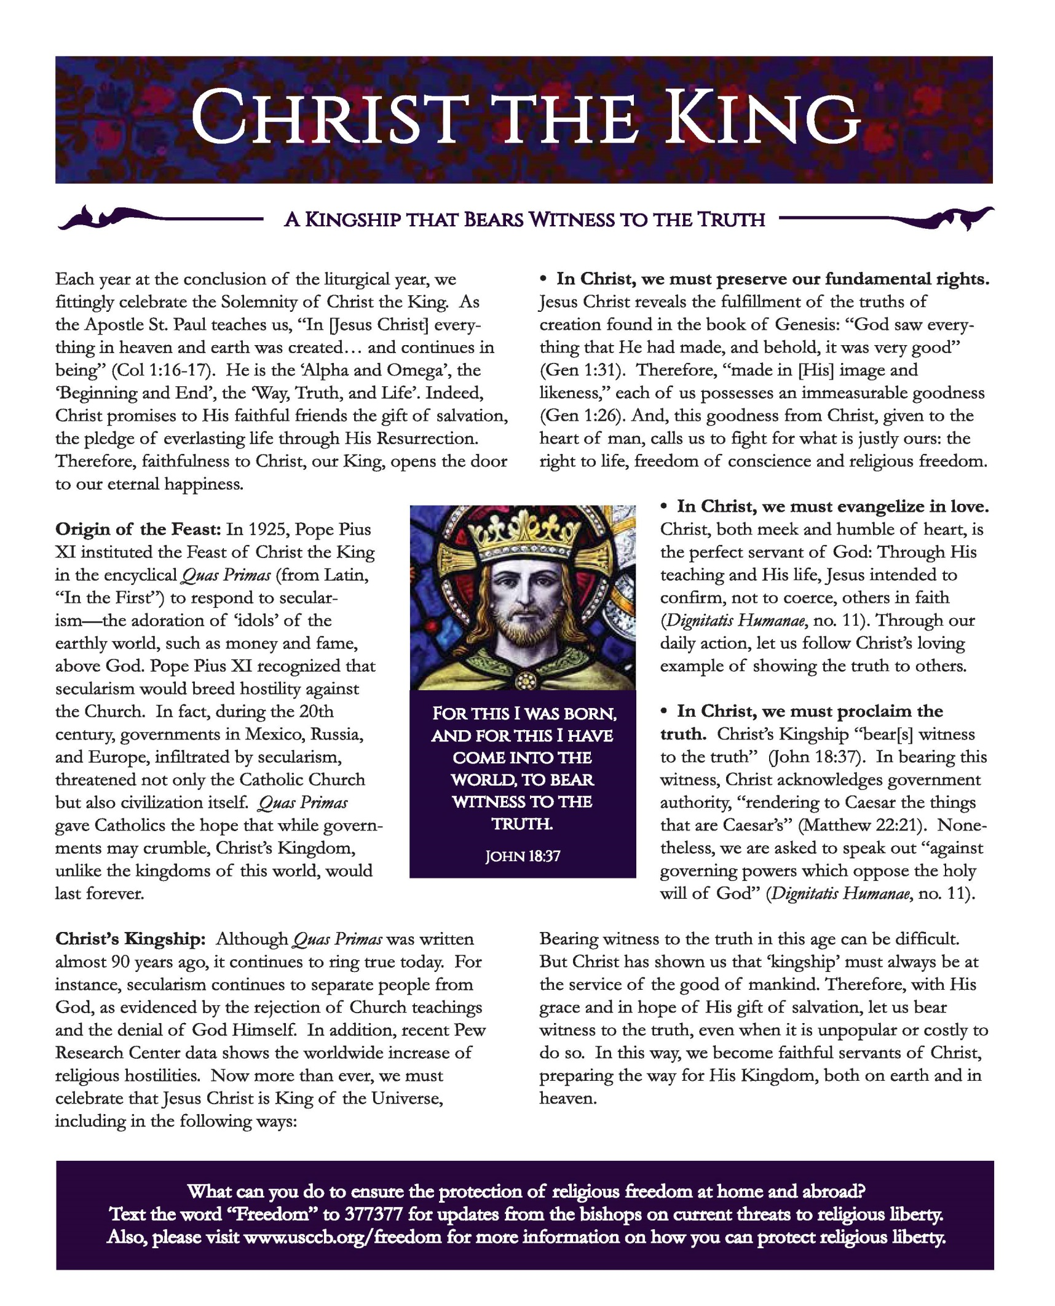

**St. Joachim School**

***“Your Future Begins With Us”***

***News from St. Joachim School & PSR***

**Mission Statement**

The mission of St. Joachim Catholic School is to assist the parents and parish community in the shared responsibility of providing an excellent religious and academic education that is *Alive in Christ* for the children of Washington County.

**FROM THE DESK OF MRS. LITTON:**

Happy Thanksgiving Week!

The month has flown by and many activities have been fulfilled. Our students did a wonderful job entertaining guests at Thursday's Thanksgiving Dinner and all enjoyed being with their loved ones for lunch. Thank you to the school staff for baking turkeys, everyone that helped with decorating, bringing food, cooking and preparing for this wonderful day. We are blessed to have such a caring and loving parish.

Tuesday, Nov. 24 the staff and students will be going to Potosi Manor to share a few songs about Thanksgiving or honoring our Veterans.

Wednesday, Nov. 25 is a 12:00 dismissal for Thanksgiving.

Dec. 2 at 6:30 is First Reconciliation for students. Parents are welcome to attend.

St. Joachim School is planning to participate in the Christmas Parade, Thursday, Dec. at 6:00.

May all of the parish & community have a thankful holiday and enjoy your families. God Bless

**HELP WANTED – DON’T FORGET!**

On Saturday, November 28th we will have a Cemetery Clean-up Work Day beginning at 9 am. We will remove all old and torn decorations, dead leaves and brush from around the headstones and graves. WORKERS ARE NEEDED! We hope to have our cemeteries in good order for the upcoming holidays. If anyone wishes to come and take care of their own family plot that day, that will be great!

We ask you to put this date on your November calendar!

**Religious Education News**

**Serve Him with Joy and Gladness**

*Encountering Christ Every Day*

**RCIA.** If interested in becoming Catholic, being fully received into Catholic Church, receiving sacrament of Confirmation call Joyce Politte, 573-438-3213 or 636-328-1343. Period of Inquiry is in session. Come and See. Rite of Acceptance into the Catechumenate will be celebrated on Sunday, Nov. 29 at 10 a.m.

**Sacrament of First Penance** will be celebrated on Wednesday, December 3. Confessions will also be heard for PSR students and families at that time.

**Confirmation candidates** will be participating in works of service to learn “how to serve, Jesus.” Some students will be helping to clean up the cemeteries on November 28, and some will be ringing the bell for the Salvation Army on Dec. 4 from 6-8 p.m.

**Mark your calendar**. A Parish Mission with Redemptorist, Father Pete Chavitz, is scheduled for September 24-28, 2016.

**Next Life in the Spirit** Monthly Prayer Meeting is February 21 at 5 p.m.

**CHRISTMAS GIVING TREE**: The “Christmas Giving Tree” is a tradition in our parish that has been going on for many, many years. The Tree is covered with paper ornaments that have a number and a short list of items that are needed for some child at Christmas time and is always displayed at our Thanksgiving Services. If you wish to take a name and purchase one or more of these items, please write your name and the number you take on the paper provided. Return the wrapped gift with the number attached by December 13th! Thank you for making a child’s Christmas special!

**Prayer for Christ the King Sunday**

O God who has set before us the great hope that Your kingdom shall be established on earth, so rule our lives by Your Spirit that all Our thoughts, desires, and acts being made obedient unto You, Your power, Your glory and the mightiness of Your kingdom may be made known unto men. Grant this O merciful Father for Jesus Christ's sake, Your son, our Lord.

Amen

**KNIGHTS OF COLUMBUS NEWS:**

**CHICKEN & BEEF DINNERS** – Dec. 6 2015. Serving is from 10:30 am to 2:00 pm (unless they run out!) Your support is very much appreciated! Desserts & Workers are always needed. Please help if you can!

JOIN US ON THANKSGIVING DAY,

NOVEMBER 27th FOR THE

9:00 AM THANKSGIVING DAY MASS

This special liturgy is a wonderful way to begin our day of Thanksgiving! Plan on joining fellow parishioners, family and friends in praising and thanking God for all He has done for us.

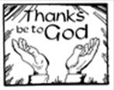

**Christmas Country Church Tour:** The St. Anne Sodality Members and all interested parishioners are invited to join us for a “Christmas Country Church Tour” in Perry, Cape Girardeau & Bollinger County Churches on Thursday, December 17, 2015. Please call the rectory office (438-6181) if you wish to join us on the wonderful tour by December 15th. We will be car-pooling, so if anyone is willing to drive that will be great. Just let us know! We will have lunch at the Apple Creek Vineyard & Winery. Please let us know by Dec. 15th if you will be going. We need to give a count to the Winery of how many people are coming.

**THIS WEEK’S READINGS:**

On this final Sunday of the liturgical year, we return to John’s Gospel for a portrait of Jesus Christ during his passion. In this conversation with Pontius Pilate, Jesus speaks of his kingdom and of his mission among us. As we hear these sacred words of scripture today, let us ponder what it means to belong to the truth so that we may listen more eagerly to the voice of Jesus, our Lord and King.

**QUESTION OF THE WEEK:**

Today’s Gospel ends just before Pilate asks Jesus another question: “What is truth?” The world asks us the same question: What is truth?

**THE ST. ANNE SODALITY** will sponsor a Turkey Bingo TODAY, Nov. 22nd beginning at 2:00 pm, in the school cafeteria. The Ladies will be serving refreshments. Doors will open at 1:00 pm. This is a Turkey Bingo, playing 20 + games, we will have a quilt raffle and a cup auction. We need the backing and support of all our parishioners! Please come out and enjoy the afternoon!

(Proceeds from this bingo will go towards the purchase of new blinds for the school cafeteria)

**THANK YOU FROM THE ST. ANNE SODALITY**: “Our Christmas Bazaar was a huge success. Thank you to all who attended and to all the people that worked to make that happen! Thank you to the KC Hall for letting us use their hall.

The winners of the Christmas Bazaar Baskets are:

1) Cold Cash – Belinda Farrier

2) Kids Basket – Cathy Belfield

3) Snowman Basket – Amy Boyer

4) Thanksgiving Basket – Tim Pratt

5) Game Night Basket – Kristain Miller

6) Gentleman Basket – Matt Aubuchon

7) Bath & Body Basket – Jean Anselman

8) Fruit Basket – Carol Graf

9) Surprise Basket – Nancy Peyton

50/50 was won by Marti Goodson

The proceeds from this fundraiser will help to pay for the new flooring in the school office.

---------------------------------------------------------------------------

The St. Anne Sodality has raised and donated back thousands of dollars to St. Joachim Parish and School throughout the years. Their most recent donations have been towards the Rectory, Convent and School renovations! They work tirelessly in their charitable endeavors and deserve a big THANK YOU! The Christmas Bazaar last weekend and the Turkey Bingo this weekend will help to put new flooring in the school office and blinds for the cafeteria. As always, the ladies appreciate all your help, for without you, we couldn’t make these things happen!

**A SPECIAL THANK YOU** to all who helped with the St. Michael House Rummage Sale on Nov. 7th. It was a great success and netted $3070.00, for the programs and maintenance of the building. Blessings on all who worked so hard!

The Rural Parish Workers

**NOTE FROM THE OFFICE:** I am preparing to set up the envelope system for 2016. If you do not receive envelopes but wish to, OR, you are not registered with the parish, and wish to be, OR, you have a change of address, please call the rectory office or send a note through the collection basket. Also, parishioner registration forms are available at the doors of the church for anyone who has not filled one out or if you need to update your information. Please update telephone numbers! We have a good many telephone numbers that are no longer valid. Also, it would be great for you to include your email address! Please update your addresses, also! If you or a family member has changed the way you receive your mail, please let us know. Thanks! Mary Ann Pratt, secretary

**CHRISTMAS DECORATIONS & POINSETTIA’S FOR THE CHURCH:** If you would like to donate towards the Christmas decorations & Poinsettia’s in memory of a loved one, you may place your donation in an envelope and drop it in the collection basket. The suggested donation is $10.00. Please do so by Dec. 21st. You may also buy and donate one of your own. Please clearly mark whom the flower is donated in memory of and your own name. These should be dropped off at church on December 20th (please do not bring them any earlier).

The Jubilee Year of Mercy begins on December 8, 2015, the fiftieth anniversary of the closing of the Second Vatican Council.

**Mercy is “the beating heart of the Gospel”**

Pope Francis writes: “It is absolutely essential for the Church and for the credibility of her message that she herself live and testify to mercy.” Mercy, he says, is “the beating heart of the Gospel” (Misericordiae Vultus). To live mercy, we must rediscover both the spiritual works of mercy (counsel the doubtful, instruct the ignorant, admonish sinners, comfort the afflicted, forgive offences, bear patiently those who do us ill, and pray for the living and the dead), and the corporal works of mercy (feed the hungry, give drink to the thirsty, clothe the naked, welcome the stranger, heal the sick, visit the imprisoned, and bury the dead). **Which spiritual works of mercy might Christ be calling you to practice? Which corporal works of mercy?**



-------------------------------------------------------------------------

**RENAMING THE CONVENT:** Currently, we are calling the Convent the “Parish Complex Building”. Suggestions were made to rename it:

1. The Incarnate Word Center
2. The Saint Anne Center
3. Saints Joachim and Ann Center

If you would like to take part in the renaming please check which one you would pick and tear this section out and send it back to us in the collection next week!

**Count your blessings**

At times it seems difficult to be thankful. But once you stop to think about what you have and who you are, being grateful seems the most natural thing in the world. Most of us simply don't take time to count our blessings. If we did, our hearts would daily sing in gratitude. And, how much more grateful must we feel for our spiritual riches. We are by adoption children of God. We are sons and daughters of the Maker of the Universe! How can we for even one fleeting moment grouse ungratefully? We cannot. We must be grateful always and everywhere.

**St. Joachim Youth Group Update**

**Mark Your Calendars!**

We are selling Krispy Kreme donuts following the Masses the weekend of Nov. 28th & 29th. Your support of our fundraiser will be greatly appreciated. Donuts are $8 per dozen.

We ask you to please keep these dates in mind for our Pro-Life Trip:

* Jan. 7th – Chaperone Meeting, 7 pm @ Cardinal Rigali Center
* Jan. 13th – Parent meeting & Reconciliation Service
* Jan. 16th – Trivia Night, 5:30 pm, $10 per person
* Jan. 20-24 – Pro-Life Trip to Washington DC.

We have 12 teens & 8 Chaperones (+Fr. Tony) going to the Pro-Life March in January. Please support us in our endeavors to raise money for the trip and please continue to pray for all the youth in our Archdiocese who will be attending (over 2500). Thank you.

*P.S. – we will gladly accept donations!*

THANK YOU! *“Thank you to all our parish family for your prayers and get well wishes during my recent hospital stay. Please continue to pray for my continuing recovery.”*  Bob & Joanne Hahn