 | 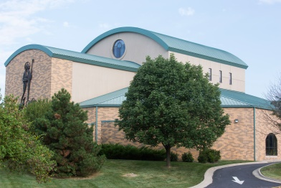 | Good Shepherd Catholic Church  12800 W 75th St  Shawnee KS 66216  913-631- 7116 www.gsshawnee.org

Gifts of Appreciated Stocks and Securities
Send a letter of instruction to brokerage firm to wire your securities to the Archdiocese of Kansas City in Kansas (sample letter below):
Date
Bank/Brokerage Firm
address
City/State/Zip
Please transfer _________ shares of _____________________ stock, ticker symbol # _______, from Account Number _____________ account to UBS DTC #221 Archdiocese of Kansas City in Kansas for the benefit of Good Shepherd Catholic Church in Shawnee KS.
Sincerely,
______________ (your signature)
______________ (your printed name)
Address _________________________________

The transfer instructions are as follows: Mail /send three copies of this letter to:
- UBS Financial Services, Attn: Hunter Wolbach/Van Wolbach, 700 W 47th Street – 5th Floor, Kansas City, MO 64112
- Email: stewdev@archkck.org or mail to Archdiocese of Kansas City in Kansas, Attn: Carla Mills, CFO, 12615 Parallel Pkwy, Kansas City KS 66109
- Good Shepherd Catholic Church, Attn: Mary Losik, 12800 W 75th ST, Shawnee, KS 66216 or mlosik@gsshawnee.org

