

CATHOLIC HIGH SCHOOL ADMISSIONS EXAM

ARCHDIOCESE OF NEWARK COOPERATIVE ADMISSIONS EXAMINATION
2023

WHO

WHEN/ WHERE

TEST CONTENT

HOW TO APPLY
FEE TIMELINE

MORE INFO
Students in 8th grade wanting to attend Catholic high school next year.

Friday, November 10, 2023 at designated testing sites in New Jersey and New York, across Bergen, Essex, Hudson, Passaic, Morris, Rockland, Sussex and Union Counties.
Make Up Exam: November 18, 2023, in select locations.
The High School Placement Test (HSPT) will be administered.
The test is designed to measure scholastic aptitude in verbal and non-verbal abilities, and achievement in reading, mathematics,
and language.
Beginning September 1st, you may register online at www.njcoopexam.org or call 888.921.COOP (888.921.2667).

Exam fee of $70.00 includes reporting scores to three high schools of your choice.
Applications and fees will be processed from September 1st
through October 25th. Students requiring extended time must
submit eligibility form and documentation by October 19th. Visit www.njcoopexam.org for specific details.
COOP
support@njcoopexam.org
888.921.COOP (888.921.2667)
Archdiocese of Newark Diocese of Paterson www.rcan.org www.patersondiocese.org


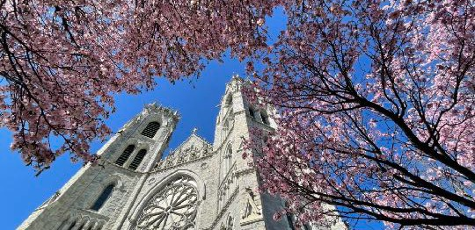
CATHOLIC HIGH SCHOOL EXPO
SEE MANY HIGH SCHOOLS IN ONE LOCATION, COLLEGE FAIR STYLE!

HIGH SCHOOL EXPO NIGHTS 2023

Tuesday, September 19th: St. Thomas the Apostle School, 50 Byrd Ave, Bloomfield Tuesday, September 26th: Academy of St. Paul, 187 Wyckoff Ave, Ramsey Wednesday, September 27th: St. Peter’s Prep, 144 Grand St, Jersey City Thursday, September 28th: St. John the Apostle School, 541 Valley Rd, Clark

ALL EVENTS ARE FROM 7:00 TO 8:30 PM
AMPLE PARKING IS AVAILABLE AT EACH LOCATION
- Learn about academics, extra-curricular activities, and how we put our faith into action
- Meet current students and admissions representatives
- Explore financial aid and scholarship opportunities
- Get one-on-one time to have your questions answered

FOR MORE INFORMATION: 973.497.4260 CATHOLICSCHOOLSNJ.ORG | @CATHOLICSCHOOLSNJ

