Pre work: Easter Reflection for Women’s Retreat on Saturday, May 18
How have you encounter God through the communion of saints?
How have you encounter God through the sacraments, especially communion?
In areas of your own personal brokenness have you drawn strength from the Resurrection story?
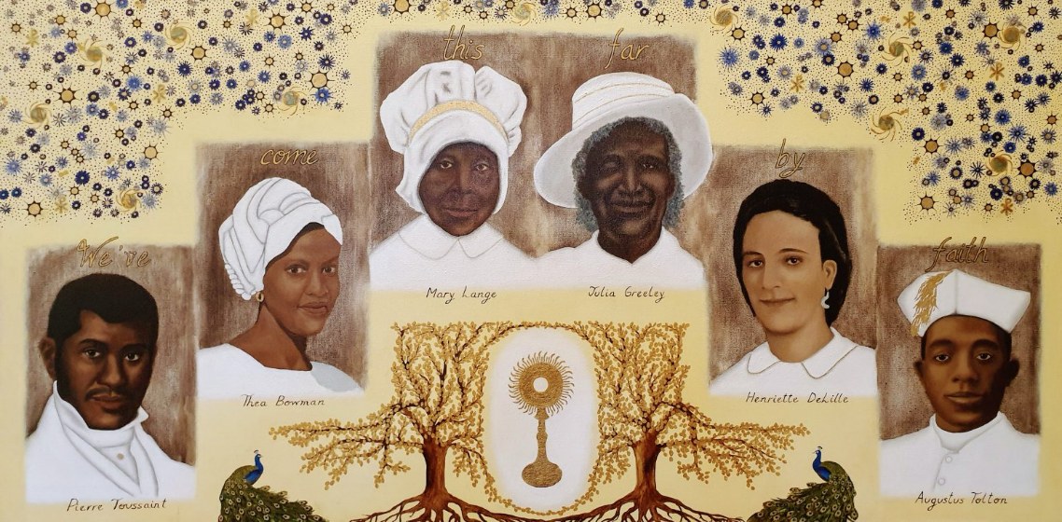
The witness of each inspires and challenges us as we seek to respond to the call to holiness in our own lives and the effects of sin in the world. Since the holiness and discipleship of the Holy Six draw us more deeply into the mystery of Christ’s saving love, we need their witness.
The lives of each of these holy men and women show us what holiness looks like. More specifically, they show us what it means to love, even when we have been shown in this world everything but love. The Holy Six teach us how to remain faithful to Christ’s call for us and how to make his heart our own. While they experienced hardships, suffering and animosity, they did not let themselves succumb to it or respond in kind.
As Archbishop José Gomez of Los Angeles wrote in the foreword to my book: “The inspiring witness of America’s black Catholic communion of saints gives us hope that we can indeed free ourselves from the sins of our past, heal old wounds and divisions, and come together to work for a society that reflects God’s beautiful plan of love for the human person.

