Names of Places and Things
This is a handy reference guide for all the places and things involved in our worship. Some of these terms are quite common things all servers should know. Some terms are a little less common and terms only a senior or experienced server will need to know or items that any server might only encounter during a special Mass, like Confirmation, funerals, weddings or liturgies at Triduum (the triad of liturgies before Easter—Holy Thursday, Good Friday and Easter Vigil. Finally, there are some uncommon terms that you may never encounter, but just in case someone ever says it or asks for it, you can learn about here. Enjoy learning more about the places and things we use in our liturgies.
COMMON LITURGICAL ARTICLES AND PLACES
Terms all servers should be familiar with and have a working knowledge of.

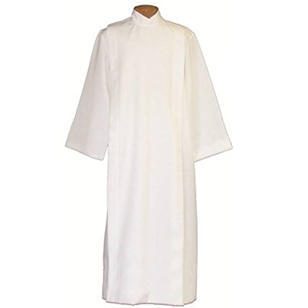 | Alb- One of the liturgical vestments, worn by clergy and servers. It is a white garment coming down to the ankles and is usually girdled with a cincture. They are white as a reminder of baptism.
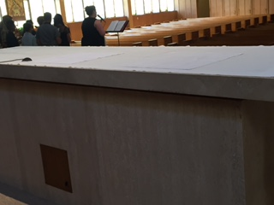 | Altar‐ The table on which bread and wine are transformed into the Body and Blood of Jesus.
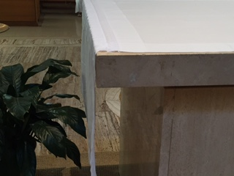 | Altar/Table Cloth- An altar cloth is used by various religious groups to cover an altar. It may be used as a sign of respect towards the holiness of the altar.
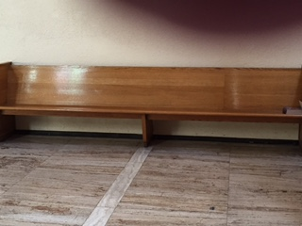 | Altar Servers’ Bench (altar pew)-The bench behind the ambo in the sanctuary where the servers and lectors sit.
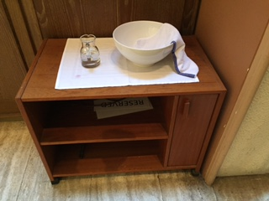 | Altar Server Table-The table behind the reredos to the left of the altar (as you face it) where the handwashing bowl, water cruet, towel, and other supplies for the servers are placed during the Mass
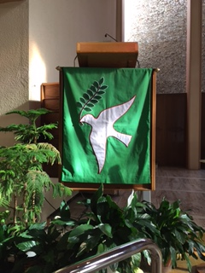 | Ambo ‐ The place from which the Scriptures are proclaimed and sometimes the homily is given.
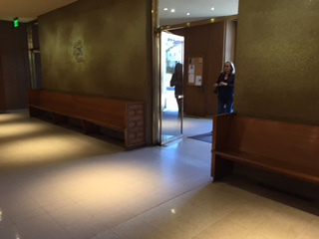 | Back of the Church-The area where the procession gathers prior to the procession. It is also the area where the gifts are kept and where the offertory process with candles and gifts begins.
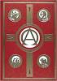 | Book of Gospels‐ A book with an ornate cover containing only the four Gospels. It is carried in the entrance procession by the deacon or lector and placed upon the altar until the Gospel Acclamation.
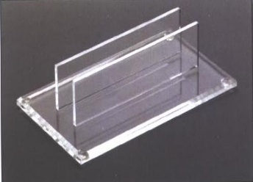 | Book of Gospels Stand-A clear plastic, wood, or metal stand that holds the Book of Gospels in the center of the altar (ours is plastic). When the Book is processed in the Lector or Deacon places it in the stand. If the Book is not processed in, then the Book of Gospels is placed in the stand in the center, front of the altar prior to Mass by either the sacristan, altar server, or lector. During the Alleluia, the Deacon or Presider removes it from this stand and processes to the Ambo.
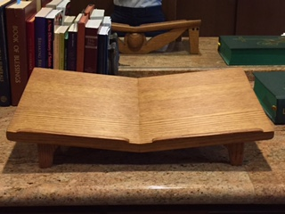 | Book Stand‐ A wooden support that props up the Roman Missal for the priest at the altar during the Eucharistic Prayer.
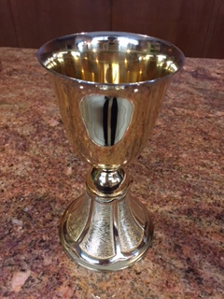 | Chalice – A vessel of gold that holds the wine which becomes the Blood of Jesus after the consecration.
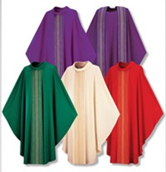 | Chasuble- The outermost liturgical vestment worn by priest for the celebration of the Eucharist. The chasuble is usually worn over the stole and alb. Like the stole, it is normally of the liturgical color of the Mass being celebrated.
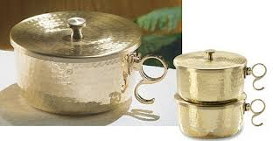  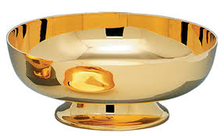 | Ciborium ‐ A large container of precious metal with a cover of the same material which will hold the Body of Christ after the consecration for distribution of Holy Eucharist. An open ciborium is used during Mass to hold the hosts to be consecrated and to distribute communion. A closed ciborium is used to store consecrated host in reserve in the tabernacle.
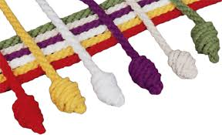 | Cincture- A long, rope-like cord with tasseled or knotted ends, tied around the waist outside the alb. The color may be white, or may vary according to the color of the liturgical season. A Catholic bishop's cincture is made of intertwining gold and green threads, a cardinal's has red and gold, and the pope's with white and gold.
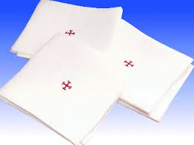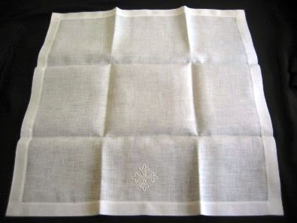 | Corporal ‐ A square, white linen cloth with a cross in the center used to protect any particles of the Host or drops of Precious Blood from being lost.
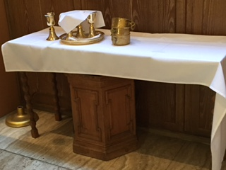 | Credence Table ‐ The table in the sanctuary which holds the cruets, chalices, and ciborium before and after the Consecration. At SPA, this is the table behind the reredos to the right of the altar (as you face it)
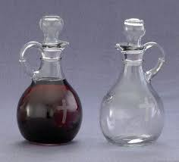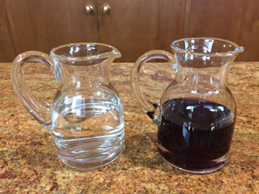 | Cruets‐ Two small, matching glass pitchers used to hold the water and wine before consecration.
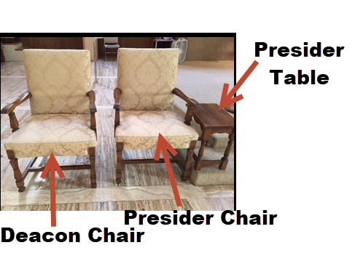 | Deacon (or other Priest) Chair-The chair that the deacon or other priest sits in always to the right of the presider.
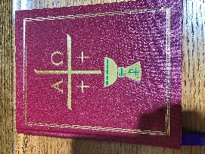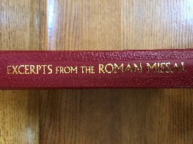 | Excerpts from Roman Missal-Contains the Order of the Mass and the opening prayers and prayers after communion for each Sunday. It is used at the beginning and end of Mass. It should always be on the Altar Servers’ bench before and during Mass.
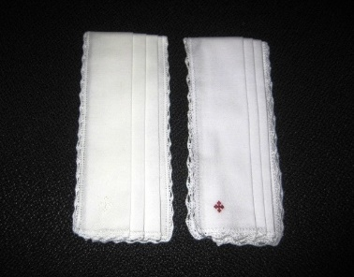 | Finger Towel (handwashing towel)‐ A small towel used to dry the priest’s fingers/hands.
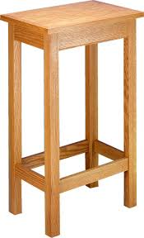 | Gifts Table‐ A small table located in the back of the church holding the bread and wine to be presented for consecration. At Spa, this table is at the back of the church.
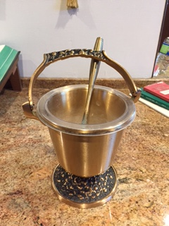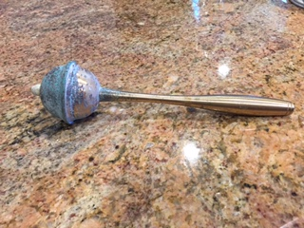  Sprinkler | Holy Water Bucket and Sprinkler (aspergillum/aspergil) – the holy water bucket holds the holy water so that the presider can dip the sprinkler in the bucket and sprinkle the people or objects to be blessed.
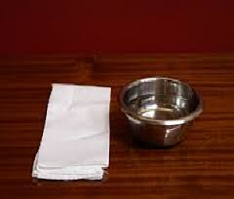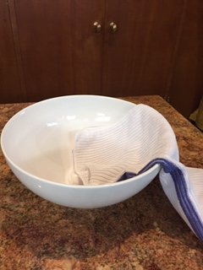 | Lavabo (handwashing bowl)‐ A small bowl, along with the cruet of water and finger towel used to wash the priest’s fingers before the Consecration. These are most often used at daily Mass here at SPA; for Sunday Masses we use a larger bowl and larger towel. Most parishes, however, use the Lavabo and Finger towel for all Masses.
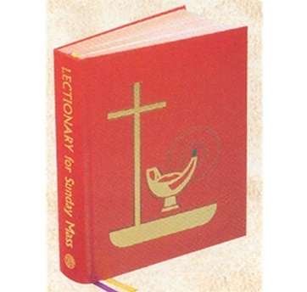 | Lectionary ‐ The book containing Scripture used for the Liturgy of the Word. It usually contains all the readings used for the three-year cycle of Sunday readings and the two-year cycle of daily Mass readings.
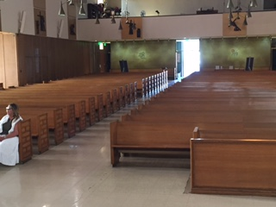 | Nave‐ The area of the church where the congregation sits—where the pews are.
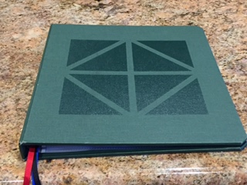 | Presider Binder-The binder that is used instead of the missal. It is the same color as the liturgical color of the Mass being celebrated
 | Presider Chair‐ The chair that the priest sits in during the celebration of the Mass.
 | Presider Table-The table to the left of the presider, which holds his binder, worship aid, etc.
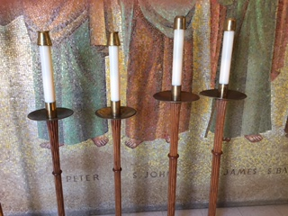 | Processional Candles‐ Small candlesticks carried by two altar servers in processions.
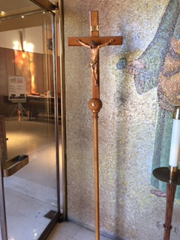 | Processional Cross‐ Tall crucifix carried by an altar server in processions.
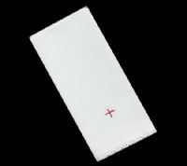 | Purificator ‐ A linen cloth used by the priest, deacon, or lay Eucharistic Minister to dry the chalice after purifying it.
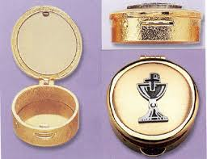 | Pyx ‐ A case, about the size of a pocket watch, in which Communion is carried to the sick or those unable to come to church. Check the presider preference card to know what to do with pyx when clearing the altar during communion.
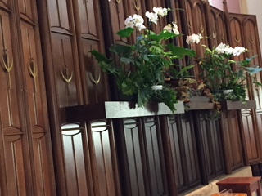 | Reredos- A large altarpiece, a screen, or decoration placed behind the altar in a church. It often includes religious images.
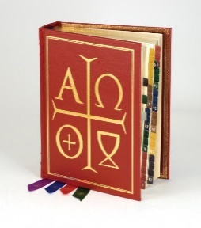  Big  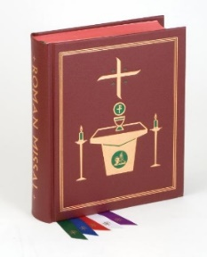  Small | Roman Missal ‐ The book containing the prayers said by the priest during the Mass.
 | Sacristan- The Person in charge of the sacristy and the liturgical vessels. Duties vary greatly by community, but the basic jobs are these: Preparing the Holy Eucharist for the celebration of the mass. This includes getting the wine, water, and hots ready and putting them in place for the start of mass; Setting up the church. Typically, sacristans arrive at church before anyone else- often even the priest/celebrant. They light the candles, arrange the books, and basically perform a little housekeeping before mass begins; assisting the altar servers-sacristans prepare and help the altar servers perform their basics duties before and during mass. This may be done by a member of the altar server committee of present; Cleaning the holy materials after Mass. There is done in the sacristy (see below), where the holy containers for the water, body, and blood are stored and cleaned. Everything is set back in its place in the sacristy before sacristans leave the church. At the Sunday 5:00 PM Mass at SPA, the sacristan will often also set up for daily mass and close and lock the church before leaving.
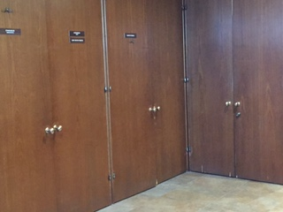Priest Sacristy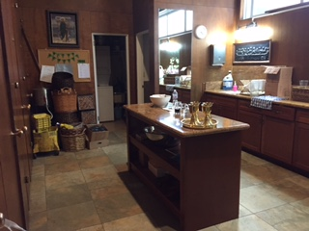Liturgical Minister Sacristy | Sacristy‐ The room behind the altar used to store the sacred vessels and other items used for Mass. At SPA, we have two: the priests’ sacristy, which is to the right as come behind the altar and the Liturgical Ministers’ (and altar server) sacristy, which is where you sign in and vest when you are an altar server. The priests’ sacristy is where lights for the church, portable lights, holy books, and microphones are.
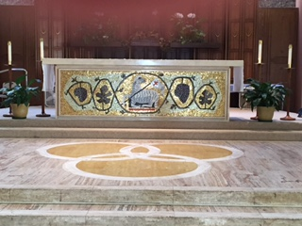 | Sanctuary‐ The part of the church in which the Liturgy of the Word and the Liturgy of the Eucharist take place.
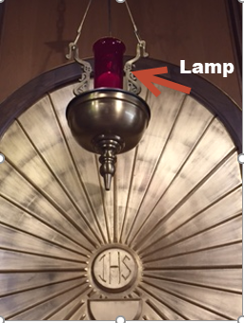 | Sanctuary Lamp‐ The red candle mounted to the left of the sanctuary which signifies the presence of Jesus in the Blessed Sacrament.
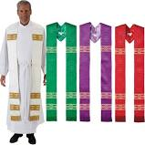 | Stole- A liturgical vestment composed of a strip of material from two to four inches wide and about eighty inches long. A small cross is generally sewed or embroidered on the stole at both ends and in the middle. The priest kisses the cross in the middle before putting it on. The stole is worn only by deacons, priests, and bishops. Deacons wear the stole like a sash, the vestment resting on the left shoulder and thence passing across the breast and back to the right side. The stole of the priest extends from the back of the neck across the shoulders to the breast, where the two halves either cross each other or fall down straight according as the stole is worn over the alb or the surplice. The color matches the Liturgical season in which the Mass being celebrated.
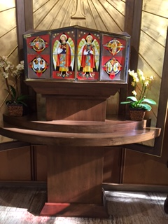 | Tabernacle‐ The ornate receptacle or case made of precious metal located behind the altar in which the Blessed Sacrament is kept. At SPA, it is to the left of altar as you face it, between the sanctuary and the statue of St. Paul the Apostle.
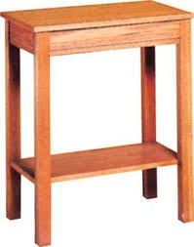 | Table at back of altar-Table just behind the altar where the missal and/or stand sits prior to being placed on the altar. The Book of Gospels stand is returned here during the preparation of the altar.

LESS COMMON TERMS FOR PLACES AND THINGS
These are very common terms with special Masses or when a Bishop is presiding. For weekend Masses, these are terms that you may not encounter. Servers will need to be familiar with and have working knowledge of these when serving at special Masses.
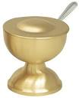 | Boat‐ A small receptacle made of precious metal that holds incense to be used in the thurible.
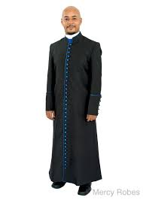 | Cassock- a close-fitting ankle-length garment worn especially in Roman Catholic and Anglican churches by the clergy and by laypersons assisting in services
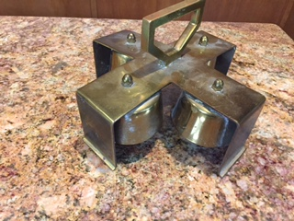 | Consecration Bells‐ Four small bells attached to a single handle used during the elevation of the Body and Blood of Christ. We don’t do this at SPA, but several parishes do. We do use the bells during Holy Thursday and Vigil during the Gloria.
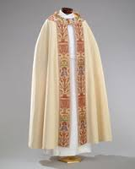 | Cope- A liturgical vestment, more precisely a long mantle or cloak, open in front and fastened at the breast with a band or clasp. It may be of any liturgical color. It is the vestment assigned to the celebrant, whether priest or bishop, for almost all functions except the Mass when the celebrant wears the chasuble instead. The cope is used, for example, in processions, in giving Benediction of the Blessed Sacrament, and the celebration of other sacraments outside of Mass. At SPA we use it during the Exposition of the Blessed Sacrament procession at the end of Holy Thursday.
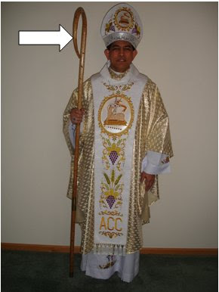 | Crozier- a hooked staff carried by a bishop as a symbol of pastoral office. During Mass an altar server will manage the crozier.
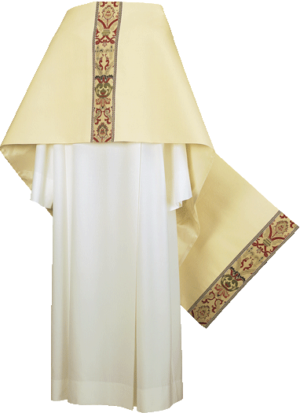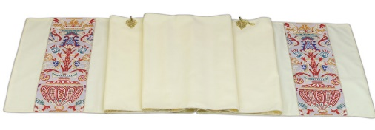 | Humeral Veil- One of the liturgical vestments. It consists of a piece cloth draped over the shoulders and down the front, normally of silk or cloth of gold, with a clasp at the neck. At the ends there are pockets in the back for hands to go into so that the wearer can hold items without touching them with the hands. It is most often used during the Exposition of the Blessed Sacrament on Holy Thursday and when the altar server wears them to hold the Bishop’s crozier and mitre.
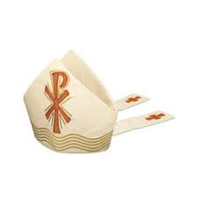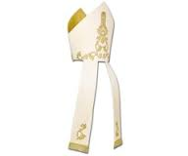 | Mitre- A tall headdress worn by bishops as a symbol of office, tapering to a point at front and back with a deep cleft between.
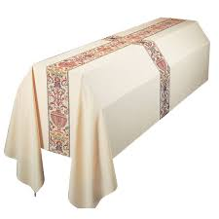 | Pall (mortcloth) ‐ a cloth that covers a casket or coffin at funerals. Commonly today palls are pure white, to symbolize the white clothes worn during baptism and the joyful triumph over death brought about by the Resurrection. The pall will often be decorated with a cross, often running the entire length of the cloth from end to end in all four directions, signifying the sovereignty of Christ's triumph over sin and death on the cross.
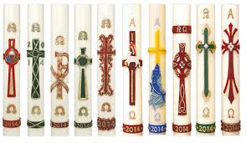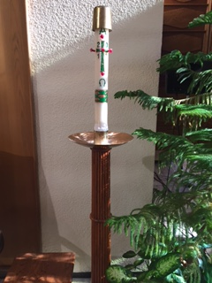 | Paschal Candle-The Paschal candle represents Christ, the Light of the World. The candle is made with pure beeswax, which represents the sinless Christ who was formed in the womb of His Mother. The wick signifies His humanity, the flame, His Divine Nature, both soul and body. Five grains of incense inserted into the candle in the form of a cross recall the aromatic spices with which His Sacred Body was prepared for the tomb, and of the five wounds in His hands, feet, and side. During the Easter Vigil on Holy Saturday night the priest or deacon carries the candle in procession into the dark church. A new fire, symbolizing our eternal life in Christ, is kindled which lights the candle. The candle, representing Christ himself, is blessed by the priest who then inscribes in it a cross, the first letters and last of the Greek alphabet, (Alpha and Omega `the beginning and the end') and the current year, as he chants a prayer; then affixes the five grains of incense. The Easter candle is lighted each day during Mass throughout the Paschal season until Ascension Thursday.
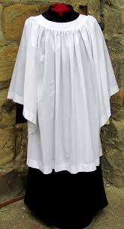 | Surplice- A loose white linen vestment varying from hip-length to calf-length, worn over a cassock by clergy, acolytes, and choristers at during Mass.
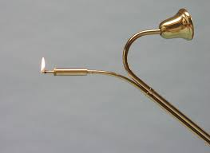 | Taper/Snuffer‐ A metal stick‐like object with wax inside used to light the altar candles. It often has a bell-shaped snuffer used to extinguish (snuff) candles—mostly the Paschal Candle.
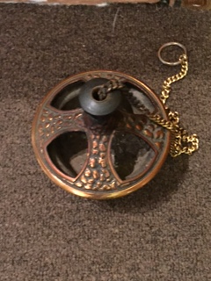 | Thurible (censer)‐ A metal receptacle attached to a chain that is used to burn incense. It is hung from a long chain so that it can be swung to disperse the incense smoke and aroma. The person who carries the thurible is called the thurifer. The thurible and boat are kept on a stand in the liturgical ministers’ sacristy or just behind the altar.

UNCOMMON TERMS FOR PLACES AND THINGS
You may never encounter these things here at SPA, but you may hear the terms—or you may see them used at another parish you may be visiting. At other parishes, some of these things are used more commonly than here at SPA.
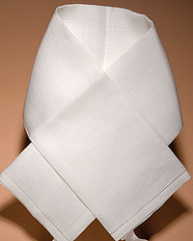 | Amice- a liturgical vestment made of an oblong piece of cloth usually of white linen and worn about the neck and shoulders and partly under the alb. It is usually worn whenever the alb does not completely cover the ordinary clothing at the neck. It is then tied around the waist. Many priests do not wear this anymore.
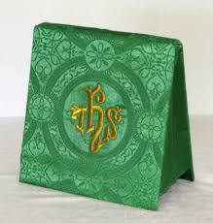 | Burse‐ An envelope type item made of cloth, matching the chalice veil used to hold the corporal cloth. It matches the liturgical color of the Mass being celebrated. We don’t use this at SPA.
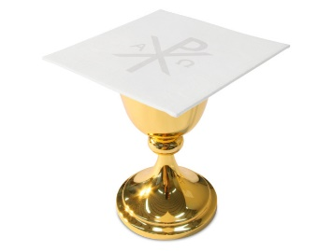 | Chalice Pall - A square piece of cardboard covered by white linen and used to cover the chalice. It is usually embroidered with a cross or some other appropriate symbol. It is used to prevent dust, insects, and other items from falling into the chalice
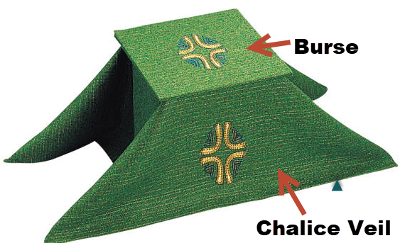 | Chalice Veil—A large cloth in the liturgical color of the day, used to cover the chalice before and after the Liturgy of the Eucharist. The color matches the liturgical color of the Mass being celebrated. We don’t use these at SPA, but some parishes still do.
 | Lunette (Luna): A thin, circular receptacle, with glass sides, metal circled with gold to hold the Sacred Host upright in the monstrance. It is a sacred vessel, having received the priest's blessing. It is sometimes called a luna.
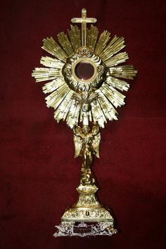 | Monstrance ‐ A large, ornate vessel used to hold the Blessed Sacrament during Adoration.
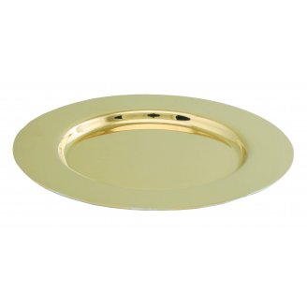 | Paten ‐ A small saucer shaped plate of precious metal that holds the Host. We don’t use these at SPA.
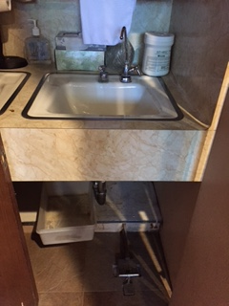 | Sacrarium ‐ A sink which drains directly into the ground. It is fitted with a cover and lock and is used for the disposal of the following: The sacred linen wash and rinse water, used holy water, used baptismal water and blessed ashes. Ours, pictured here, is located in the Priest Sacristy in the locked closet.

Set-up/Prep Photos
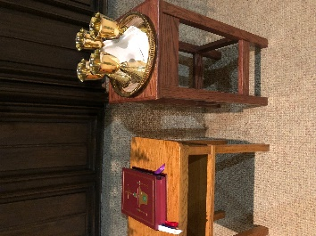 | Set-up for Chalices and Missal for Preparation of the Altar
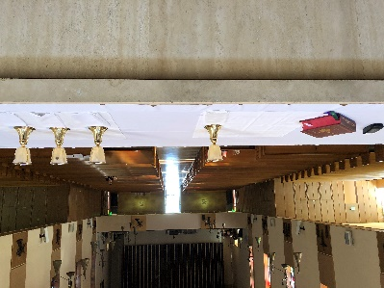 | Prepared Altar

