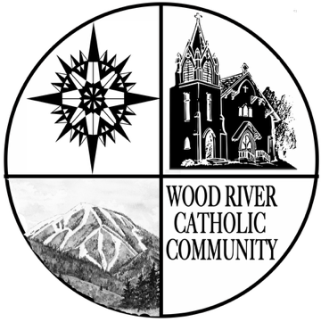
Parishes of the Wood River Valley
St. Charles Borromeo & Our Lady of the Snows Confirmation Sponsor Registration Form
Requirements for Sponsors:
Sponsors must be:
(1) sixteen years of age
(2) have received the Sacraments of Baptism, Confirmation and Eucharist, and
(3) practicing Catholics in good standing and able to receive Holy Communion.
Parents cannot be a sponsor their own teen. However, if the Sponsor cannot be present for the Rite of Confirmation, parents can proxy their teen through the Rite on behalf of the
Sponsor: Candidates select their sponsors in consultation with their parents. The selection of sponsors is to be based on appropriate lifestyle, participation in the Catholic faith, and the ability to provide the nurturing supportive role expected of a sponsor. The Sponsor may be male or female.
Name of Confirmation Candidate:
Sponsor's Full Name

Sponsor's Mailing Address
Sponsors parish name:
City Sate

I certify that:
1. I am at least 16 years of age
2. I am Baptized
3. I have received First Communion
- I have been Confirmed
- I am a practicing Catholic, and able to receive Communion

Yes No
Yes No
Yes No
Yes No
Yes No

Note: Sponsors will be encouraged to attend a Sponsor Orientation prior to the day of Confirmation. If the sponsor cannot attend, then a parent must attend in the sponsor’s place.
I attest that the information provided is correct, honest, and true.

Signature of Sponsor
Date

Revised: August 2023

