All Souls and All Saints Day Intentions
The purple envelope in your offertory boxes is for All Souls/All Saints Day. Intentions may be written on the front of the envelope and put, with or without a contribution, in the offertory basket. Any offering will be a donation to the church.
All intentions from the All Souls/All Saints Day envelopes along with the intentions from the Book of the Faithful Departed will be remembered at Mass during the month of November. The Book of the Faithful Departed will be in the front of church beginning Saturday, October 29th. The book will be removed, Friday, November 18th, as Sunday, November 20th is the Solemnity of Christ the King.
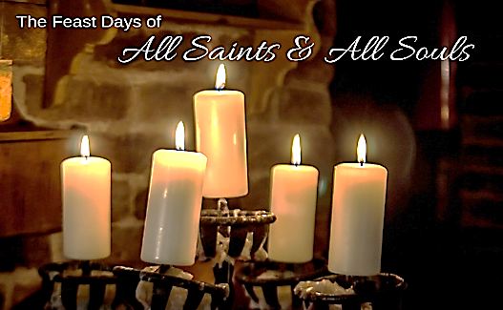
All Saints Day
All Saints Day Mass, Tuesday, November 1st, will be at 8:30 am with school students at St. Joseph. There will be a 6:00 p.m. Mass at St. Peter of the Fields. Following Mass, the St. Vincent de Paul Society will be sponsoring a dinner in St. Peter Hall. All are invited to attend.
“The Solemnity of all Saints is celebrated on the first of November. It was instituted to honor all the Saints, both known and unknown, and, according to Poe Urban IV, to supply any deficiencies in the faithful celebration of saints’ feasts during the year. In the early days of the Church, Christians were accustomed to solemnizing the anniversary of a martyr’s death for Christ at the place of martyrdom. In the fourth century diocese began to interchange feasts, transfer relics, to divide them and to join in a common feast. Frequently groups of martyrs suffered on the same day which naturally led to a joint commemoration. In the persecution of Diocletian, the number of martyrs was so great a separate day could not be assigned to each, so a common day for all was appointed. The first trace of this we find is in Antioch on the Sunday of Pentecost. There is also mention of a common day in a sermon of St. Ephrem the Syrian (373) and the 74th homily of St. John Chrysostom (407)”. Catholic Encyclopedia-Growing in God

All Souls Mass
The All Souls Day Mass of Remembrance will be a combined service of our pastorate. It will be held Wednesday, November 2, 6:00 p.m.at St. Peter of the Fields. As in the past, the names of the beloved deceased (from November 1, 2021 to October 30th, 2022), will be read. After each name the Sacristy Bells will be rung in memory of our loved ones.

Adoration will take place after the Mass until 7:30 p.m.

