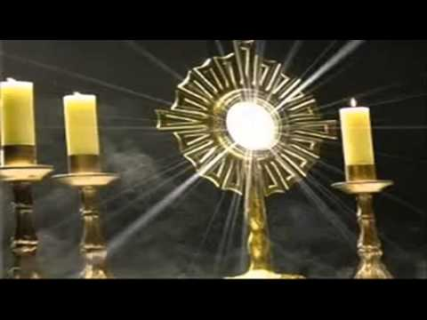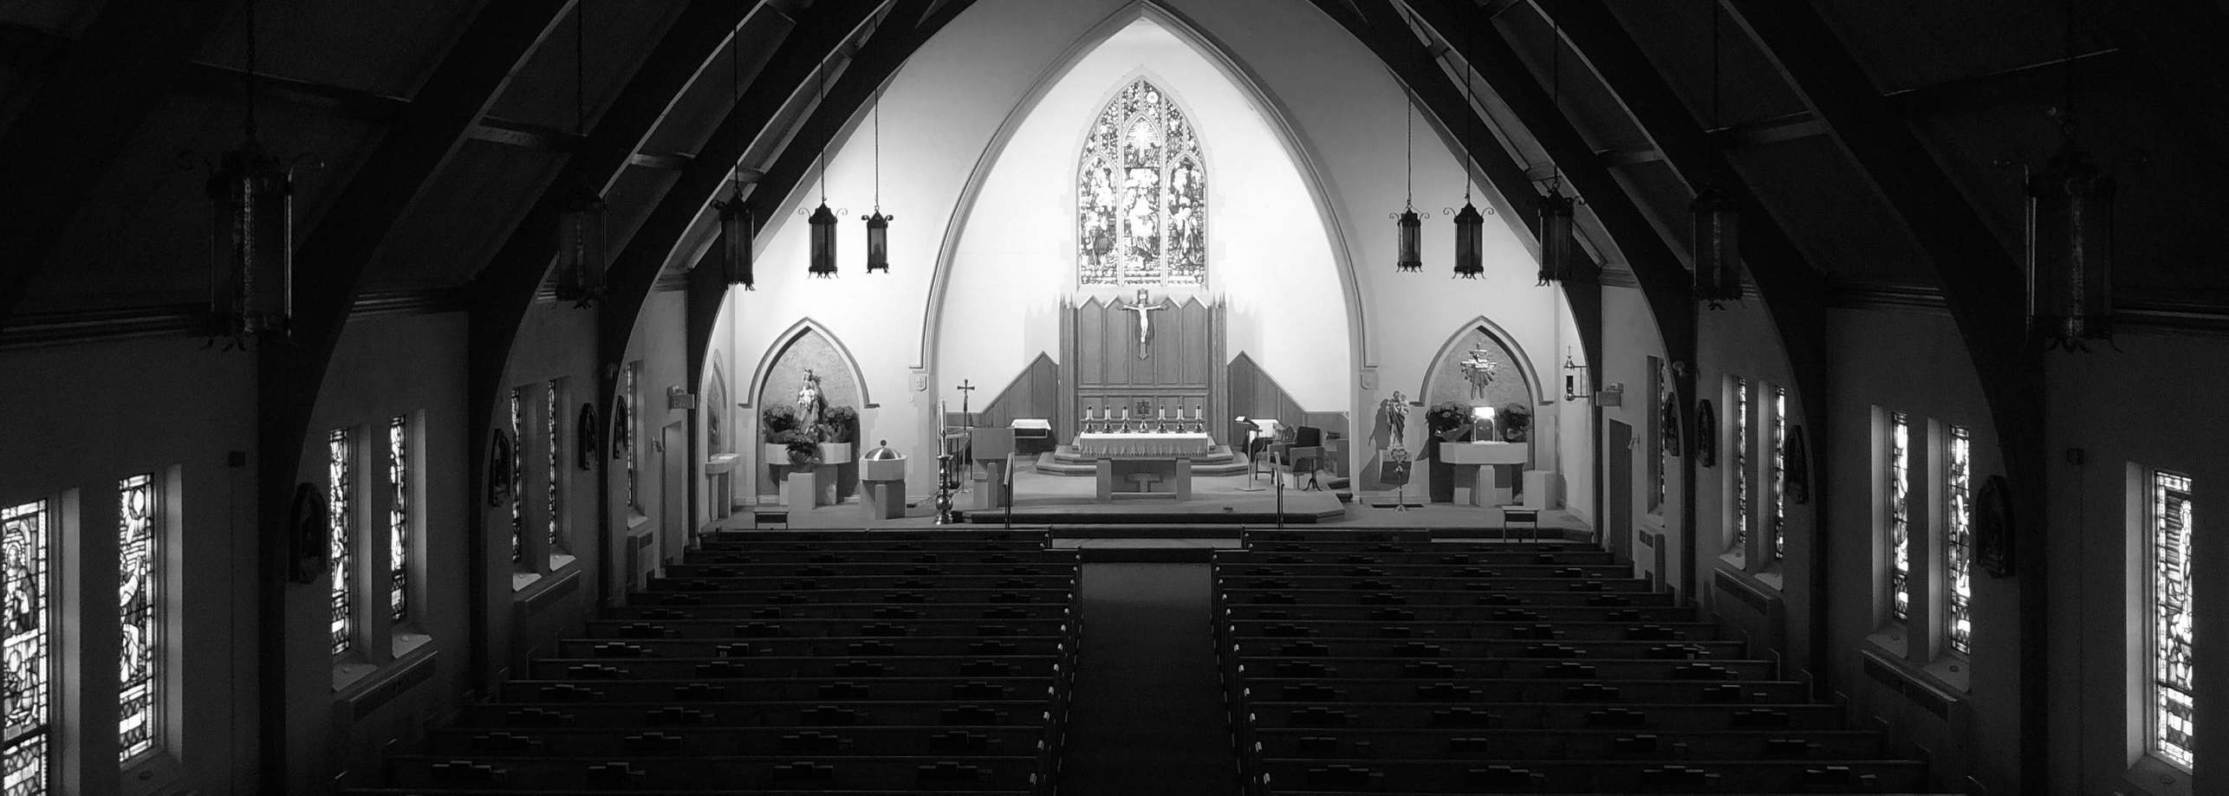

This week, Fr. Michael will privately celebrate Masses for the following intentions :

November 29, 2020

St. Mary Star of the Sea Parish

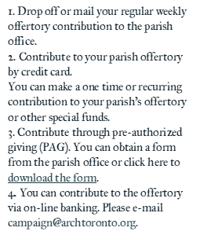

Isaiah 25:6-10 | Psalms 23:1-6 | Matthew 15:29-37

Wednesday, December 2, 2020

Adoration of the Blessed Sacrament will be from 9:00 am to 10:00 am on Wednesday, Thursday and Saturday.

December 4th is the First Friday of the month. Adoration will be from 9:00 am until 12:00 noon.

*Only 10 people, including Father Michael Simoes, will be allowed inside the Church for Adoration.*

Lyn & Frank Carroll and Special intention of John & Mary Secko

 Pietro Battagin

Isaiah 30:19-21, 23-26 | Psalms 147:1-6 | Matthew 9:35—10:1, 6-8

Saturday, December 5, 2020

Isaiah 29:17-24 | Psalms 27:1, 4, 13-14 | Matthew 9:27-31

Friday, December 4, 2020

Maria-Luisa Sr., Secondo Gregorio Dalle and Rudolfo De Campo

Isaiah 26:1-6 | Psalms 118:1, 8-9, 19-21, 25-27 | Matthew 7:21, 24-27

Thursday, December 3, 2020

Melecio Capillo Sr. Lynn & Frank Carroll and the Special intention of Tessie Tesoro

 Asunta Benetti

Isaiah 11:1-10 | Psalms 72:1, 7-8, 12-13, 17 | Luke 10:21-24

Tuesday, December 1, 2020

Lynn & Frank Carroll

Romans 10:9-18 | Psalms 19:2-5 | Matthew 4:18-22

Monday, November 30, 2020

Anita Coleman

Attilio & Maria Barbisan

For the People of the Parish

Isaiah 63:16-17, 19 | Psalms 80:2-3, 15-16, 18-19 |

1 Corinthians 1:3-9 | Mark 13:33-37

Saturday, November 29, 2020

11 Peter St. S., Mississauga, ON L5H 2G1 | (905) 278-2058 | stmarystaroftheseami@archtoronto.org

Humanitarian Relief – Philippines Relief Effort

Kids’ Link to Faith

During Advent we are asked in the readings at Mass to prepare the way of the Lord. We prepare at home, in school and at the church. But the most important preparation is what happens in our hearts

Watching for Jesus! A reflection based

on the readings for the 1st Sunday in

Advent.

The Archdiocese of Toronto has partnered with Development and Peace – Caritas Canada to help the Philippine victims of Typhoon Vamco and Super Typhoon Goni. At this time, we ask the faithful to please donate to the Philippines relief effort, if they are able.

Those wishing to help may do so in the following ways:

. Online through the Archdiocese of Toronto website (click on the

“Donate Now” button at the top of the page): www.archtoronto.org

· By phone through the Development Office – 416-934-3411

· Through the parish, making cheques payable to:

Name of Parish – Philippines Relief Effort – Disaster Relief

[](https://www.youtube.com/watch?v=Z4QEk5Nx_Sc)



2021 ENVELOPE BOXES

Please note that we are issuing new envelope numbers to all parishioners. Thank you to all who picked up your boxes last weekend. For those who would like to pick up their box of envelopes, please call Marilyn Fernandes at 905-278-2058 or email MFernandes@archtoronto.org. Please remember to write your name on the first couple of envelopes you use.

For those of you who are unable to come to Church at this time, please continue to drop off your envelopes through the mail slot in the office door, make online donations or sign up for Pre-Authorized Giving (forms available on the website). Thank You!

Links to Faith

November 29, 2020

Week 48 – An Examination of Conscience for Venial Sins – by Liz Estler

“Well, it’s spiritually healthy to confess, without entering into scrupulosity, even small or venial sins. Why? Because the sacrament gives us graces which, if we cooperate with them, help us to grow in virtue and avoid sin. And, habitual small sins weaken our resolve. They keep us attached to the world and worldly things. They make us more vulnerable to mortal sin. They make it easier to say yes to bigger and/or more frequent venial sins until voila! We’ve fallen into mortal sin … once again.”

To read this article from the Spiritual Direction website, click on Links to Faith at the bottom of the parish homepage: www.stmarystarofthesea.ca and select Week 48 – An Examination of Conscience for Venial Sins – by Liz Estler



FORMED



Website



YouTube



Twitter



Facebook

Follow Us On:

2020-2021 Sunday Missals are all sold out. If you would like a copy of the Sunday Missal, please call or email the parish office and we will order a copy for you.

Those of you, who would like a copy of the monthly Living with Christ Missalettes for the year April 2021 to March 2022, please call or email the parish office so we can place the order for you as soon as possible.

For assistance call: 647-628-2058

Leave your name, number and a brief message and someone will get back to you as soon as possible.

Society of Saint Vincent de Paul Help Line

Registering for FORMED is easier than ever:

1. Go to https://signup.formed.org/

2. Enter your parish name or postal code, click on your parishes' name

3. Enter your name and email

4. Start watching

11 Peter St. S., Mississauga, ON L5H 2G1 | (905) 278-2058 | stmarystaroftheseami@archtoronto.org

11 Peter St. S., Mississauga, ON L5H 2G1 | (905) 278-2058 | stmarystaroftheseami@archtoronto.org