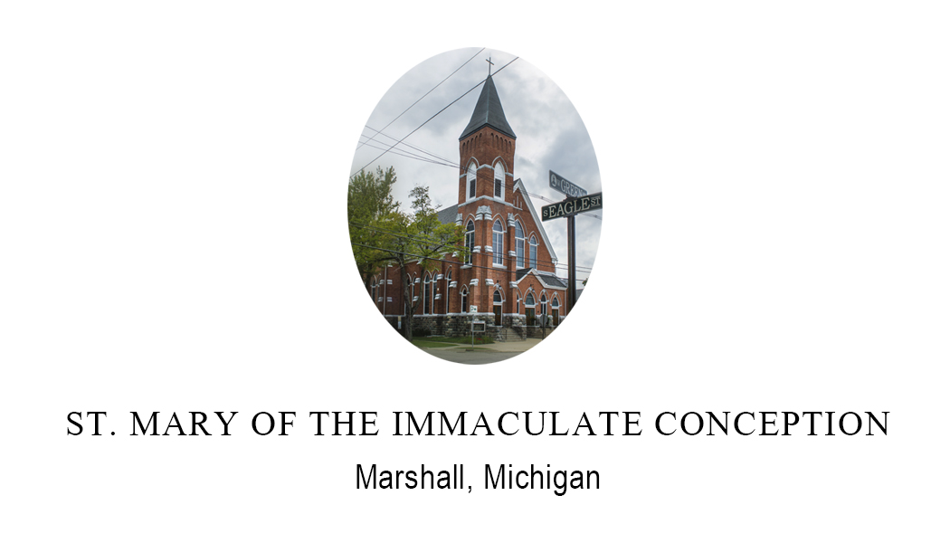
ORGANIST / DIRECTOR OF MUSIC MINISTRY
St. Mary Catholic Church, Marshall, MI

St. Mary Roman Catholic Church in Marshall, Michigan, is seeking an Organist and Director of Music. Our National Historic Landmark District community is committed to economic growth and innovative technology. Our church is a singing church. We have a new 2021 custom Allen 3 manual drawknob organ housed in the beautifully renovated historic church with an ideal acoustic music environment. St. Mary Church offers three weekend Masses. The qualified candidate should be a skilled organist and choir director who can effectively work with cantors, instrumentalists, and adult and youth choirs. The Organist/Director of Music would collaborate closely with the pastor in support of the liturgies. We prefer a degree or equivalent in music or a related field and an understanding of and respect for Catholic traditions and liturgy. Leadership and communication skills and a passion for sacred liturgy and music are essential qualities. This is a 30 hour per week (on average) position with a negotiable salary and benefits program commensurate with experience/qualifications/hours. Compensation is also provided for other services. Relocation expenses negotiable.

*Point of contact: E-mail resume and pertinent material to Office Manager, Mrs. Stacie Contat, St. Mary Church at stmarymarshall@aol.com (269-781-3949). Also, visit our website at www.stmarymarshall.org.

