STEPS TO COMPLETE A JOB REQUISITION

Go to: www.admin.applicantpro.com
- Login
userid: Type your school email address
password: Type your password. If you forget your password contact Robin Hartkorn at rhartkorn@archindy.org or Joni Ripa at jripa@archindy.org and they will send you an invitation to reset your password.

- Choose the Jobs icon from the top of your screen, and then select the Requisitions tab.
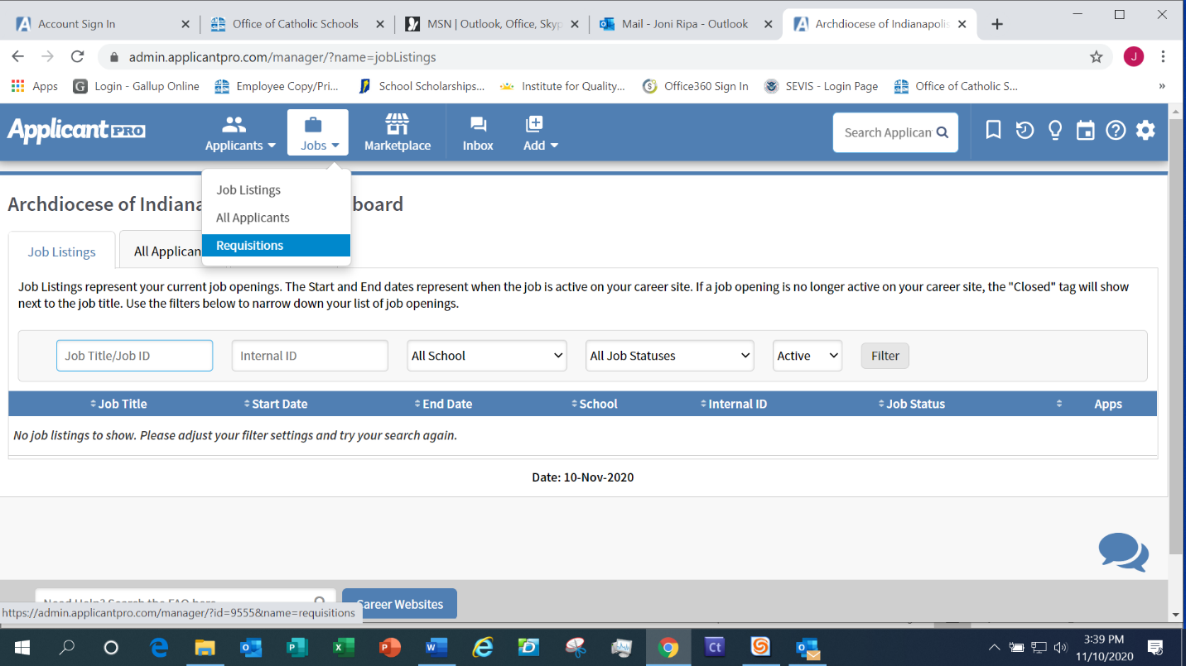

3.) Select the +New Job Requisition button to begin a new Requisition.
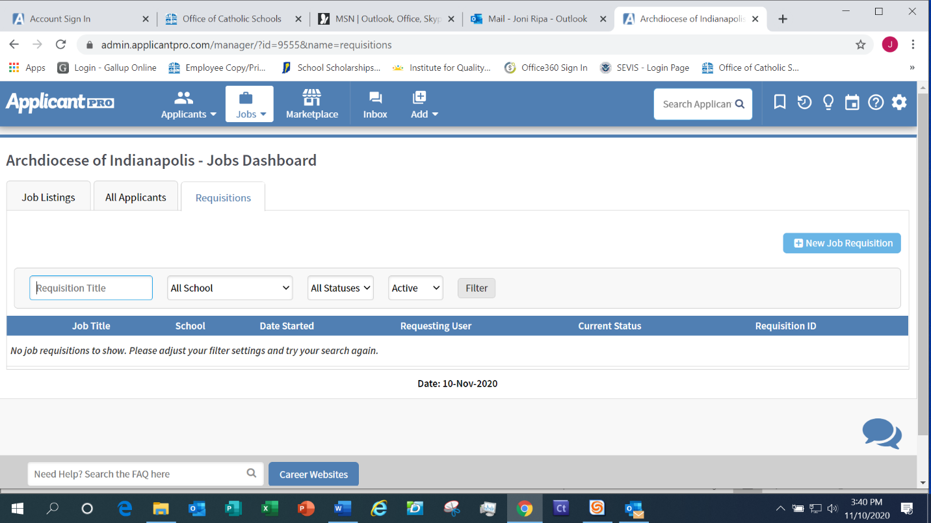

4.) The Add Requisition box appears. The only field you will complete is the Job Template field. You do not need to do anything with the Requisition Form field. Click on Select a Template and the drop-down menu will appear. Select Teacher, General Application or Food Service depending on what position you are posting. General Application is for staff positions on non-teaching or administrative positions. The applicant will complete the Archdiocese General Application. If you select Food Service, the applicant will complete the Food Service application and if you select Teacher Application the candidate will complete the Teacher Application.
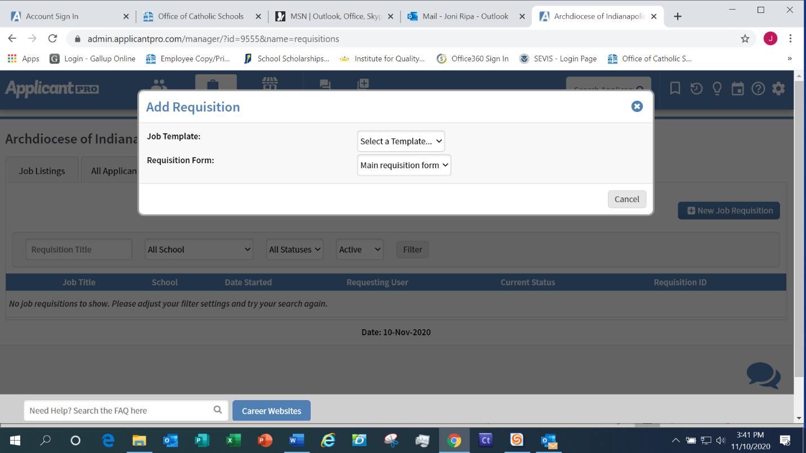
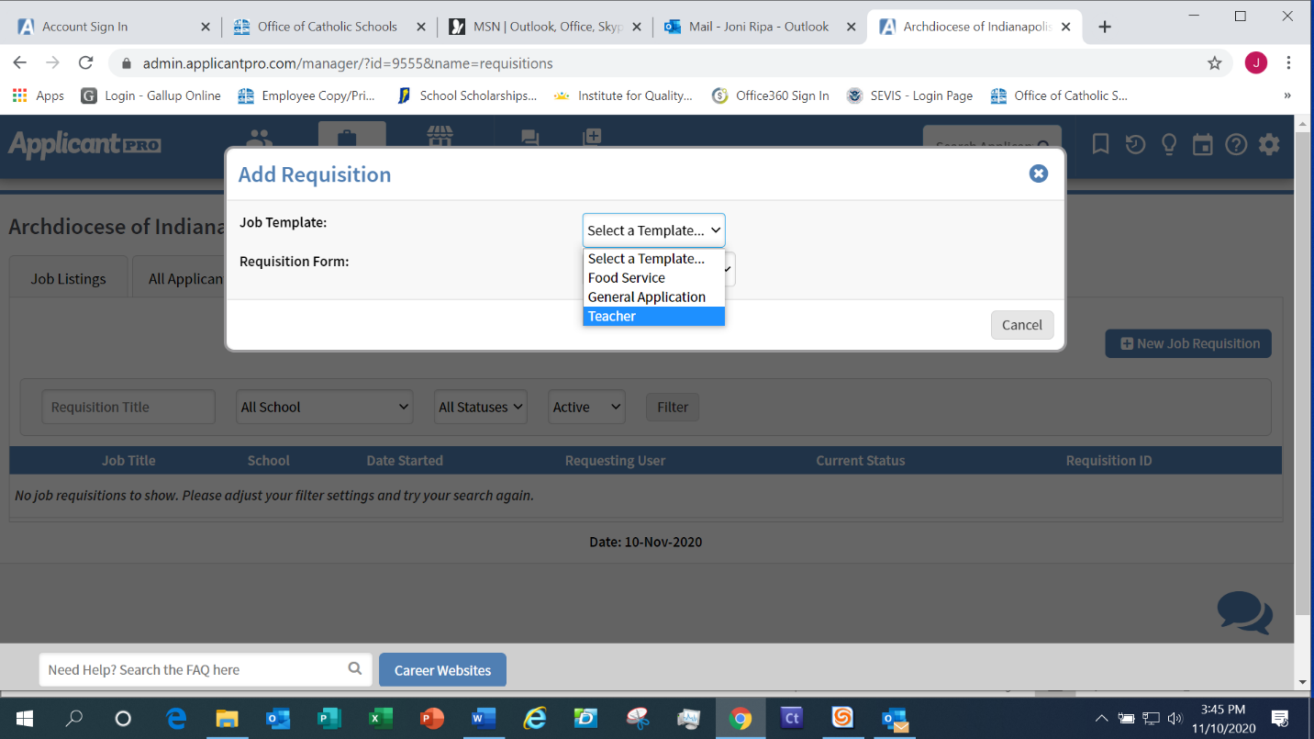

5.) The second Add Requisition box appears. In the section directly under the Add Requisition title, the
Job Template field, Requisition Form field and Proposed Job Title field will be pre-populated. The only
two fields you need to complete is the Number of Positions field and the School field. Your school
name should appear in the dropdown box. Select your school. Go to the Number of Positions: enter
how many positions you need to fill for that job. Job Description should say See Full Description.
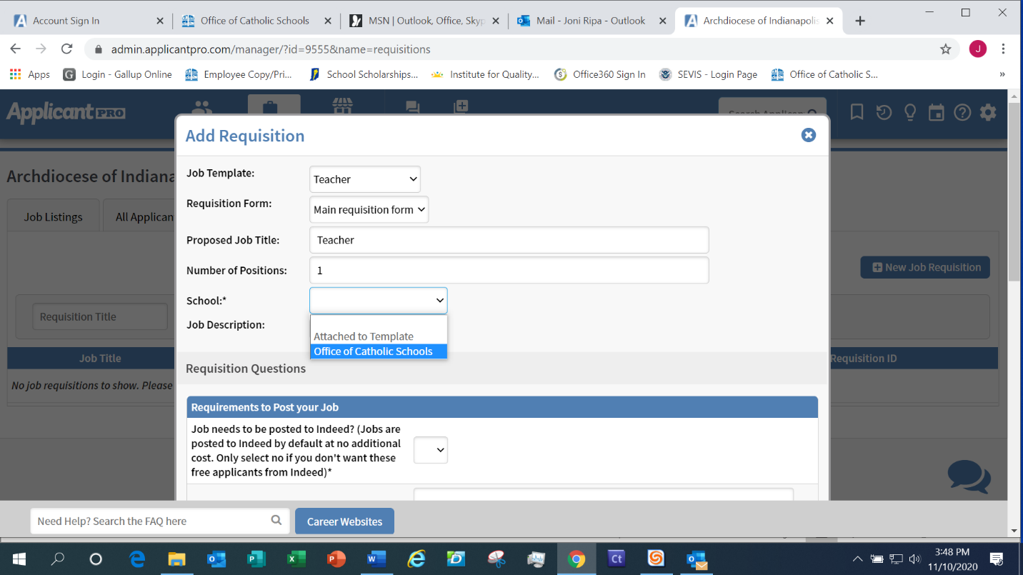

6.) Job Needs to be posted to Indeed? Always select “Yes”. If you select No than the job will not be pushed out to Indeed or the other job boards.
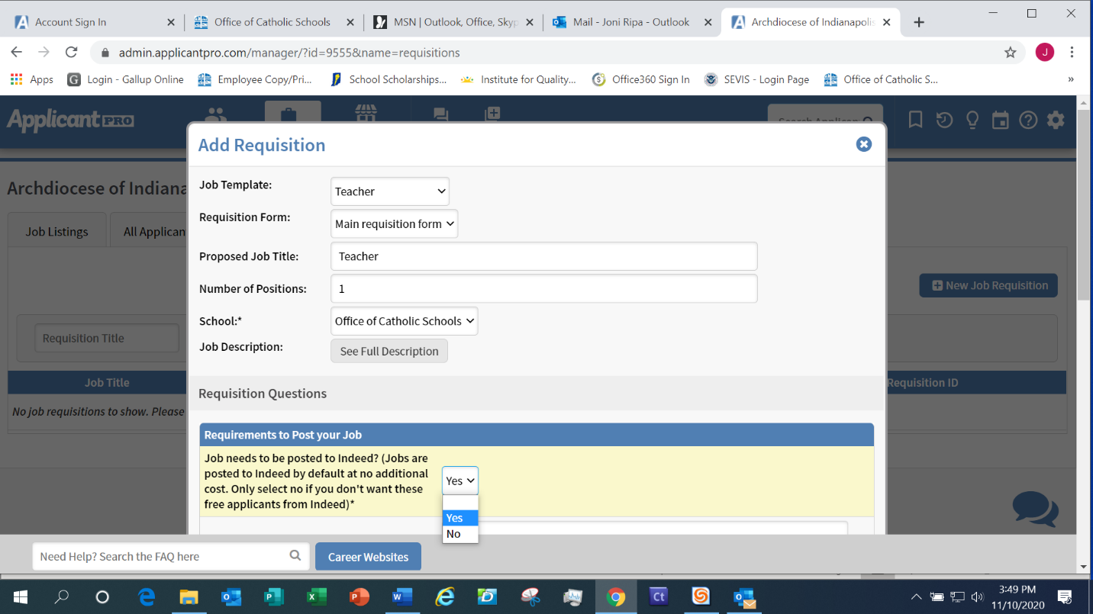
7.) Copy and Paste Custom Job Description: If you have the job description in another document
you can copy and paste it in this field. If you do not, you can type the job description.

IMPORTANT: Please include the name of your school, where it is located and a brief
description of your school. Then include a brief description of the position, and the
requirements necessary for the position (i.e. licensed teacher, 3-years’ experience, practicing
Catholic etc.)

8.) Date Range (Start and End Dates of when you will be accepting applicants for this position):
Type in today’s date and the end date of the job posting. You will receive an email from ApplicantPro notifying you when the job posting will expire. Or you can type in today’s day and put until filled (i.e. 1/21/21-until filled).

9.) List of Pay Rate and Benefits (Optional): We do not recommend you include pay rate unless it
is an hourly position (i.e. aftercare, food service etc.).

10.) Employment Type: Although teacher’s sign a contract we ask you choose full-time, part-time.
Seasonal, Contract and Other do not apply here.
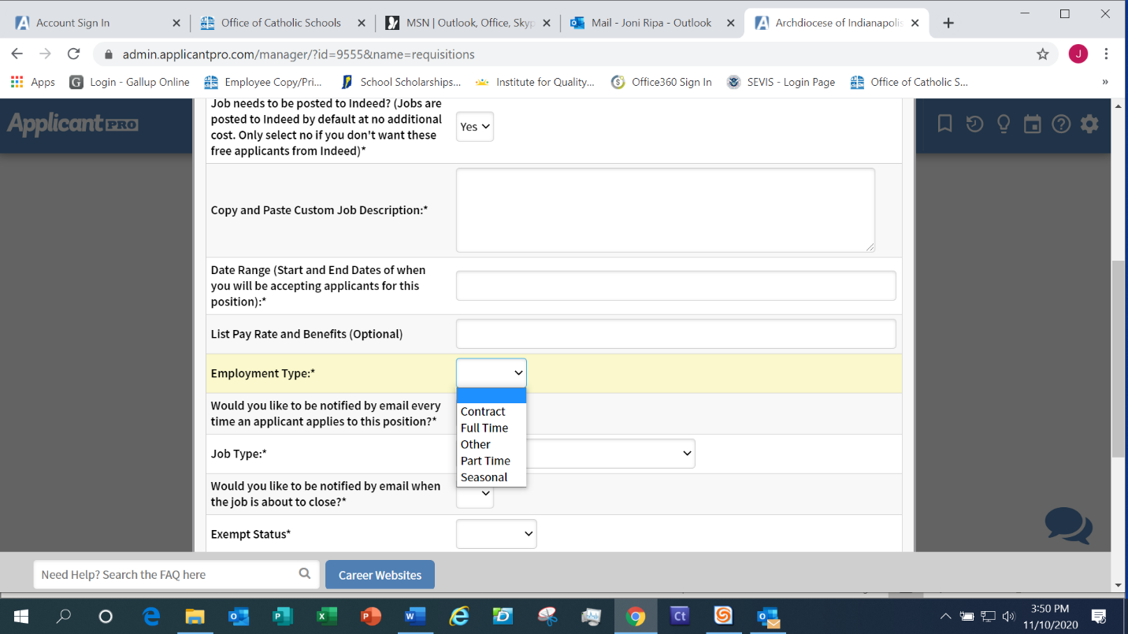

11.) Would you like to be notified by email every time an applicant applies to this position? Choose yes or no.
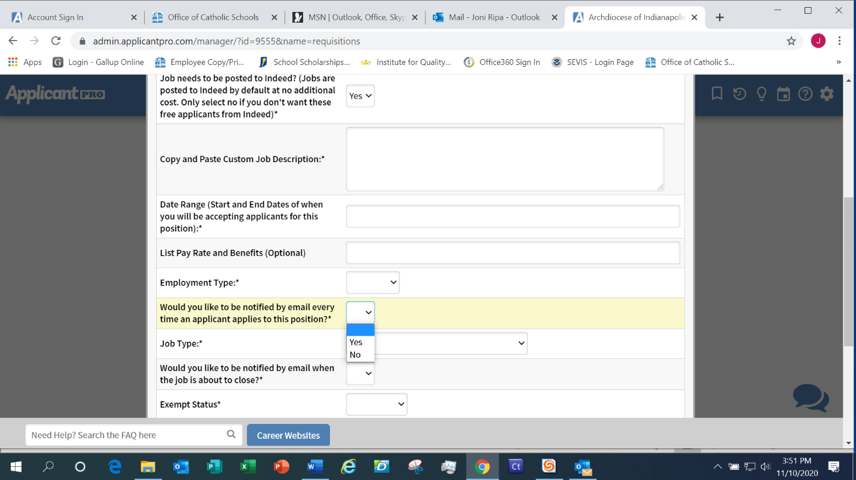

12.) Job Type: Choose External or Both. Intenal means OCS can create a link to publish for employed staff to view open positions in the OCS.
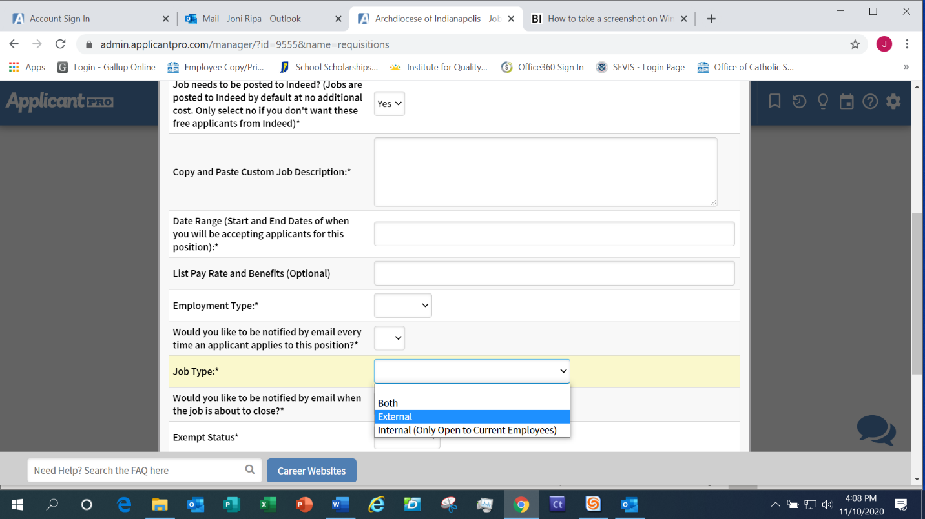

13.) Would you like to be notified by email when the job is about to close?: Choose yes.
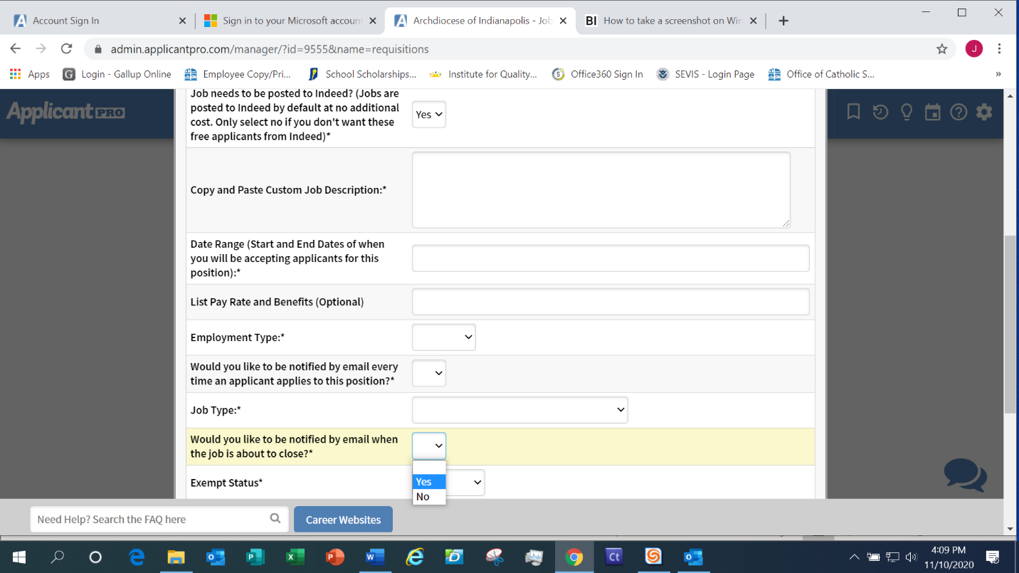

14.) Exempt Status: Choose either Exempt (Salaried employees), Non-Exempt (Hourly employees) or N/A (neither salary or hourly employees).
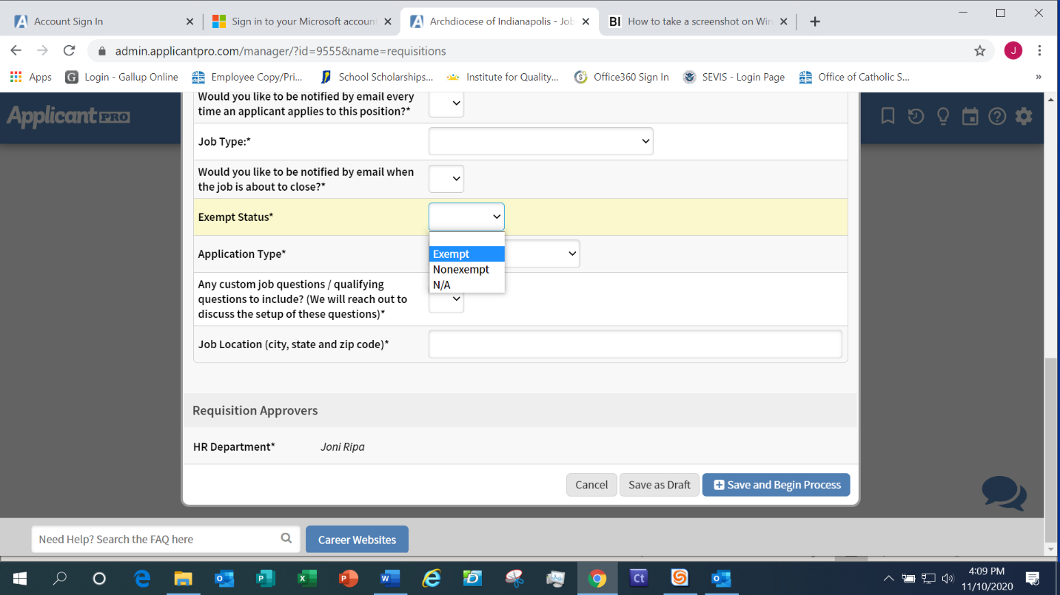

15.) Application Type: Choose the application for the position. Teacher = Teacher Application,
Staff = General Application, Food Service = Food Service Application
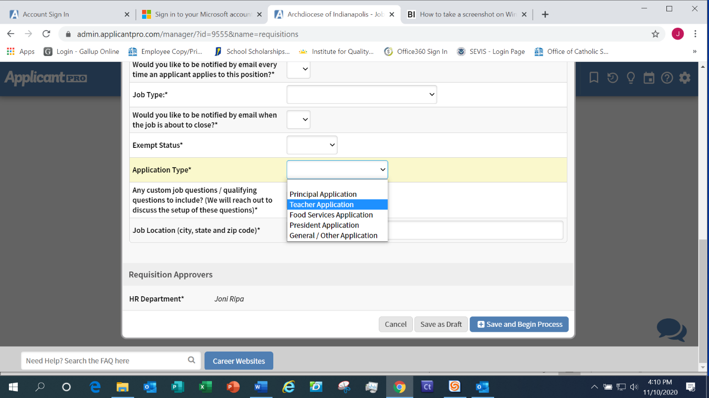

16.) Any custom questions/qualifying questions to include? (We will reach out to discuss the setup to
these questions): Answer No.
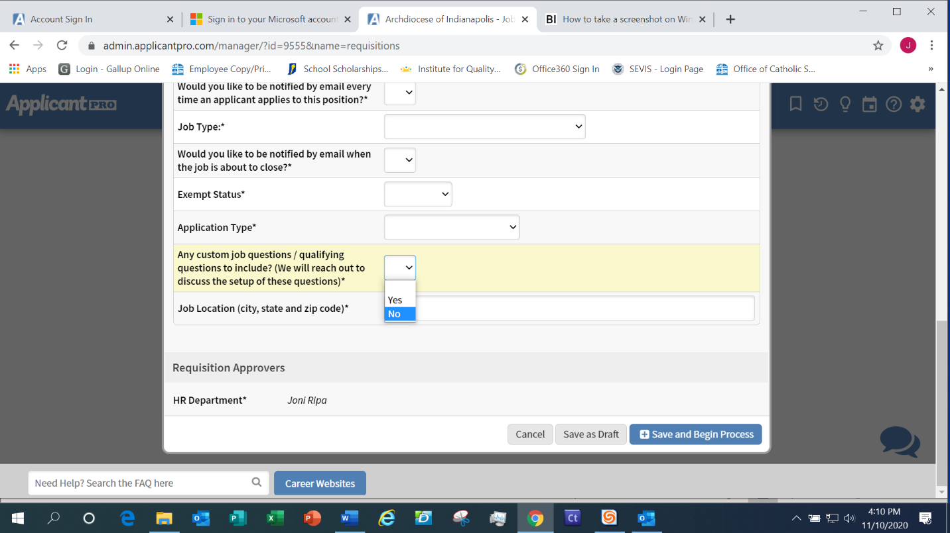

17.) Job Location: Your school city, state, and zip

18.) Approval Process

Choose the Requisition Approvers. You will choose Robin Hartkorn to approve. Robin Hartkorn will receive the request. Requisitions now send automated reminders via email when a requisition has been in a Pending status with an Approver for at least 2 days. It will send a reminder every two days after that until the requisition is approved or bypassed. Robin and Joni monitor ApplicantPro and will make every effort to post your positions within 24 hours of receiving the requisition (other than weekends).

Click Cancel to exit the form without saving, Save as Draft to save the form without sending it to the approvers and allow future editing, or Save and Begin Process to submit the requisition for approval. NOTE: A requisition can only be edited in Draft mode. One you hit Save and Begin Process you cannot edit. If you realize you made an error, please notify Robin and she will delete the job requisition and you can resubmit a new requisition.

Once the requisition is fully approved, an email is sent to the creator of the requisition AND a notice is sent to the person chosen to be notified, if one was specified during set-up. If the requisition creator and final user are the same, they will only receive one email.

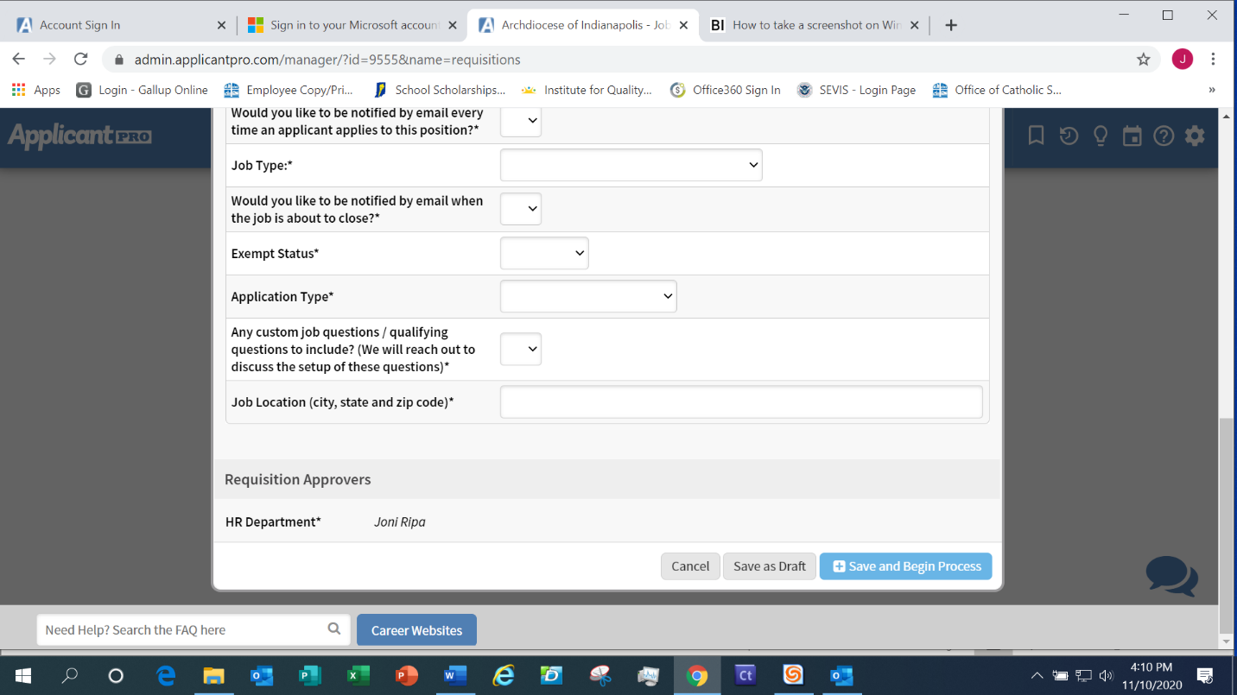

Done!

Please do not hesitate to contact Joni Ripa at jripa@archindy.org, (317)236-1444 or Robin Hartkorn at rhartkorn@archindy.org,(317)236-1441 if you have any questions.

