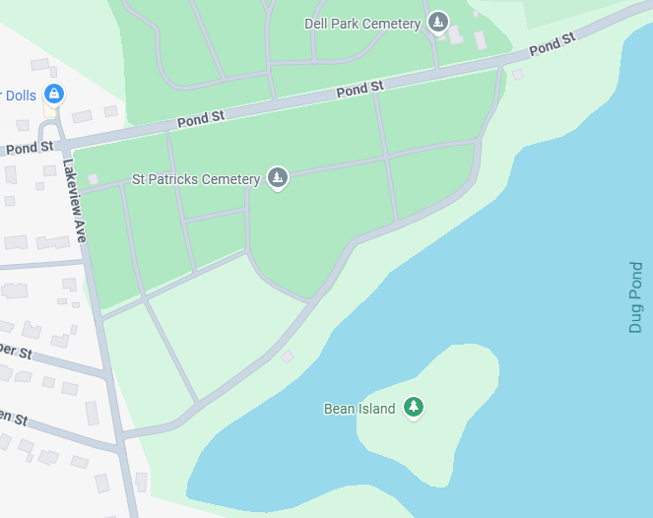
(IF)
(IF)
(Bar)
(Bar)
(BAR)
(BAR)
(BAR)
(BAR)
(BAR)
(BAR)
(IF)
(IF)
(IF)
(IF)
Tomb
St. Patrick Cemetery
SD -Single Deep Grave
DD-Double Deep Grave
BAR - Continuous Foundation
IF- Individual Foundation
DD
2
grave lts.
Annunciation Ave.

Cremation lots
KOC
Sisters
SOJ
DD
4 grave lots
I3
-----
SD 1 grave lts.
SD 1 grave lts.
DD
2 grave lts.
DD 1 grave lts.
SD
1grave lts.
-----
DD 4grave lts.
-----
----
DD
2 grave lts.
------
Bethlehem St.
DD
1grave lts.
---- -
SD
2 grave lots
Resurrection Rd.
Michael MacEwen Way
DD
4
grave lots
- -------
G
SD
1 grave lots
SD 4 grave lots
SD
16 grave lots
SD
4 grave lots
DD 4 grave lots
B
SD 4 grave lots
Main
Gate

----
------
------
---
-----
-----
Garage
Garage
Infant
Section
St. Patrick Way
MSGR. Delaney Way
Pentecost Rd.
Gethsemane Way
Nazareth Ave.
Fill
St. Joseph St.
R
St Patrick Way
MS2
Q
KA
K
MS
L+LA
J
I2
N

A

I1
Priests
H
S
T
Ds Gs
E
D
F
C

