St. Maria Goretti Catholic School
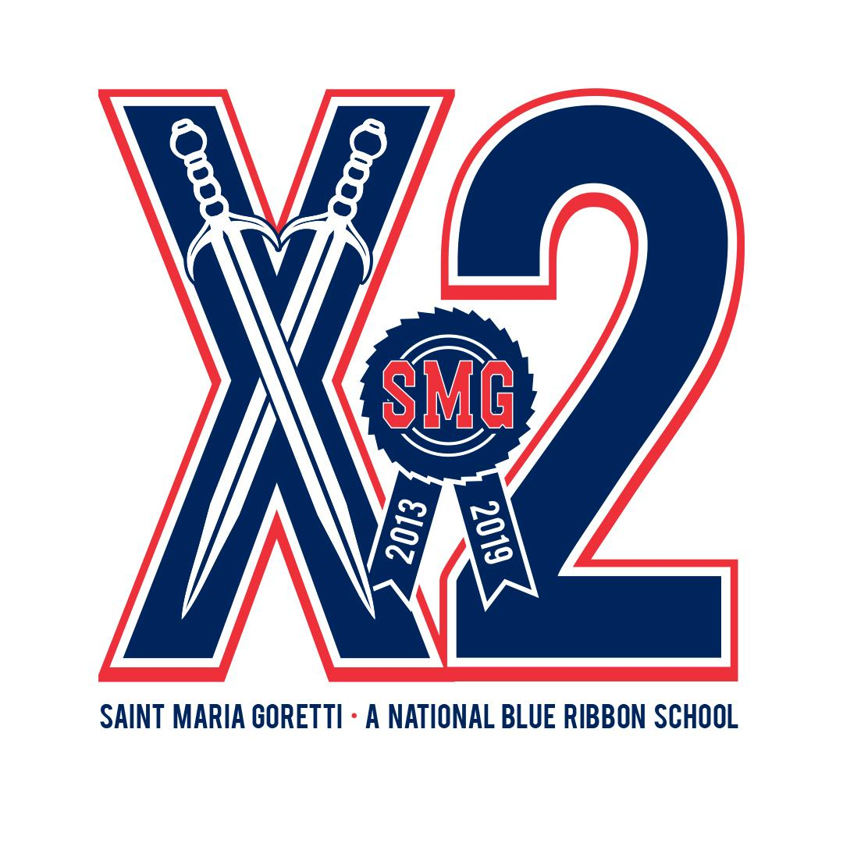
17104 Spring Mill Road
Westfield, IN 46074
317.896.5582
www.smgonline.org/school
2013 and 2019 National Blue Ribbon School of Excellence

GRADE Kindergarten *** Supplies may also be ordered from 1stdayschoolsupplies.com by 6/15/22

Qty | Description
1 | Colored Pencils - Crayola - 12 Ct
1 | Composition Book - Wide Ruled – Black Marble - 100 Ct
2 | Crayons - Crayola - Twistables - 08 Ct
1 | Dry Erase Markers – Expo – 4 Color Set – Fine
2 | Eraser – Papermate – Pink Pearl – Large – 1 Pk
2 | Folder - Plastic & Pocket - 3 Hole – Blue
1 | Folder - Plastic & Pocket - 3 Hole – Red
1 | Folder - Plastic & Pocket - 3 Hole - Yellow
2 | Glue - Elmers - Washable Stick - Purple - .21 oz - 01 Pk
1 | Glue - Elmers - Washable Stick - Purple - .21 oz - 06 Pk
1 | Markers – Washable – Crayola – Classic – 10 ct - Thick
1 | Headphones
1 | Notebook - 1 Sub - Spiral - Wide - Red - 70 Ct - Mead
1 | Pencil Pouch - Clear - 9 x 10.5 - 3 Ring
3 | Tissue - Kleenex - 100 Ct
2 | Wipes - Disinfectant - Clorox - 70 Ct
1 | Hand Sanitizer – Flip Top or Pump – Purell – 8oz

St. Maria Goretti Catholic School
17104 Spring Mill Road
Westfield, IN 46074
317.896.5582
www.smgonline.org/school
2013 and 2019 National Blue Ribbon School of Excellence

GRADE 1st *** Supplies may also be ordered from 1stdayschoolsupplies.com by 6/15/22

Qty | Description
1 | Colored Pencils - Crayola - 12 Ct
1 | Composition Book - Wide Ruled - Black - 100 Ct
1 | Composition Book - Wide Ruled - Green - 100 Ct
2 | Crayons - Crayola - Twistables - Minis - 24 Ct
4 | Dry Erase Markers - Expo - Black - Chisel
2 | Eraser – Papermate – Pink Pearl – Large – 1 Pk
1 | Folder - Plastic & Pocket - Blue
2 | Folder - Plastic & Pocket - Green
2 | Folder - Plastic & Pocket - Purple
1 | Folder - Plastic & Pocket - Yellow
1 | Folder - Plastic Pocket & Prong - Red
3 | Glue - Elmers - Washable Stick - Purple - .21 oz - 01 Pk
1 | Glue - Elmers - Washable Stick - Purple - .21 oz - 12 Pk
1 | Hand Sanitizer - Dispensing Pump - Purell - 8 oz
2 | Markers - Washable - Crayola - Classic - 10 Ct - Thick
1 | School Box - 5.6 in x 8.4 in x 2.5 in - Plastic - Asst Colors
1 | Scissors - Fiskar - Kids - 5 Inch – Pointed
1 | Tissue - Kleenex - 100 Ct
1 | Wipes - Disinfectant - Clorox - 70 Ct
1 | Headphones

St. Maria Goretti Catholic School
17104 Spring Mill Road
Westfield, IN 46074
317.896.5582
www.smgonline.org/school
2013 and 2019 National Blue Ribbon School of Excellence

GRADE 2nd *** Supplies may also be ordered from 1stdayschoolsupplies.com by 6/15/22

Qty | Description
1 | Binder - Durable - View - 1 Inch - Blue  - Avery
1 | Composition Book - Wide Ruled - Black  - 100 Ct
4 | Crayons - Crayola - 24 Ct
4 | Dry Erase Markers - Expo - Black - Fine
2 | Eraser - Papermate - Pink Pearl –  Large - 1 Pk
1 | Folder - Plastic & Pocket – Red
1 | Folder - Plastic & Pocket - Yellow
1 | Folder - Plastic & Pocket - 3 Hole - Green
1 | Glue - Elmers - Washable Stick - Purple - .21 oz  - 12 Pk
2 | Markers - Washable - Crayola - Assorted - 12 Ct  - Thick
2 | Notebook - 1 Sub - Spiral - Wide – Blue- 70 Ct - Mead  Mead
1 | Notebook - 1 Sub - Spiral - Wide – Green  - 70 Ct - Mead
1 | Pencil - Sharpened - No 2 - 12 Pk
1 | Pencil Sharpener – Canister – 2 Hole
1 | Pens – BIC – 2 Pk - Black
1 | Pens – BIC – 2 PK - Blue
1 | Pens - BIC - 2 Pk - Red
1 | School Box - 5.6 in x 8.4 in x 2.5 in - Plastic –  Asst Colors
1 | Scissors - Fiskar - Kids - 5 Inch - Pointed
3 | Tissue - Kleenex - 100 Ct
1 | Wipes - Disinfectant - Clorox - 70 Ct
1 | Earbuds / Headphones

St. Maria Goretti Catholic School
17104 Spring Mill Road
Westfield, IN 46074
317.896.5582
www.smgonline.org/school
2013 and 2019 National Blue Ribbon School of Excellence

GRADE 3rd *** Supplies may also be ordered from 1stdayschoolsupplies.com by 6/15/22

Qty | Description
1 | Colored Pencils – Crayola – 12 Ct
1 | Crayons - Crayola - 24 Ct
2 | Eraser - Papermate - Pink Pearl - Large - 1 Pk
1 | Flash Cards - Multiplication - (0 to 12) - 54 Cards
1 | Folder – Plastic & Pocket - Blue
1 | Folder – Plastic & Pocket – Green
1 | Folder – Plastic & Pocket – Purple
1 | Folder – Plastic & Pocket – Red
1 | Folder – Plastic & Pocket - Yellow
1 | Glue - Elmers - Washable Stick - Purple - .21 oz - 01 Pk
2 | Highlighter - Chisel - Yellow - 1 Pk – Avery
1 | Markers - Washable - Crayola - Classic - 08 Ct – Thin
1 | Notebook - 1 Sub - Spiral - Wide - Blue - 70 Ct – Mead
1 | Notebook - 1 Sub - Spiral - Wide - Red - 70 Ct – Mead
2 | Paper Towel - Scott - Mega Choose a Size - 102 Ct
2 | Pencil - Sharpened - No 2 - 12 Pk
1 | Pencil Pouch - Clear - 9 x 10.5 - 3 Ring
4 | Pens – Flair – Black – Qty: 1
1 | Scissors - Fiskar - Kids - 5 Inch – Pointed
2 | Tissue - Kleenex - 100 Ct
1 | Wipes - Disinfectant - Clorox - 70 Ct
1 | Earbuds / Headphones

St. Maria Goretti Catholic School
17104 Spring Mill Road
Westfield, IN 46074
317.896.5582
www.smgonline.org/school
2013 and 2019 National Blue Ribbon School of Excellence

GRADE 4th *** Supplies may also be ordered from 1stdayschoolsupplies.com by 6/15/22

Qty | Description
1 | Binder - Durable - View - 1 Inch - Blue – Avery
1 | Colored Pencils - Crayola - 12 Ct
1 | Composition Book - Wide Ruled – Black  - 100 Ct
1 | Crayons - Crayola - 24 Ct
3 | Dry Erase Markers - Expo - Black - Chisel
2 | Eraser – Papermate – Pink Pearl Large – 1pk
1 | Folder - Plastic & Pocket - Orange
1 | Folder - Plastic & Pocket - Purple
1 | Folder - Plastic & Pocket - Red
2 | Folder - Plastic & Pocket - Yellow
1 | Folder - Plastic & Pocket - Black
1 | Folder - Plastic Pocket & Prong - Blue
1 | Folder - Plastic Pocket & Prong - Green
1 | Glue - Elmers - Washable Stick - Purple  - .21 oz - 01 Pk
2 | Hand Sanitizer - Dispensing Pump – Purell - 8 oz
2 | Highlighter - Chisel - Yellow - 1 Pk - Avery
3 | Index Cards - 4 x 6 - Ruled - White - 100 Ct
1 | Markers - Crayola - Classic - 08 Ct - Thick
1 | Notebook - 1 Sub - Spiral - Wide - Green - 70 Ct
1 | Notebook - 1 Sub - Spiral - Wide - Red - 70 Ct
1 | Paper - Filler - Wide - 100 Ct
1 | Paper Towel - Mega Choose a Size - 102 Ct
2 | Pencil - Sharpened - No 2 - 12 Pk
1 | Pencil Sharpener - Canister - 2 Hole
2 | Pens - BIC - 2 Pk - Red
1 | School Box - 5.6 in x 8.4 in x 2.5 in – Plastic  - Asst Colors
1 | Scissors - Fiskar - Kids - 5 Inch - Pointed
3 | Tissue - Kleenex - 100 Ct
2 | Wipes - Disinfectant - Clorox - 70 Ct
1 | Earbuds / Headphones

St. Maria Goretti Catholic School
17104 Spring Mill Road
Westfield, IN 46074
317.896.5582
www.smgonline.org/school
2013 and 2019 National Blue Ribbon School of Excellence

GRADE 5th *** Supplies may also be ordered from 1stdayschoolsupplies.com by 6/15/22

Qty | Description
1 | Binder - Durable - View - 1 Inch - Blue - Avery
1 | Binder - Durable - View - 1 Inch - White - Avery
1 | Colored Pencils - Crayola - 12 Ct
6 | Composition Book - Wide Ruled - Black -100 Ct
1 | Divider- Avery 8 Tab -White Big Tab Write On
2 | Dry Erase Markers - Expo - 4 Color Set - Chisel
1 | Folder - Plastic Pocket & Prong - Blue
1 | Folder - Plastic Pocket & Prong - Green
1 | Folder - Plastic Pocket & Prong - Red
1 | Glue - Elmers - Washable School Bottle - 4 oz
1 | Glue - Elmers - Washable Stick - Purple - .21 oz - 01 Pk
1 | Graph Paper - 4 x 4 Quad - Filler Paper - 80 Ct
2 | Highlighter - Chisel - Yellow - 1 Pk - Avery
1 | Index Cards - 3 x 5 - Ruled - White - 100 Ct
1 | Markers - Crayola - Classic - 10 Ct - Thick
3 | Paper - Filler - College - 150 Ct
2 | Paper Towel - Scott - Mega Choose a Size - 102 Ct
2 | Pencil - Sharpened - No 2 - 12 Pk
1 | Pens - Erasable - Papermate - Black - Qty:1
1 | Protractor - 6 Inch
1 | Ruler - 12in/30cm - Plastic - Transparent
1 | Scissors - Fiskar - 7 Inch - Pointed
1 | Sticky Notes - Post It - 3 x 3 - Plain - Yellow - 100 Pk
3 | Tissue - Kleenex - 100 Ct
3 | Wipes - Disinfectant - Clorox - 70 Ct
1 | Earbuds / Headphones

St. Maria Goretti Catholic School
17104 Spring Mill Road
Westfield, IN 46074
317.896.5582
www.smgonline.org/school
2013 and 2019 National Blue Ribbon School of Excellence

GRADE 6th *** Supplies may also be ordered from 1stdayschoolsupplies.com by 6/15/22

Qty | Description
1 | Binder - Hvy Duty - View - 1 In - Black - One Touch EZD Ring - Avery
1 | Binder - Hvy Duty - View - 1 In - Blue - One Touch EZD Ring - Avery
1 | Binder - Hvy Duty - View - 1 In - Green - One Touch EZD Ring - Avery
1 | Binder - Hvy Duty - View - 1 In - Red - One Touch EZD Ring - Avery
1 | Binder - Hvy Duty - View - 1 In - White - One Touch EZD Ring - Avery
2 | Colored Pencils - Crayola - 12 Ct
5 | Composition Book - Wide Ruled - Black - 100 Ct
5 | Divider - Avery - 5 Tab - White - Big Tab Write On
1 | Eraser - Papermate - Pink Pearl - Large - 1 Pk
2 | Folder - Plastic Pocket & Prong - Blue
2 | Folder - Plastic Pocket & Prong - Green
2 | Folder - Plastic Pocket & Prong - Yellow
1 | Glue - Elmers - Washable Stick - Purple - .21 oz - 01 Pk
1 | Highlighter - Chisel - Yellow - 1 Pk - Avery
2 | Notebook - Five Star - 1 Sub - WR - 8 x 10.5 - 100 Ct
5 | Paper - Filler - Wide - 100 Ct
2 | Pencil - Sharpened - No 2 - 12 Pk
3 | Pens - BIC - 2 Pk - Blue
1 | Pens - BIC - 2 Pk - Red
2 | Tissue - Kleenex - 144 Ct
2 | Wipes - Disinfectant - Clorox - 70 Ct
1 | Earbuds / Headphones

St. Maria Goretti Catholic School
17104 Spring Mill Road
Westfield, IN 46074
317.896.5582
www.smgonline.org/school
2013 and 2019 National Blue Ribbon School of Excellence

GRADE 7th *** Supplies may also be ordered from 1stdayschoolsupplies.com by 6/15/22

Qty | Description
1 | Binder - Hvy Duty - View - 1 In - Black –  One Touch EZD Ring - Avery
1 | Binder - Hvy Duty - View - 1 In - Blue –  One Touch EZD Ring - Avery
1 | Binder - Hvy Duty - View - 1 In - Green –  One Touch EZD Ring - Avery
1 | Binder - Hvy Duty - View - 1 In - White –  One Touch EZD Ring - Avery
2 | Colored Pencils - Crayola - 12 Ct
4 | Divider - Avery - 5 Tab - White –  Big Tab Write On
2 | Dry Erase Markers - Expo - 4 Color Set –  Chisel
1 | Eraser - Papermate - Pink Pearl - Large –  1 Pk
1 | Folder - Plastic & Pocket – Blue
1 | Folder - Plastic & Pocket - Green
1 | Folder - Plastic & Pocket - Red
1 | Folder - Plastic & Pocket - Yellow
1 | Highlighter - Chisel - Yellow - 1 Pk - Avery
1 | Index Cards - 4 x 6 - Ruled - White –  100 Ct - Mead
2 | Notebook - Five Star - 1 Sub - CR –  Asst Color – 11 x 8.5 - 100 Ct
2 | Notebook - Five Star - 3 Sub - CR –  Asst Color - 8.5 x 11
3 | Paper - Filler - College - 150 Ct
2 | Pencil - Sharpened - No 2 - 12 Pk
3 | Pens - BIC - 2 Pk - Blue
1 | Pens - BIC - 2 Pk - Red
2 | Tissue - Kleenex - 100 Ct
1 | Wipes - Disinfectant - Clorox - 70 Ct
1 | Earbuds / Headphones

St. Maria Goretti Catholic School
17104 Spring Mill Road
Westfield, IN 46074
317.896.5582
www.smgonline.org/school
2013 and 2019 National Blue Ribbon School of Excellence

GRADE 8th *** Supplies may also be ordered from 1stdayschoolsupplies.com by 6/15/22

Qty | Description
1 | Binder - Hvy Duty - View - 1 In - Blue - One Touch EZD Ring - Avery
1 | Binder - Hvy Duty - View - 1 In - Green - One Touch EZD Ring - Avery
1 | Binder - Hvy Duty - View - 1 In - Red - One Touch EZD Ring - Avery
1 | Binder - Hvy Duty - View - 1 In - White - One Touch EZD Ring - Avery
1 | Colored Pencils - Crayola - 12 Ct
2 | Composition Book - College Ruled - Hard Marble
4 | Divider - Avery - 5 Tab - White - Big Tab Write On
1 | Highlighter - Pen Style - Chisel - Clip - 3 Pack - Yellow, Blue, Pink
1 | Index Cards – 3 x 5 – Ruled – White – 100 ct – Med
2 | Notebook - 3 Sub - Spiral - CR - Asst Color – Mead
4 | Paper - Filler - College - 150 Ct
1 | Pencil - Ticonderoga - Sharpened - No 2 - 12 Pk
1 | Pens - BIC - 10 Pack - Black
1 | Pens - BIC - 2 Pk - Red
2 | Tissue - Kleenex - 100 Ct
1 | Wipes - Disinfectant - Clorox - 70 Ct
1 | Earbuds / Headphones

