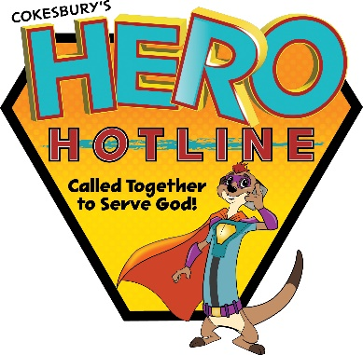
St. John the Evangelist
Vacation Bible School Registration Form 2023
Registration Deadline is June 21, 2023
Questions: Theresa Konitzer at 410-592-6206, Ext. 107
konitzermt@sjehydes.org

Thank you for your interest in St. John the Evangelist Vacation Bible School. The program will be held June 26 – 30, 2023 from 9:00 a.m. – 12:00 noon in the Church Hall. Rising Preschool 4 to Grade 5 are invited to participate. Students rising to grades 6 – 12 are invited to be crew leaders.

Cost: $50.00 for first child and $25.00 for each sibling. The cost includes participation in all activities including “Water Day,” crafts, materials, and snacks for the entire week of Vacation Bible School.
Checks can be made payable to St. John the Evangelist and mailed to
Theresa Konitzer, St. John the Evangelist, 13305 Long Green Pike, Hydes, MD 21082.
Family Last Name:______________________________________________ Parent/Guardian Name: ________________________________________________
Address: _______________________________________________________ State: ____________________________ Zip Code: _______________________
Contact Phone Number: _________________________________________ E-mail Address: ______________________________________________________
Additional Emergency contact name & telephone number: _________________________________ Relationship to Participant: _________________________
Child’s First Name | Child’s Date of Birth | Grade in  School 2023-2024 | Special Needs  (Food Allergies, IEP, Reading Difficulties, etc.)
If an EPI pen is needed for your child, please call our office directly.
To complete this registration, please read, date, sign the attached permission forms to:
Theresa Konitzer, St. John the Evangelist, 13305 Long Green Pike, Hydes, MD 21082 or konitzermt@sjehydes.org

