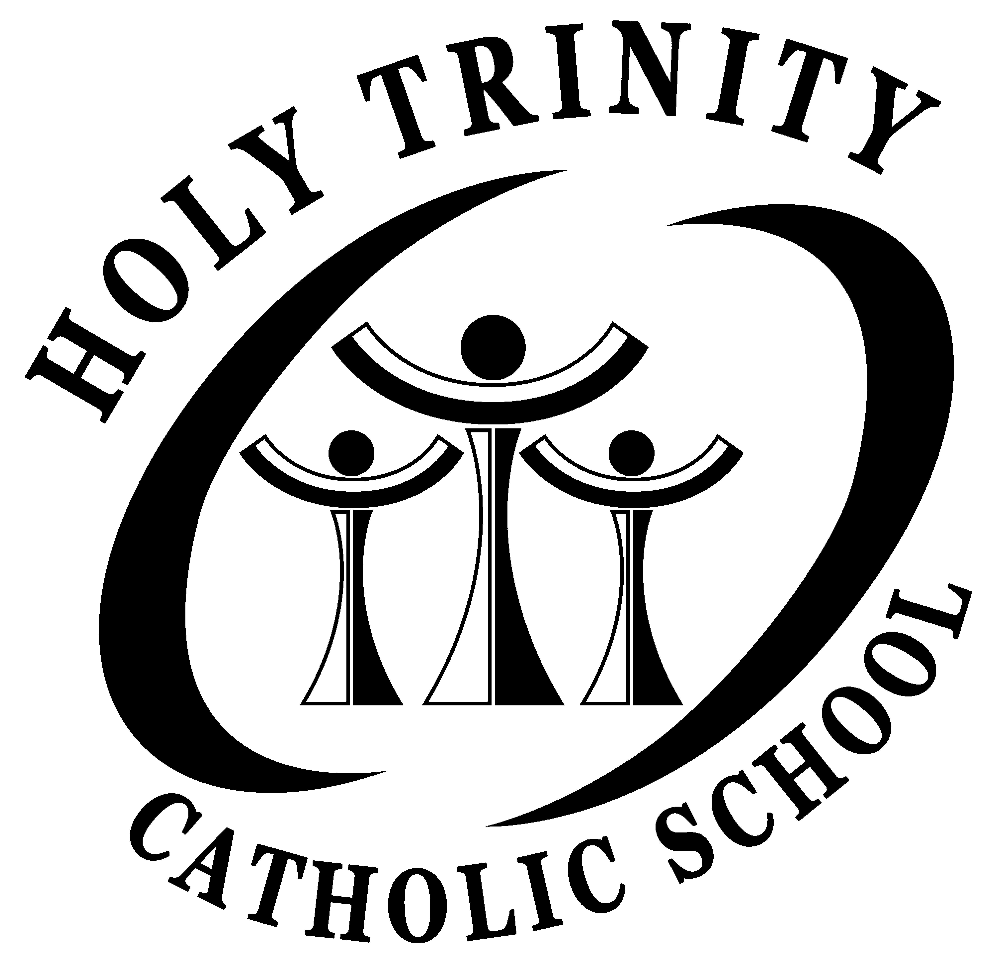
Holy Trinity Catholic School
745 6th Avenue South
South St. Paul, MN 55075

2021-2022 HOLY TRINITY MIDDLE SCHOOL UNIFORM POLICY
GRADES 6-8

Donald’s Uniform is our official uniform store. All styles and colors worn must be identical to Donald’s.
Donald’s Uniform, 972 Payne Avenue, Saint Paul, MN 55130
651-776-2723 www.donaldsuniform.com

BOYS

Shirt: Red knit shirt (long or short sleeve). All shirts must be tucked in.

Pants: Navy blue twill uniform pants.

Shorts: Donald’s navy “walking” length uniform shorts - May be worn until 10/20 and after 4/1.
Other: Socks are to be plain solid white with no logos or decorations. All socks must be above the ankle. Black or navy belt is mandatory.

GIRLS

Shirt: Red knit shirt (long or short sleeve). All shirts must be tucked in.

Skirt: Solid navy uniform skirt. Should be approximately knee length. Navy or black shorts can be worn under skirts so as not to be seen below the hem of the skirt.

Pants: Navy blue twill uniform pants.

Shorts: Donald’s navy “walking” length uniform shorts - May be worn until 10/20 and after 4/1.
Other: Navy blue button up uniform sweater is acceptable. Solid white knee-highs or above the ankle socks with no logos or decorations. All socks must be above the ankle. Black or navy belt is mandatory with uniform pants and shorts. Hairpieces may be navy, white or red.

Sweatshirts: Holy Trinity logo crew neck sweatshirts are considered part of the uniform. HOWEVER, no other type of sweatshirt is allowed. The Holy Trinity sweatshirt must be worn over the uniform shirt. Sweatshirts are not to be tied around the waist.

Shoes: Tennis shoes or black dress shoes for boys and tennis shoes or black flat dressy shoes for girls.

