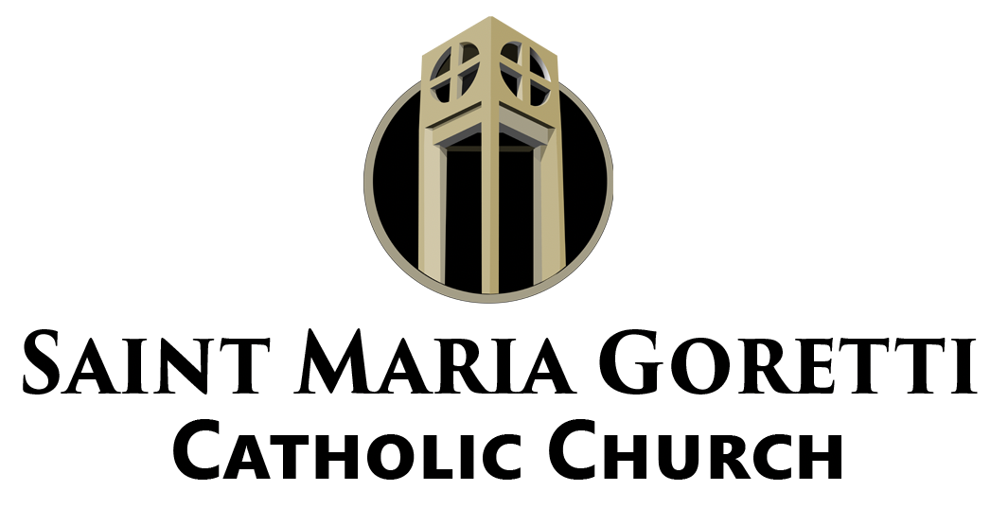

DIRECTOR OF MUSIC AND WORSHIP

MISSION CONTEXT
St. Maria Goretti Parish exists to reveal the presence of Christ in the New Orleans East community and bring the scattered to Him. The Director of Music and Worship serves this mission by ensuring that the Church’s public prayer is celebrated with reverence, theological integrity, cultural authenticity, and pastoral sensitivity so that the People of God are drawn into full, conscious, and active participation in the liturgy.

POSITION OVERVIEW
The Director of Music and Worship is responsible for the planning, preparation, and execution of music and liturgical elements for parish worship, with particular attention to the Weekend Experience as the source and summit of parish life. This role collaborates closely with the Pastor and parish leadership to ensure that music and worship are not treated as standalone functions, but are fully integrated into the pastoral vision, preaching themes, liturgical seasons, and broader mission of the parish.

The Director of Music and Worship is not simply a musician, but a liturgical leader who understands the Mass as prayer, proclamation, and encounter, and who forms others to serve within that vision.

PRIMARY RESPONSIBILITIES
Liturgical Planning and Leadership
• Plan music and worship in fidelity to the Roman Missal, the liturgical calendar, and the norms of the Church, with particular care for Ordinary Time, Advent, Lent, Easter, and major
solemnities.
• Collaborate with the Pastor to align music with preaching themes, seasonal movements, and parish wide focuses.
• Ensure that music serves the liturgy rather than drawing attention to itself, supporting prayer, proclamation, and communal participation.
• Prepare and oversee music for all weekend Masses, holy days of obligation, and major parish liturgies.
• Coordinate worship for special liturgies including funerals, weddings, school Masses, sacramental celebrations, and parish wide services.

Music Ministry Development
• Recruit, train, and pastorally accompany cantors, choir members, instrumentalists, and other music ministers.
• Foster a prayerful and disciplined music ministry culture rooted in service, preparation, and reverence.
• Provide ongoing formation for music ministers that deepens their understanding of the Mass, sacred music, and the spiritual nature of their role.
• Schedule and oversee rehearsals that are purposeful, well organized, and respectful of
volunteers’ time.

Musical and Cultural Sensitivity
• Select music that is theologically sound, pastorally appropriate, and resonant with the cultural life of the parish, particularly within the Black Catholic tradition.
• Balance tradition and accessibility so that the assembly is able to sing, respond, and pray rather than observe.
• Ensure musical choices support congregational participation and do not overshadow the spoken and proclaimed Word.

Collaboration and Administration
• Work collaboratively with parish staff, especially the Pastor, Director of Parish Life, and Director of Discipleship, to support the overall pastoral plan of the parish.
• Prepare worship schedules, music plans, and seasonal outlines in advance.
• Manage music ministry resources responsibly, including music library, instruments, and
equipment.
• Support the formation of liturgical ministers by understanding how music interfaces with
lectors, presiders, servers, and hospitality.

QUALIFICATIONS AND FORMATION
• A practicing Catholic with a demonstrated love for the Eucharist and the Church’s liturgy.
• Formal training or significant experience in music, liturgy, or sacred music ministry.
• Strong understanding of the structure of the Mass and the purpose of music within it.
• Ability to lead others with clarity, patience, and pastoral sensitivity.
• Comfort working within a collaborative parish staff environment and receiving direction from the Pastor.
DESIRED QUALITIES
• Deep respect for the sacredness of the liturgy.
• Pastoral instinct and cultural awareness.
• Organizational skill and attention to preparation.
• A spirit of humility, service, and prayer.

WORKING RELATIONSHIPS
The Director of Music and Worship reports directly to the Pastor and works collaboratively within the parish leadership structure to support the mission and vision of St. Maria Goretti Parish.

