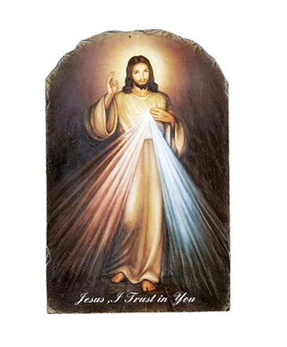**SJN Middle School Youth Ministry**

“God is Good All the Time”

*For more detailed information please visit:* [*https://www.sjnnh.org/edge*](https://www.sjnnh.org/edge)

**Our Mission:** *As Disciples, our mission is to reflect the love of Christ to all we encounter, expressing excitement and enthusiasm for the opportunity to share our church home and to welcome all visitors in such a way that they would be transformed from strangers into friends.*

**What are Edge Nights?** Our Sunday youth ministry will take place from 4:30-6pm, finishing up in time to attend the 6pm mass at Saint John Neumann. We are diving into catechesis, enjoying a snack, and adding some social activity for an engaging conversation! We have planned times of fellowship, opportunities to give back to our community, as well as outings! All of our events are open to everyone in grades 6-8! We invite you to check out our schedule of upcoming events on our website, <https://www.sjnnh.org/edge>

**Fall ‘25 - Spring ‘26 Edge Night Outline**

**September:**

* 7th – Kick off Picnic
* 21st – Below the Surface: Dive In

**October:**

* 5th – Below the Surface: Sonar
* 19th -Below the Surface: Diving Signals

***November:***

* 2nd – Below the Surface: Deep Water
* 16th – Below the Surface: Suit Up

**December:**

* 7th – Adoration Night
* 14th – Holly Jolly Journey- Christmas Party outing at Mel’s in Litchfield

**January:**

* 11th – Below the Surface: Submerged
* 25th – Safe Environment Sunday

**February:**

* 1st – Below the Surface: Rip Current
* 15th – Below the Surface: Go Fish

**March:**

* 8th – Star Gazing: Blue Skies
* 22rd – Adoration Night

**April:**

* 12th – Star Gazing: Light Pollution/ Morning Star
* 19th - Last Class Luau

**Edge Night Series Descriptions:**

* ***Below the Surface*** *– In this series we will dive into a deeper understanding of the sacraments discussing their inward and outward signs as well as how they aid us on our journey toward Heaven. We will learn more how the sacraments are not just a “check point” in our lives but aids to stay on our journey towards Heaven.*
* ***Star Gazing –*** *In these sessions we will delve deeper in to the theological virtues with an emphasis on Hope. Keeping our eyes fixed on the “Hope of Heaven” and rooting our belief and trust in Christ’s promises.*

**Other activities throughout the year:**

* Apple Picking and pie making- **October 4th (11:30- 2pm - Currier Orchards and Parish Hall)**
* Christmas shopping and wrapping for those in need - **November 21st and 22nd**
* Holly Jolly Journey at Mels’ in Litchfield- **December 14th**
* Social outings to be announced (i.e. bonfires, hiking, Indoor rock climbing, and more!)
* Other events TBA

*If you have any questions concerning Edge Nights and any other middle school events, please contact Emilie Fulchino, the Middle School Youth Minister, at* [*MSyouth@sjnnh.org*](mailto:MSyouth@sjnnh.org)*.*

