BANNERS FOR
FIRST EUCHARST

For the Liturgy celebration, each communicant makes a banner for his or her family pew. This banner is a wonderful way that you, the parent, along with your child (and other family members!) to make this a special part of the celebration! And a great keepsake too! However, let the children give the ideas and let them do most of the work.

Please follow these simple directions:

- The banner is to be 12” (width) by 16” (length). The size of the
banner is important so that it will fit on the end of the church pew.

- The base of the banner is to be made of fabric, felt or burlap in any
color desired.

- The child’s first name only should appear on the FRONT of the
banner. (This can be across, down, diagonal). No family (last) names, please.

- The child may choose any appropriate symbol(s) for the banner. Appropriate symbols include: bread, wheat, cup, plate, person,
scripture, etc. These symbols can be made with material and trimmings.

- Words may be used on the banner but it is not necessary.

- The banner should come from the child, noting special parts/symbols of First Eucharist.

- Banners need to be attached to a 14” rod or wooden dowel with a string or ribbon so that they can be hung from the pew.

First Name Only
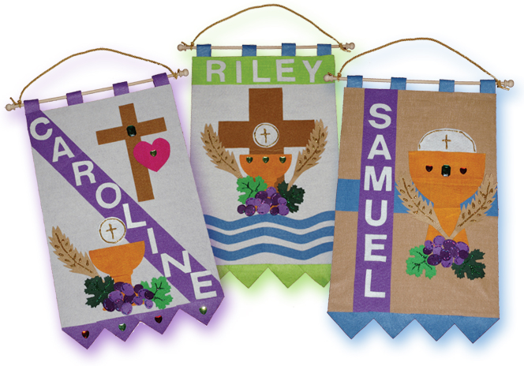

Be Creative
Appropriate symbols include: bread, wheat, cup, plate, person, Scripture, etc.
These symbols can be made with material and trimmings.
Note: Please follow the direction
Please Bring the Benner for the Day of the Liturgy Celebration

Full Name of Child
Date and Time of your Child’s First Eucharist

- DUE? Banners need to be brought to the Celebration.

(See other side for illustrated guide for making banner)

