PREPARING

for the

SACRAMENT of RECONCILIATION

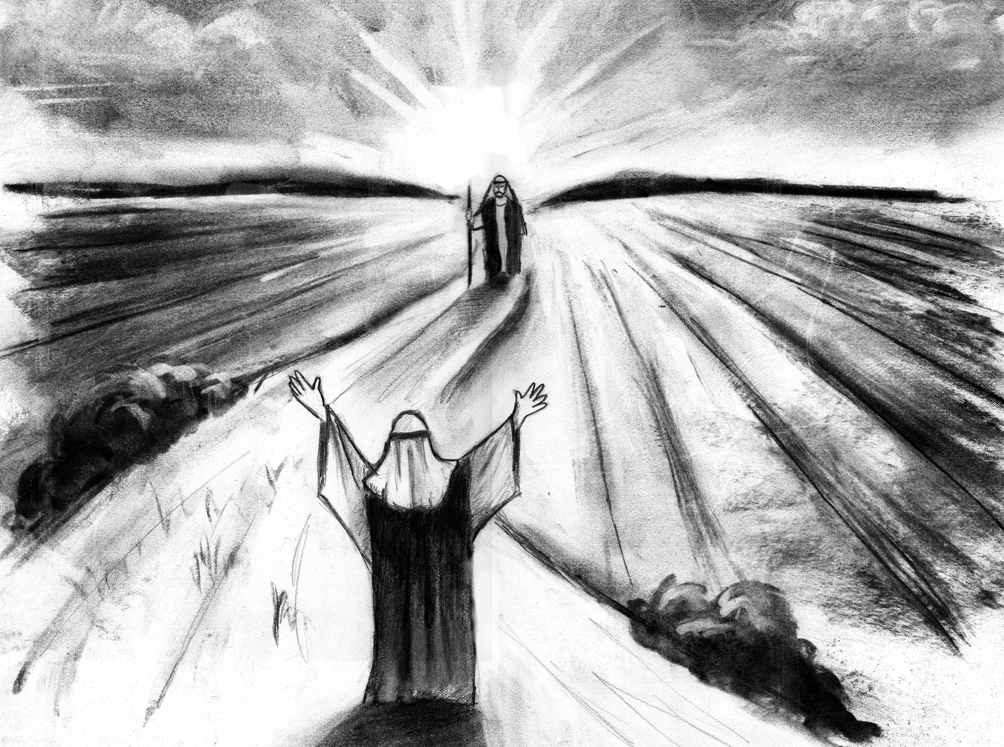

Our Lady of Sorrows—St. Anthony Parish
Hamilton, New Jersey

Dear Parents and Guardians:

We hope this handbook will serve you well in preparing your child for the Sacrament of Reconciliation—the celebration of God’s love and mercy. Your child learns best by witnessing your own faith and love. Our parish is pleased to assist you in bringing your child to this sacramental encounter. In this booklet are activities and information that will be helpful in this process. Please take the time to review the material and to mark your calendars for the events that have been planned for you! Our priests, catechists and staff are always willing to help you. Do not hesitate to call on us with any questions or concerns.
God bless you!
Mariyam Francis Msgr. Thomas Gervasio
Director of Religious Education Pastor

FREQUENTLY ASKED QUESTIONS
ABOUT THE
SACRAMENT OF RECONCILIATION
“A Little Catechism”

What is the Sacrament of Reconciliation?

It is the Sacrament established by Christ Jesus so that we might be reconciled to God by the forgiveness of our sins. This sacrament:
- Reconciles us with God and the Church;
- Restores, if lost through mortal sin, the state of grace;
- Offers us peace, serenity of conscience and spiritual consolation; and
- Gives us an increase of spiritual strength for the struggle of Christian living

Where does the Church find this authority in Scripture?

The risen Lord instituted this Sacrament on Easter when he showed himself to the apostles and said to them, “Receive the Holy Spirit. If you forgive the sins of any, they are forgiven; if you retain the sins of any, they are retained.
(Jn 20: 22-23) The Church is faithful to this commission, assuring us that God is willing to forgive sins as it looks to the words and actions of Christ who came to “search out and save what was lost.” (Luke 19:10)

What is the name of this Sacrament?

Having a number of names, it may be called the sacrament of:
- Penance, because it involves the steps of conversion and satisfaction
- Confession, since one acknowledges sins and discloses these to a priest
- Forgiveness, since through absolution, God grants pardon and peace
- Reconciliation, since it restores our relationship with God.

What are the five steps necessary to receive this sacrament worthily?

The five steps are:
- Examining one’s conscience (knowing our sins).
- Contrition (being sorry for our sins)
- Resolution (being determined to avoid sin in future)
- Confession (telling our sins to the priest)
- Penance (carrying out the action imposed by the priest in restitution)

What is the “Seal of Confession?”

The confessional “seal” is the sacred obligation of the priest to keep secret what has been revealed to him in confession. This “seal” may never be broken.

What happens if I overhear another person’s confession?

Should this occur, you are strictly bound by secrecy. Regarding one’s own confession, we are not bound by secrecy but it is better not to speak of it

What do we mean by “confessor” and “penitent?”

A confessor is the priest who administers the sacrament of penance. A penitent is the person who confesses his or her sins.

What is meant by “absolution?”
The term means “releasing” and refers to the words the priest prays over the penitent that sets them free from sin.

Does a priest ever refuse to absolve our sins?

This is only done if the penitent makes it clear that he/she is not truly sorry for sin and has no intention of correcting him/her self. True sorrow is necessary for reconciliation.

Why should we tell our sins to a priest?

We tell our sins to a priest because Christ gave to his apostles (the first priests) the authority and power to forgive sins. The priest is also the representative of the Church which we have offended through sin. He is the instrument of God’s merciful love.

How often can the sacrament be received?

The Church recommends a regular confession, perhaps even once a week or once a month. However, a Catholic should confess his or her sins whenever he or she is aware of any serious (mortal) sin. This is also important so that one might receive the Eucharist worthily. During the celebration of the sacrament one is bound to confess all sins since the last confession.

What is sin?

Sin is disobedience to God’s law. There are two kinds of sins: original and personal (sometimes called actual) Original Sin is that lack of grace with which each of us comes into the world, through the fault of our first parents. Personal (actual) sin is sin that we ourselves commit. One should know the commandments, laws of the Church, and the duties of one’s state in life (vocation).

What kinds of personal sins do we commit?

Personal sin may be serious (mortal) or less serious (venial).

What makes a sin serious (mortal)?

A sin is serious if:
- It regards a serious matter
- One is clearly aware of its seriousness and fully consents to it

THE ROLE OF PARENTS

Parents, as primary educators of their children are responsible for preparing them for the sacraments of initiation. They should strive to be models of moral living and forgiveness.
With the support of our parish religious education program, parents should prepare their child for this sacramental encounter in the following ways:

- Modeling Catholic life by receiving the Sacrament of Penance regularly

- Maintaining a regular prayer life in the home

- Reviewing the basic prayers, especially the Act of Contrition

- Attending meetings sponsored by the parish in preparation for Penance

- Review the catechetical information of the text and class regularly, especially the section, Together as Family at the end of each chapter

- Reading and discussing the Bible stories that teach us about God’s love and pardon

- Speaking positively of your own experience of reconciliation

- Helping their child distinguish between deliberate and accidental acts

- Encouraging their child to take responsibility for actions rather than blaming others.

- Assessing whether their child has a basic understanding of sorrow, forgiveness and trying to do better.

Beyond the celebration of first Reconciliation, parents should:

- Celebrate on Reconciliation Day with a small family party

- Continue their conversations about the great gift of this sacrament

- Bring their child to confession again, regularly (at the parish scheduled times on Saturday and/or the communal celebrations during Advent and Lent.

THE RITE OF RECONCILIATION

BEFORE CONFESSION

- Precede the sacrament by prayerful reflection and examination of conscience.
(The Examination of Conscience in this handbook may be helpful.)

- Be truly sorry for sin out of love for God.

DURING CONFESSION

- Enter the confessional (or approach the confession “station”) and greet the priest. The penitent usually begins by saying:

“Bless me, Father, for I have sinned. This is my first confession.”
(Or “It has been ____(weeks, months) since my last confession.”

My sins are… (The penitent then tells the priest his/her sins.)

- Listen then to the priest who will usually offer some advice and impose some type of penance to carry out. This is usually in the form of prayer, almsgiving, or other good work.

- The Penitent prays the Act of Contrition.

- Remain to receive the Absolution from the priest. Toward the end of the prayer of absolution, the penitent makes the sign of the cross.

- The penitent concludes by saying “Thank you, Father” and depart.

AFTER CONFESSION

- The penitent returns to his/her place in church to thank God for his mercy and pardon and then does the penance imposed.

THE ACT OF CONTRITION
(To be memorized by all children)

My God, I am sorry for my sins with all my heart.
In choosing to do wrong and failing to do good,
I have sinned against you whom I should love above all things.
I firmly intend, with your help, to do penance, to sin no more,
And to avoid whatever leads me to sin.
Our Savior Jesus Christ suffered and died for us.
In his name, my God, have mercy. Amen.

THE PARISH CELEBRATION OF RECONCILIATION

ATTIRE

Our dress often denotes the importance we attach to a particular occasion. Parents shall want to convey to their child that Reconciliation is a formal, sacred encounter with the Lord. It is also being celebrated within a group setting. Wearing one’s “Sunday best” is a good rule to follow. Jeans, sneakers, athletic attire, tee shirts (however creative) are unacceptable choices. Girls may wear dresses, jumpers, dress slacks, or skirts. Boys should wear dress trousers and dress shirt or turtleneck, a vest or sweater.

ARRIVAL

All children should arrive at church at least twenty minutes before the service time. Each student is to “report” to his or her catechist upon entering the church.

SEATING

Children will be seated as a group in the main nave for the celebration, (i.e. the center “wing.”) Family members and friends in attendance will be seated just behind the group. Seating will not be permitted in the side wings (at Our Lady of Sorrows Church) since these areas will be utilized for the confessional stations.

PHOTOGRAPHY / VIDEOGRAPHY

The sacred and most private character of this sacrament must be respected and protected. For this reason, the taking of photographs and/or video is strictly forbidden. Should the family like a photo remembrance of this sacrament, this may be done in church following the celebration.

THE TEN COMMANDMENTS & THEIR MEANING
A HELP IN THE EXAMINATION OF CONSCIENCE
I. I am the Lord, your God.  You shall have no other gods before me. | Love God above all things and adore Him.  We are to learn all we can about our faith.  Be faithful to our public & personal prayer.
II. You shall not take the name of the Lord your God in vain | Speak reverently of God, the Blessed Virgin & Saints  Be truthful in taking oaths and fulfilling vows  Respect sacred persons, places or things.  Do not curse (wish evil on a person, place or thing)
III. Remember to keep holy the Lord’s Day | Assist at Mass on Sundays & Days of Obligation  Respect the Lord’s Day as a day of rest and prayer
IV. Honor your father and your mother | Show respect to parents, others in authority & elders.  Do not to be stubborn, unkind, complaining or disobedient to them.  Accept correction and advice from them.
V. You shall not kill | Do not take innocent human life.  Take proper care of our life & the life of others.  Do not abuse alcohol or drugs.
VI. You shall not commit adultery | Be pure modest in our behavior alone & with others. We should not look at impure things.  Married people are to be faithful to their vows.
VII. You shall not steal | Do not take from others or their destroy property.  Do not cheat.  Workers and employers are to be fair & just
VIII. You shall not bear false witness | Be truthful & think the best of others.  Do not gossip about others.  Do not tell secrets we are bound to keep.
IX, You shall not covet your neighbor’s wife | Be pure in thoughts & desires.  Respect the bond of marriage.
X, You shall not covet your neighbor’s goods.

A CHILD’S EXAMINATION OF CONSCIENCE

Do I show my love for God by praying every day?

Do I use bad language?

Do I sometimes wish bad things on others?

Have I missed Mass on Sundays or holydays of obligation?

Do I misbehave in church or not pay attention at Mass?

Did I keep the Eucharistic Fast before receiving Communion?

Did I receive Communion without first confessing serious sin?

Do I respect my parents, teachers, and elders?

Do I fight with my family members or friends?

Am I rude or stubborn, always wanting to have my own way?

Do I forgive others when they hurt me or do I hold a grudge?

Am I helpful to others in need?

Have I told lies?

Do I cheat in schoolwork or games?

Do I “show-off” or treat others badly?

Do I share or am I selfish?

Do I complain about my chores or others things I should do?

Am I jealous of others?

Do I get angry or violent?

Do I talk “behind another’s back?”

BIBLE STORIES AND FAMILY ACTIVITIES

We recommend the use of a Catholic Children’s Bible for these times of study and reflection. It should contain beautiful illustrations and age appropriate texts.

Chapter One: God Loves Us: Luke 15-46

Scripture Background

The parable of the Lost Sheep is one of the three parables Jesus told about being lost. In it Jesus compares God to a shepherd and a sinner to the sheep. Just as the shepherd rejoices on finding his lost sheep, so God rejoices whenever we turn to him for forgiveness after wandering from him through our sin. The shepherd’s task was to protect the flock and to lead it to good pasture and fresh water. A good shepherd would be devoted in his care for the sheep. Jesus, the Good Shepherd loves and cares for us.

Other Bible References: Psalm 23; Matthew 18: 10 -14; John 10: 1-6

We Belong to God: Family Activities

This chapter teaches that we belong to God in a special way. God knows and loves us. We become God’s children through Baptism.
Suggested Activities:
- Write to your child’s godparents to thank them for their love and care.
- Review with your child the “Sign of the Cross,” pointing out that at baptism he/she was marked and baptized with the sign of the cross.
- Visit the baptismal font of the church. Bless yourselves with the blessed water in the font or at the doors, making the sign of the cross.
- Gather the family and share photos, video and stories of your child’s baptism day.

Chapter 2: The Great Commandment: Matthew 22: 34-40

Scripture Background

The Law of Moses commands that we are to love God with our whole hearts, soul and strength (Deuteronomy 6:5) and that we should love our neighbors as ourselves. In this story, Jesus explains this commandment. In fact, he joins them into one “Great Commandment.”

Other Bible References: Matt 5: 43-48; Mk 12: 28-34; Lk 6: 27-36; 10: 25-28; Jn 13: 31-35

We Follow Jesus: Family Activities

The great Commandment teaches us that to live a holy life we are to love God and others.
Suggested Activities:
- List ways (old and new) that your family lives the Great Commandment.
- Hang a banner or special reminder in the home to live the commandment.

Chapter 3: The Good Samaritan: Luke 10: 29-37

Scripture Background

This is a parable that teaches us that our neighbor is anyone who is in need of help. A person’s background or social status is not the basis for the help we extend. In this story, a Samaritan helps the poor victim. This would not be expected since Samaritans were despised by the Jews because they married non-believers and did not obey the Law of Moses. For this reason they were not allowed to worship in the Temple of Jerusalem. Those who passed by the victim committed the sin of omission. The Samaritan showed an active charity. Jesus broadens our hearts and invites us to be generous in our love.

We Listen to the Holy Spirit: Family Activities

Chapter Three teaches us that followers of Jesus are Good Samaritans.
- Talk about those people who help you make good decisions. Pray for them.
- Look at today’s newspaper. Find stories of Good Samaritans.
- Share stories about a time when a Good Samaritan helped you.

Chapter 4: Zacchaeus: Luke 19: 1-10

Scripture Background

This event in Our Lord’s life illustrates how Jesus’ message and his salvation was intended for everyone—even an outcast. In the time of Jesus, tax collectors were despised because they unfairly took money in their business with people. They used this money to build up their own wealth. By going the house of Zaccheus, a tax collector, Jesus shows that he came to save all people. Zaccheus changes his life.

Other Bible References: Matt 18: 12-14, 21-35

We are Sorry: Family Activities
Zaccheus was sorry for his sins and changed his life. Suggested activities:
- Talk about the times you felt better after saying you were sorry for doing something wrong
- Talk about why it is important to say “I am sorry.”
- Discuss ways we can show we are sorry. Pray together the “Act of Contrition.”

Chapter 5: The Forgiving Father: Luke 15; 11-32

Scripture Background

This is, again a parable about being “lost.” In the story, the Father is God and the rebellious son is the sinner. Sometimes this story is called the “Parable of the Prodigal Son” “Prodigal” means “wasteful” or “extravagant.” The son wasted the property and the resources the Father gave him, and then, coming to his senses returns home. Just as the
father celebrates the homecoming of his wayward son, so God rejoices in our admission of sin and our return to him.

We Are Forgiven: Family Activities
In Sacrament of Reconciliation is an experience of God’s forgiveness, love and new beginning. Suggested activities:
- Share stories about a time when someone forgave you. How did this make you feel?
- Discuss why it is important to say, “I forgive you.”
- Visit the confessional of the church. Take time to be comfortable with it.

Chapter Six: The Gift of Peace: John 14: 15-27, 20-21

Scripture Background

In speaking to his apostles, Jesus promises them the gift of the Holy Spirit so that after his return to the Father, they would know his continued presence and peace. They were not to be afraid of anything.

Other Bible References: Luke: 1: 79; 2: 14; Ephesians 6: 15

We are Peacemakers: Family Activities
The Sacrament of Reconciliation offers us the gift of the Holy Spirit, the gift of peace.
Suggested Activities:
- Make Holy Spirit Prayer Cards for the members of the family
- Pray together to the Holy Spirit: “Come Holy Spirit, fill the hearts of your faithful and kindle in them the fire of your love. Send forth your Spirit and they shall be created. And you will renew the face of the earth.”
- Talk about the ways the Holy Spirit helps your family live as disciples of Jesus.

SUGGESTED FAMILY READING

The Book of Virtues, (Wm. Bennett, Ed.) In this anthology on great themes such as friendship, self-discipline, responsibility, and honesty, read “Little Girls Wiser than Men”, “Pinocchio,” or “Someone Sees You.”

The Tale of Peter Rabbit (B. Potter) This treats the consequence of behavior.

The Stinky Sneakers Contest (J.A. Peters) This explores a cheating friend and the relationship between a father and son.

Saint George and the Dragon (M. Hodges) In a battle between good and evil, a knight restores joy to the Kingdom.

The True Story of the Three Little Pigs (J. Sciezka) This retelling of the tale from the wolf’s perspective, shows that conflict has another side.

Elbert’s Bad Word (A. Wood) This helps a child choose alternate behaviors and words. It illustrates the power of words in a very funny way!

Lon Po Po—A Red Riding Hood Story from China, (E. Young) Three young girls learn a lesson about obedience.

I Hate My Brother Harry and I Hate My Sister Maggie (C Dragon-Wagon) These books explore sibling rivalries.

Spinky Sulks (W. Steig) A funny story about family relations. Spinky has been hurt but refuses to accept his family’s apologies.

Old Henry (J. Blos) This explores different people learning to live together. It treats the possibility of compromise.

The Hating Book (C. Zolotow) This explores how a simple misunderstanding can threaten friendship.

Jamaica’s Find (J. Havill) Jamaica finds a stuffed dog but when she doesn’t feel good about keeping it, she finds its owner and a truth she can use for life.

Arnie and the Stolen Markers and Harriet and the Garden (N. Carlson) Both books treat the subject of honesty.

Loudmouth George (N. Carlson) This provides plenty of opportunities to discuss something most children do—making excuses.

