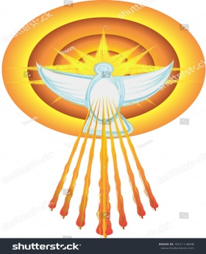
✨ Poster Instructions ✨
Create a Poster on the Gift of the Holy Spirit you have received.
This is your chance to express your faith with creativity and meaning!
🌟 Guidelines for Your Poster
- Theme: Focus on the Gift of the Holy Spirit that you personally received (for example: wisdom, courage, understanding, Counsel, knowledge, Reverence , Wonder and Awe)
- Required Text: Be sure to include the phrase:
“GIFT OF THE HOLY SPIRIT”
- Optional Wording: You may also write something like:
“Come, Holy Spirit, give the gift of [insert your gift here].”
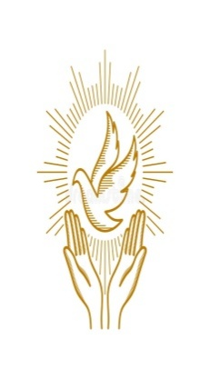
- Symbols: You are encouraged to include Christian symbols such as the dove, flames, clouds, or any other design that helps bring your gift to life.
- Creativity Counts! Use colors, drawings, and personal touches to make your poster meaningful and beautiful.
📏 Poster Size Options

- Medium Poster: 18” x 24”
- Concert Poster: 24” x 36”
🙌 Important Details
- Your poster will be proudly displayed during the 8th Grade Confirmation Reception in the Church Hall.
- Please sign your name at the bottom of your poster so it can be returned to you afterward.
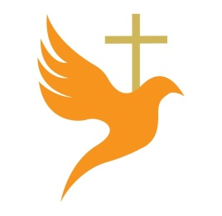
- Put care, effort, and thought into your design—it’s a reflection of the Spirit’s gift in you!
✨ We look forward to seeing your creative expressions of the Gifts of the Holy Spirit!
Due Date: February 7, 2026, Bring the pastor for Sponsor–Candidate Spirituality
Day

