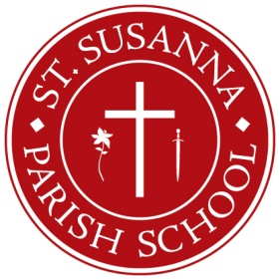
School Commission Nominations 2023
Accepting Nominations for 2023-2024 School Commission

As our Blue Ribbon school continues to develop into one of the finest academic institutions in the area, keeping our School Commission staffed with inspired leadership is vital. Three seats will open for the 2023-2024 school year. We are now accepting nominations to fill those positions. If you feel called to help continue the important work of the School Commission, or know of someone who would, please fill out the nomination form and drop it off at the Parish Office or School Office or place it in the collection basket in an envelope marked “School Commission”. Nominees must be at least 18 years of age and members of St. Susanna Parish. Nominations will be accepted until April 1st. Nominees will be contacted by April 7th for further instruction. For additional information, please contact the chair of the School Commission at schaferpm@gmail.com.
- - - - - - - - - - - - - - - - - - - - - - - - - - - - - - - - - - - - - - - - - - - - - - - - - - - - - - - - - - - - - - - - - - - - - - - - -
NOMINATION FOR SCHOOL COMMISSION

I am nominating ___________________________________to be a member of the St. Susanna School Commission.
I believe he/she will make a strong addition to the School Commission for the following reasons: ______________________________________________________________________
______________________________________________________________________________
______________________________________________________________________________

You may contact him/her at the following phone number: ______________________________
You may contact me at the following phone number: __________________________________
Signature: _____________________________________________________________________

