Family Ministry

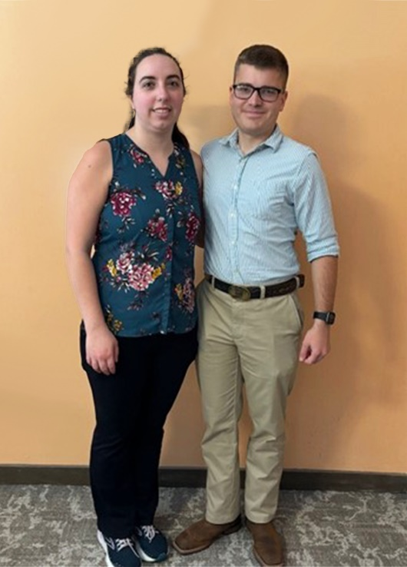
To meet the needs of our Catholic families, we provide Family Ministry, beginning at the tender moments when couples prepare for marriage and continuing to support them through challenging times.
Our Family Ministry partners with couples to strengthen the vocation of marriage and family life through marriage preparation, marriage enrichment, natural family planning, and family support. The family is the basic cell of society, promoting holy and healthy marriages is essential for our communities.
“Catholic Engaged Encounter was a deeply impactful and emotional experience for my fiancée and me. We grew together in our mutual relationship with the Lord and got to know each other a little better in the process.”
-Andrew and Katelyn Martin,
Annunciation Catholic
Church, Columbus
Through the Catholic Service Appeal, your donation provides funding for programs that strengthen and support our couples and families.

SCAN TO GIVE

Please give today!
csa.jacksondiocese.org

