St. Joseph Parish Religious Education Program
Family Handbook

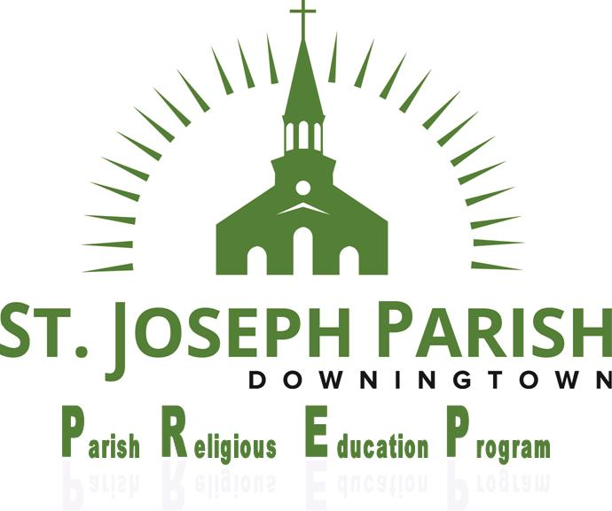

Father,
Life giving,
loving,
forgiving yet firm,
encouraging—
have patience with me
as I learn to walk in your footsteps.
2025-2026

St. Joseph Parish Religious Education Program
340 Manor Avenue, Downingtown, PA 19335
(610) 873-8798

PREP Mission Statement

We in the St. Joseph Parish Religious Education Program (PREP) are part of a parish family that is deeply committed to the religious education of our children. Our program strives to foster faith formation through teaching the message of Christ, celebration of the Sacraments, family involvement, and community service. We encourage our children to bring Jesus into their daily lives and to become stewards of our Catholic faith.

Catechesis
“The definitive aim of catechesis is to put people not only in touch but in communion, in intimacy, with Jesus Christ: only He can lead us to the love of the Father in the Spirit and make us share in the life of the Holy Trinity.” (St. John Paul II)

Catechesis describes the essential ministry of the (Catholic) Church through which the teachings of Christ have been passes on to believers throughout the ages as understood and taught by the Roman Catholic Church. The definitive aim of catechesis is an education and a spiritual formation in the Catholic faith which brings children, young people and adults into an intimate relationship with Jesus Christ. Keeping in mind that all baptized have a right to catechesis, every person, however limited, is capable of growth in holiness. Therefore, catechetical and sacramental programs are inclusive of parishioners with disabilities and may need to be adapted for some parishioners with dis abilities.

St. Joseph PREP
On behalf of the St. Joseph PREP faculty, we welcome you and your child to our parish religious education program. This program is open to all parish-registered members with children from grades kindergarten through 7 who attend public or nonparochial schools.

Parish Leadership
Pastor: Rev. Christopher Rodgers
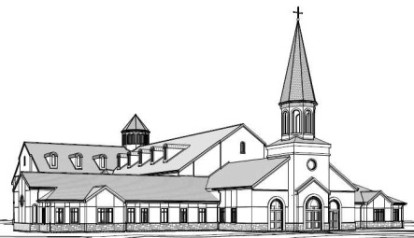
Parochial Vicars: Rev. Andrew Auletta
Resident: Rev. Louis Monica
Permanent Deacon: Deacon Michael Murtha
Deacon Matt Coyne
Deacon Edward Schiappa

DRE: Mrs. Kathleen Greco
PREP Office Personnel: Ms. Kara Christoph
Mrs. Mary Ann Korpics

School Principal: Sister Lisa Golden, IHM

Mass Schedule Confession Schedule

Monday through Friday: 7 a.m. and 9 a.m. Saturday: 3:30-4:30
Saturday morning: 8 a.m. Wednesday morning: 6:30 and 8:30 a.m.
Saturday evening: 5 p.m. Wednesday evening: 6:30 p.m.
Sunday: 6, 7:30, 9, 10:30 a.m.;
12 noon; 4 p.m.

Parish web page address: http://www.stjosephrc.org
Parental Participation
“The Christian home is the first school and the parents are the first to communicate the faith to their children.” Vatican II
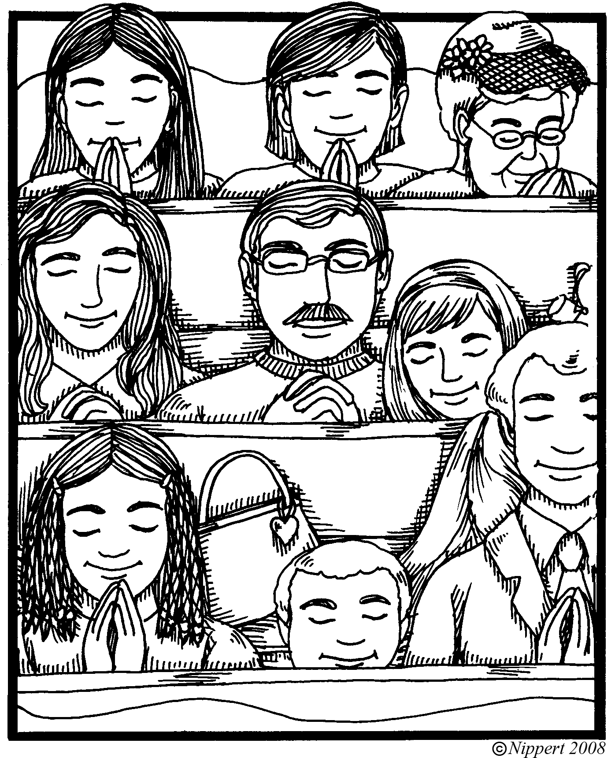
Since example is more powerful than words, parents are urged to:
- provide an atmosphere of prayer in the home
- promote Saturday/Sunday Mass as a family
- encourage frequent reception of Penance and Eucharist
- model Catholic ethics and gospel charity within and outside of the family
- attend sacramental-preparation workshops
- reinforce the catechist’s work by seeing that their children arrive on time for class and by supervising study and written assignments
- participate in activities sponsored by PREP
- read emails in a timely manner or check website
- support the code of acceptable behavior and dress
- observe the arrival and dismissal routine
- notify the PREP office and individual catechist about special learning needs of their children; absences and emergency lateness; pertinent health and medical information; and change of address, telephone, or other family information. (If moving out of the parish, parents should notify the PREP office and the student records will be forwarded.)

Registration implies commitment to all sessions.

Class Schedules

Monday
Levels 1 to 6 5:10 to 6:30 p.m.
Level 7 (Confirmation) 5:10 to 6:30 p.m.
Level 7classes meet the first Monday of the month.

Tuesday
Levels 1 to 6 6:10 to 7:30 p.m.
Lower Level Initiation 6:10 to 7:30 p.m.
Upper Level Initiation 6:10 to 7:30 p.m.
Level 7 (Confirmation) 6:10 to 7:30 p.m.
Level 7 classes meet weekly for 7 weeks Beginning in January and once before receiving the Sacrament of Confirmation.

Sunday
Levels 1 to 6 8:45 to 10:20 a.m.
classes meet once a month – Parents teach at home during the rest of the month and students test per catechist instructions
Level 7 – Confirmation 8:45 to 10:20 a.m
classes meet monthly with work completed at home during the month

Day of class will be chosen at registration. Once a class is full, it is no longer available. Every child is registered for each new PREP year (see Re-Registration). Class changes can be made until August 15 if space is available.

Monthly Sunday registration must be completed before September 1.
IF WEEKLY REGISTRATION IS COMPLETED after September 1, you child(ren) will start September 26 or 27.

Student Responsibilities

The communication of religious truths needs an atmosphere of love and trust so that each child may have a fulfilling experience of faith. For this experience to take place, mutual respect is imperative. Student responsibilities for creating this atmosphere include:
- respectful attitude and speech to teachers and fellow students at all times;
- cooperation in classroom and program projects;
- reverent attention to and participation in prayer services and teaching component;
- punctuality, preparedness (e.g., bringing textbook, completing homework), study, attentiveness (e.g., no gum chewing), appropriate dress (e.g., no hats on boys or girls in the building, no inappropriate clothing (e.g. pajama bottoms, no rollerblade sneakers , no cleats, ), and responsibility (e.g., caring for books and property of other students who use the same classroom and for school property).
- Use of cell phones, or other electronic devices, is NOT permitted during class time, unless requested by the teacher.

Absentee/ Lateness Policy

Students are expected to attend all classes in a given academic year. Given the fact that unforeseen circumstances arise, the following policy has been instituted:
- A written note from the parent is required to explain all absences for Levels 1—7. Catechists will assign make up work, which parents are responsible for having children complete and turn in by the next class.
Monday and Tuesday classes:
- Three (3) absences = parent/child meeting with the DRE plus a grade level appropriate make–up assignment.
- Four (4) absences = a warning to parent that their child may be dismissed for the program for the remainder of the year if absences continue (case-by-case review of situation).
- Five (5) absences = parent/child meeting with DRE; child dismissed from the program; parents finish year at home and schedule child for testing in the PREP office by August before the child can advance to the next grade level.
Sunday Classes:
Absences for Sundays are not allowed; however, we do understand there are circumstances out of our control. One absence with good reason will be accepted. If a child misses more than one class for Sundays during the PREP year, your entire family will no longer be eligible to register for the Sunday PREP classes going forward. You will have to register for Monday or Tuesday. Your child is also responsible for making up the work however their catechist seems fit, i.e. make up lesson of the day, project, service time, etc,

Late arrivals and early dismissals are disruptive to the rhythm of each class. Parents are encouraged to be on time and to keep their children in class for the full time. Extenuating circumstances will be taken into account. The Absentee Policy includes lateness and early dismissals as follows:
Three( 3) late arrivals/early dismissals = one (1) absence (refer to policy above).
Children arriving late (5 minutes or more after the designated start time ) will be given a late slip at the lobby desk to take to class with them and give to the catechist.
Children dismissing early (not more than 15 minutes) should provide their teacher with a Note and will be sent the PREP Office for pick-up.

Arrival

Students who arrive at their classrooms before their teacher should wait quietly in the hallway outside the classroom until the teacher arrives. No student is permitted in any classroom without a teacher.
Monday and Tuesday classes enter through the Main Doors of the Education Center (school).
Sunday classes enter through the Parish Meeting Center doors (behind the school).

Attendance
- To derive the maximum benefit from classroom activities and formal instructions, students should strive for punctual and consistent attendance. According to policy, candidates preparing to receive a Sacrament (Penance, Eucharist, Confirmation) must have had at least two (2) years of religious education immediately preceding the reception of the Sacrament. It is strongly recommended that Three (3) absences = parent/child meeting with the DRE plus a grade level appropriate make–up assignment.
- Four (4) absences = a warning to parent that their child may be dismissed for the program for the remainder of the year if absences continue (case-by-case review of situation).
- Five (5) absences = parent/child meeting with DRE; child dismissed from the program; parents finish year at home and schedule child for testing in the PREP office by August before the child can advance to the next grade level.
- If child (children) exceeds the allotted absences your child will have to repeat that grade level.
Time is a gift we value greatly, and we are therefore challenged to make the most of the limited time we do have with your children. We ask you to help your children arrange their extracurricular activities around the instructional time scheduled for PREP classes. (see Absentee/Lateness Policy).
Please discuss with the Director of Religious Education any difficulties or hardships your family may have.
Bullying
Bullying involves actions or words against another for the purpose of inflicting physical or emotional harm or discomfort or damage to a person’s reputation that is intimidating or threatening and affects the learning environment. If bullying is threatening harm, a student should tell a catechist, adult volunteer and/or the Director of Religious Education immediately. Bullying in any form may result in a student being suspended for in-person instruction for the remainder of the year.
Calendar
A calendar with class dates is available on the PREP Website and at the end of this booklet.

Change of Address or Phone Number OR email

We would appreciate your notifying the PREP office as well as the Parish Offices of a change of address or telephone number as soon as is possible.

Class Cancellations

In the event of inclement weather, an announcement will be posted on the PREP website and an email will be sent (if you are not receiving PREP emails, please email PREP@stjosephrc.org and you will be added to our list).
Please do not call the Parish Offices or School. If Downingtown school district closes or dismisses early due to inclement weather, PREP classes for that day will be canceled automatically.

Class Location

First floor: Rooms 101 through 112
Second floor: Rooms 201 through 222 (see MAP towards the end of the Handbook).

Communications

Thorough communication between parents and the program is extremely important to the achievement of our collaborative goals. Avenues of communication used to inform parents of major happenings may take one of the following forms:
- information will be posted on our website
- emails to parents (if you are not currently receiving emails please email PREP@stjosephrc.org to be added to our list). If you do NOT have internet capability, please notify the PREP office in writing. Hard copies will be available for you to pick-up in the PREP Office.
- notices in the parish’s weekend bulletin
- informational meetings
Parents should check their child’s folder weekly for important notices and homework assignments. Occasionally, a teacher may feel the need to contact a parent. Teacher-/parent communication is encouraged to resolve troublesome issues, and teachers have been encouraged to involve parents at the earliest sign of a problem. Parents are encouraged to contact the DRE any time a question or concern arises.

CONFESSION

Sunday classes Level 3 and Up in Advent and Level 2 and Up in Lent are required to attend a prep confession as a class on a Monday or Tuesday during advent and lent. The teacher will pick the date the class will attend together. This is required of the Sunday classes in addition to once -a-month class.

Damage

Children are expected to respect the personal property of the classroom in which they meet and the desk to which they are assigned. There is no need for children to touch anything inside another’s desk … or items hanging in the halls.
Parents will be required to pay for any damage caused by their child.

Discipline

Good conduct is expected from every child who is attending PREP. A disruption is unfair to both the teacher and the other students. Serious breaches of conduct, such as constant interruptions of the class, destruction of property, bullying etc., are cause for a child to be dismissed from class and sent to the DRE. Parents will be notified of the situation and perhaps further disciplinary action may be needed.

Dismissal

All children in the kindergarten, Level 1, Level 2 must be picked up by a parent on Sunday’s. Monday’s and Tuesday’s dismissal will be from the cafeteria for all students. One parent must pick up child(ren) If an adult other than a parent is picking up the child, the teacher must be notified in writing. Your cooperation in adhering to this dismissal policy is greatly appreciated. CHILDREN SHOULD NEVER WALK INTO THE PARKING LOT ALONE; THEY SHOULD ALWAYS BE ACCOMPANIED BY AN ADULT. MONDAY AND TUESDAY THERE IS NO DISMISSAL TO THE BACK PARKING LOT.

Early Dismissal

Early dismissal should be considered an unusual occurrence (if 3 early dismissals are accrued, the student will receive ONE absence). In the event that an early dismissal is necessary, the following procedure must be followed: Send a note to the teacher so that your child may be sent to the office at the correct time. The parent must meet the child in the PREP office (second floor). No exceptions. (see Absentee/Lateness Policy)

home Assignments

As part of the students’ religious education, homework will be required for Levels 1 to 7. Each teacher will notify the students. As parents, your cooperation in this matter is expected so that the child will finish homework on time. We urge you to show your interest in your child’s religious education by discussing throughout the week the material covered in class. There is a designated section for you to read and discuss with your child. Please use this section as often as you can to reinforce classroom instruction.

Learning Challenges; Health Concerns

Please help us help your child by alerting the PREP Coordinator to any special learning challenges your child has. Your child participates in an academic situation while here. Please help us to assist your child in the best way possible. Please let the teacher and the office know in writing.We want to support each student in the way that is best for him or her. If your child has any medical conditions of which we should be aware (e.g., bee-sting allergies), as with learning challenges, please let the teacher and the office know in writing. Also provide a cell-phone number and email address if possible for the office to have on file.

Parking Lot

Extreme care must be used in our busy lot. Watch out for all of our children. Always exercise care in the parking lot. Do not park in the bus/fire lane in front of school or in the handicapped parking unless appropriate. The bus lane may be used before a PREP session dropping-off children only. If you are walking your child(ren) in, you MUST park in a parking space. At pick-up the BUS LANE is NOT to be used at all! Please encourage your child(ren) not to run between, around, in front of, or behind other parked cars. Please be mindful of moving vehicles at any time of the day. Also, please do not park in the driveway at the end of the building (cafeteria side) or in the driveway in front of the Church. Thank you for your cooperation.

Progress reports (Level 1 through 7)

As in all formal educational processes, the students will be tested on the material taught. Testing can occur in a number of different ways (written, oral, etc.). Progress reports will be issued three (3) times during the year for Monday / Tuesday classes and two (2) during the year for Sunday classes to children in Levels 1 through 7. Teachers will give the progress reports directly to the students. Parents are to read, sign, and return to the classroom the following week the first two progress reports. They may keep the final report.

Re-registration
You re-register for PREP classes each spring. In this way we are able to update our records, attend to class changes, etc. Once in the program, you will be notified of re-registration each spring. Register online as soon as possible. If you are volunteering your children are placed during the session you volunteer, unless you indicate otherwise. Registration is handled on a first come, first placed; being in a session is NOT automatic. Some grade levels in some sessions fill up the first week of registration.

kindergarten program

Kindergarten: This program provides children with the means to participate in the worship of God at a level they can appreciate and understand. Thus, they come to know God during these impressionable and formative years.The kindergarten program is designed to open children to God’s love through a discovery of the many good things he has placed in their world.

Levels 1, 3, 4, 5, 6
Christ In Us series, William H. Sadlier, Inc.
Level 1: Children are introduced to God the Father, Son, and Holy Spirit. They discover the beauty of God’s world and begin to think of God in a personal way as they come to realize that they are part of God’s family.

Level 3: This year focuses on the child’s identity as a member of the Catholic faith community. It presents key aspects of what it means to be Catholic by teaching discipleship, liturgy and worship, and leadership of the church community.

Level 4: This year aims to help children grow in Christian moral life by living according to the law of love and the Beatitudes. The children discover why God gave us the Commandments and explore ways to be more just and peaceful in building up God’s kingdom.

Level 5: This year emphasizes the Sacraments, the expression of Christ’s continued love for us, and ways we live out these Sacraments as members of the Catholic Church.

Level 6: This year the students will explore Sacred Scripture helping students become sensitive to God’s presence and his message for our contemporary world and begin preparing to receive the Sacrament of Confirmation.

Level 2 BLESSING from Dynamic Catholic (Reconciliation and Communion): Children learn about the Sacraments, with emphasis on Penance and Eucharist. As they grow more aware of belonging, loving, and being loved, children become more sensitive to sin and the need for forgiveness. They are introduced to the parts of the Mass, the presence of Jesus in the Eucharist, and the partaking of the Eucharist. Children will receive Penance in the winter and Eucharist in the spring.

Level 7 Gifted with the Spirit from PFLAUM

Special Education: Each child will learn to love God according to his or her level of development. Please discuss your child and his/her needs with our program director.
Prayer

Archdiocesan guidelines require that prayer memorization be part of the religious education curriculum. Prayer memorization for grade Levels 1 to 6 is worked on at home. A prayer sheet with the required prayers will be sent home. Below is a list of the prayers children in each grade must memorize.

Prayers We Cherish and Commit to Memory

Level 1
Sign of the Cross
Our Father
Hail Mary
Glory Be to the Father

Level 2
Act of Contrition
Form of Confession

Level 3
Levels 1-2 prayers
Apostles’ Creed & Morning Offering
Level 4
Levels 1-3 prayers
Hail, Holy Queen
The Rosary

Level 5
Levels 1-4 prayers
Prayers at Mass
The Angelus

Level 6
Levels 1-5 prayers
Acts of Faith, Hope, and Love

Level 7
Levels 1-6 prayers
Come, Holy Spirit

PREP Office (610) 873-8798

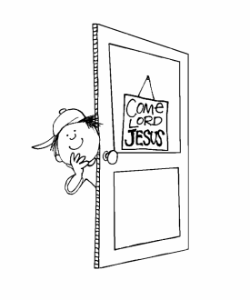
The PREP office is on the second of floor of the parish school. An adult volunteer will always be in the office during all class sessions.
PREP
Office
Hours during the PREP year (September – May):
Monday and Tuesday: 9 a.m. – 6:30 p.m.
Wednesday and Thursday : 9 a.m. – 2:30 p.m.
Friday, Saturday, Sunday : CLOSED
Summer Hours (June–August):
Monday through Thursday: 9 a.m.—12:00 noon

Safe environment
All volunteers are required to submit to a criminal-record check, a child-abuse clearance, and attend a safe environment session, “Protecting God’s Children,” and Mandated Reporter training (online at: https://childyouthprotection.org/index.php/staff-volunteers/information-for-volunteers) .They also are required to follow the rules and guidelines of the Volunteer’s Code of Conduct.
All children receive age appropriate training in personal safety. Parents will be notified by catechist when the lesson will take place. You can view the KID TALK lessons online at http://phillyocf.org/safe-environment/

Supplies

At the beginning of the year, students in Level 1 through Confirmation class will receive a textbook and folder. Students are required to bring their book and folder with them to every class. A replacement fee ($35) will be charged for lost texts. Pencils, crayons, paper, and other supplies are provided for each student as needed. If you prefer, you can supply your own.

Works of Mercy
Each grade level will be involved in various outreach projects during the year.
Separate communications about these efforts will be sent home with the students

volunteering

PREP is able to maintain a high level of performance because of the exemplary work of volunteer lay men and women, who are an intrinsic part of this organization. However, to remain at a high level, our organization must always seek to improve its operation and to bring in new, enthusiastic people willing to sacrifice time to further the work. You can help in many ways, all of which are important. Please contact the office to see how your gifts can be used. Thank you.
Prayers

Sign of the Cross
In the name of the Father, and of the Son, and of the Holy Spirit. Amen

Our Father
Our Father, who art in heaven, hallowed by thy Name; thy kingdom come; thy will be done on earth as it is in heaven. Give us this day our daily bread; and forgive us our trespasses as we forgive those who trespass against us; and lead us not into temptation, but deliver us from evil. Amen

Hail Mary
Hail Mary, full of grace, the Lord is with you; blessed are you among women and blessed is the fruit of your womb, Jesus. Holy Mary, Mother of God, pray for us sinners now and at the hour of our death. Amen

Glory Be to the Father (Doxology)
Glory be to the Father, and to the Son, and to the Holy Spirit; as it was in the beginning, is now, and ever shall be, world without end. Amen

Apostles’ Creed
I believe in God, the Father almighty, Creator of heaven and earth,
and in Jesus Christ, his only Son, our Lord, who was conceived by the Holy Spirit, born of the Virgin Mary, suffered under Pontius Pilate, was crucified, died and was buried;
he descended into hell; on the third day he rose again from the dead;
he ascended into heaven, and is seated at the right hand of God the Father almighty;
from there he will come to judge the living and the dead.
I believe in the Holy Spirit, the holy catholic Church,
the communion of saints, the forgiveness of sins,
the resurrection of the body, and life everlasting. AMEN.

Grace Before Meals
Bless us, O Lord, and these your gifts, which we are about to receive from your bounty, through Christ our Lord. Amen

An Act of Faith
O my God, I firmly believe that you are one God in three divine Persons, Father, Son, and Holy Spirit; I believe that your divine Son became man, and died for our sins, and that he will come to judge the living and the dead. I believe these truths which the holy Catholic Church teaches, because you have revealed them, who can neither deceive nor be deceived. Amen

An Act of Hope
O my God, relying on your infinite goodness and promises, I hope to obtain pardon of my sins, the help of your grace, and life everlasting, through the merits of Jesus Christ, my Lord and Redeemer. Amen

An Act of Love
O my God, I love you above all things, with my whole heart and soul, because you are all-good and worthy of all my love. I love my neighbor as myself for the love of you. I forgive all who have injured me, and I ask pardon of all whom I have injured. Amen

The Angelus
The angel of the Lord declared to Mary and she conceived by the Holy Spirit. Hail Mary . .
Behold the handmaid of the Lord, be it done to me according to your word. Hail Mary . . .
And the Word was made Flesh. And dwelled among us. Hail Mary . . .
Pray for us, O Holy Mother of God, that we may be worthy of the promises of Christ.
Let us pray: Pour forth, we beseech you, O Lord, your grace into our hearts that we to whom the incarnation of Christ your Son was made known by the message of an angel may, by his passion and cross, be brought to the glory of his resurrection, through Christ our Lord. Amen

Come, Holy Spirit
Come Holy Spirit, fill the hearts of your faithful and kindle in them the fire of your love. Send forth your Spirit and they shall be created. And You shall renew the face of the earth. Amen



The Mysteries of the Rosary

The Joyful Mysteries
The Annunciation
The Visitation
The Birth of Jesus
The Presentation of Jesus in the Temple
The Finding of Jesus in the Temple

The Sorrowful Mysteries
The Agony in the Garden
The Scourging at the Pillar
The Crowning with Thorns
The Carrying of the Cross
The Crucifixion and Death of Jesus

The Luminous Mysteries

Jesus’ Baptism in the Jordan
The Miracle at the Wedding at Cana
The Proclamation of the Kingdom of God
The Transfiguration
The Institution of the Eucharist

The Glorious Mysteries
The Resurrection
The Ascension
The Descent of the Holy Spirit upon the Apostles
The Assumption of Mary into Heaven
The Coronation of Mary in Heaven

Hail, Holy Queen
Hail, Holy Queen, Mother of Mercy; hail, our life, our sweetness, and our hope! To you do we cry, poor banished children of Eve; to you do we send up our sighs, mourning and weeping in this valley of tears. Turn, then, most gracious advocate, your eyes of mercy toward us; and after this our exile, show unto us the blessed fruit of your womb, Jesus.
O clement, O loving, O sweet Virgin Mary
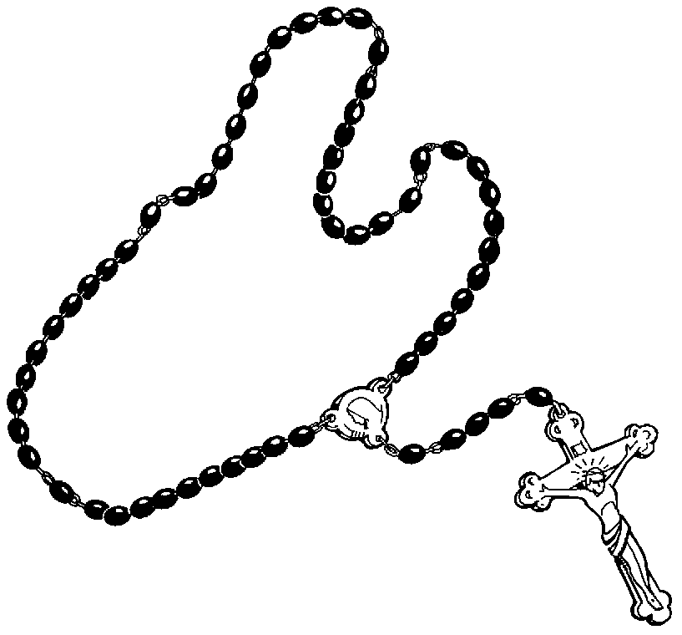

St Joseph Parish Education Center & Parish Meeting Center

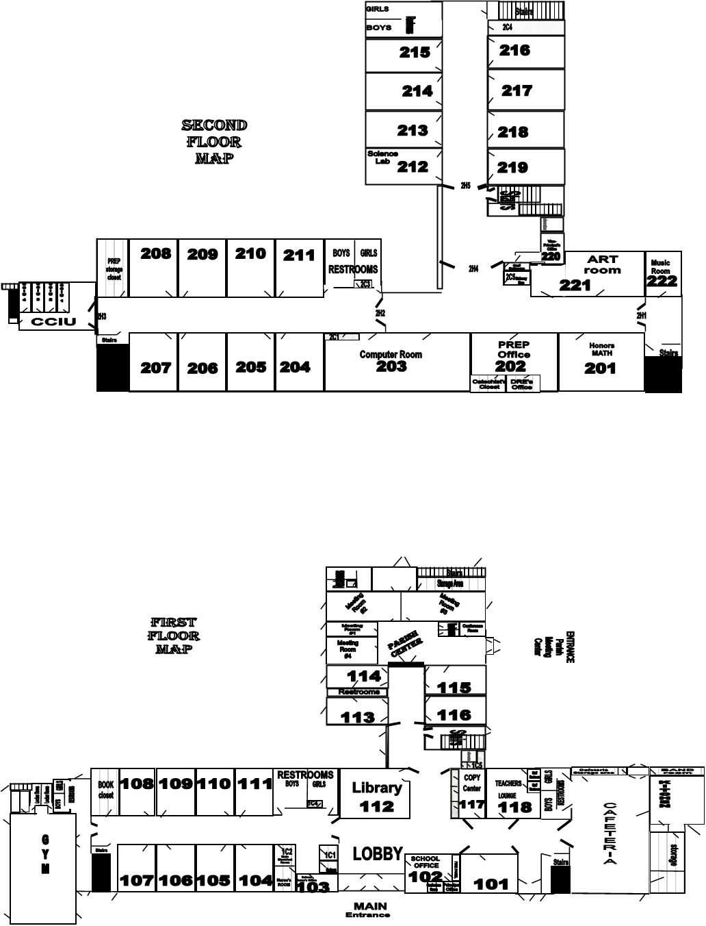

Please keep this handbook in a
convenient place so that you can
refer to it throughout the year.



Published by
St. Joseph PREP
Downingtown, PA
2025

