**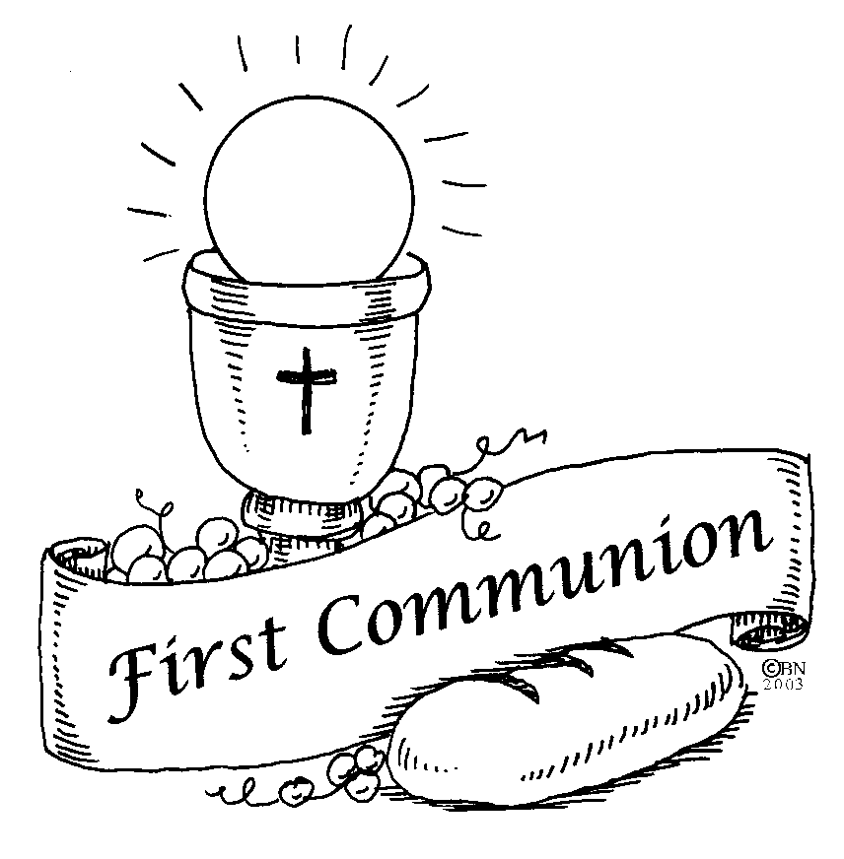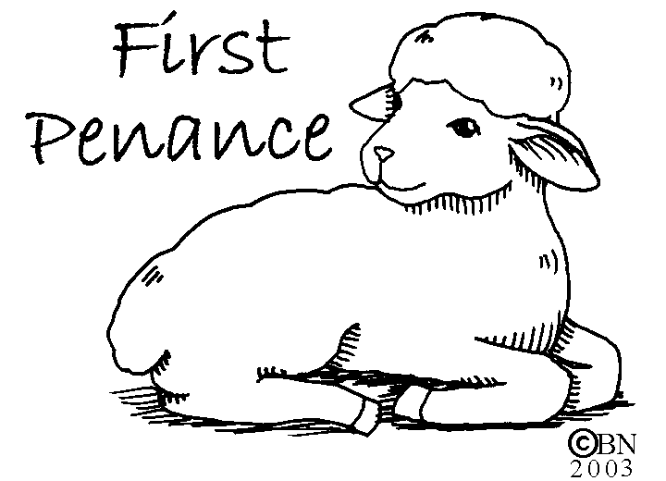 First Penance/First Communion Packet**

**Date due to your child’s teacher: Week of December 1st**

**Child’s Name:**\_\_\_\_\_\_\_\_\_\_\_\_\_\_\_\_\_\_\_\_\_\_\_\_\_\_\_\_\_\_\_\_\_\_\_\_\_\_\_\_\_\_\_\_\_\_\_\_\_\_

Check One: St. Joseph School \_\_\_\_ PREP \_\_\_\_ Home \_\_\_\_ Private \_\_\_\_

Teacher:\_\_\_\_\_\_\_\_\_\_\_\_\_\_\_\_\_\_\_\_\_\_\_\_\_\_\_\_\_\_\_\_\_\_\_\_\_ Classroom #: \_\_\_\_\_\_\_

(St. Joseph PREP or St. Joseph School teacher)

Checklist:

1. \_\_\_\_\_ Information sheet for Sacrament Register
2. \_\_\_\_ Copy of Baptism certificate
3. \_\_\_\_\_ Letter to Child for First Reconciliation
4. \_\_\_\_\_ Prayer Support Sheet
5. \_\_\_\_\_ Photo/Video Policy during Communion Mass
6. \_\_\_\_\_ $65.00 for supplies (certificates, DVD, Scapular, etc.)

check payable to: St. Joseph

\_\_\_\_\_ (if applicable) First Communion Mass Volunteer Form

\_\_\_\_\_ (if applicable) Altar Server Form

\_\_\_\_\_ (if applicable) Visiting Clergy Form

\_\_\_\_\_ (if applicable) Handicap Seating

~~~~~~ ~~~~~~ ~~~~~~ ~~~~~~~ ~~~~~~ ~~~~~~ ~~~~~~

Dear Families,

Your Sacrament packet contains very important information and dates for the coming year. Please keep it in a safe location and refer to it often.

The six (6) required elements, listed above, and any other applicable forms, **must be returned** to your child’s teacher the **week of December 1, 2025.**

Thank you for all you are doing to prepare your child to receive the Sacraments of Reconciliation and Eucharist.

Father Rodgers

Sister Lisa Golden, IHM

Mrs. Kathleen Greco, DRE

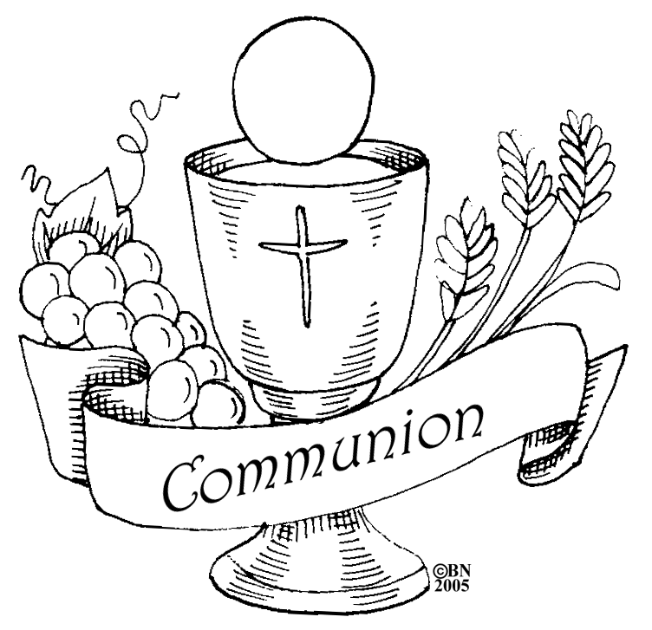 **INFORMATION FOR FIRST COMMUNION REGISTER**

It is important to provide complete and accurate information. Thank you.

**Name \_\_\_\_\_\_\_\_\_\_\_\_\_\_\_\_\_\_\_\_\_\_\_\_\_\_\_\_\_\_\_\_\_\_\_\_\_\_\_\_\_\_\_**

(*Baptismal Name*) First Name Middle Name Last Name

**Place of Birth \_\_\_\_\_\_\_\_\_\_\_\_\_\_\_\_\_\_\_\_\_\_\_\_\_\_\_\_\_\_\_\_\_\_\_\_\_**

From Birth Certificate: City, State

**Date of Birth \_\_\_\_\_\_\_\_\_\_\_\_\_\_\_\_\_\_**

Month Day Year

**Age (**at time of First Communion**)\_\_\_\_\_\_\_\_\_\_\_\_\_\_**

**Catholic**

Please provide, attach,

a copy of Baptismal

certificate.

As with all Sacraments of Initiation, the information is

sent to your

Church of Baptism after the sacrament is received.

**Church of BAPTISM\_\_\_\_\_\_\_\_\_\_\_\_\_\_\_\_\_\_\_\_\_\_\_\_\_\_\_\_\_\_\_\_\_\_\_\_\_\_\_\_\_**

(or Catholic Church of Profession of Faith)

**Church’s street address\_\_\_\_\_\_\_\_\_\_\_\_\_\_\_\_\_\_\_\_\_\_\_\_\_\_\_\_\_**

**City\_\_\_\_\_\_\_\_\_\_\_\_\_\_\_\_\_\_\_ State \_\_\_\_\_\_ Zip Code\_\_\_\_\_\_\_**

**Date of Baptism\_\_\_\_\_\_\_\_\_\_\_\_\_\_\_\_\_**

Month Day Year

**Home Address \_\_\_\_\_\_\_\_\_\_\_\_\_\_\_\_\_\_\_\_\_\_\_\_\_\_\_\_\_\_\_\_\_\_\_\_**

**\_\_\_\_\_\_\_\_\_\_\_\_\_\_\_\_\_\_\_\_\_\_\_\_\_\_\_\_\_\_\_\_\_\_\_\_\_\_**

**Primary Telephone # \_\_\_\_\_\_ \_\_\_\_\_\_\_\_\_\_\_\_\_\_\_\_\_\_\_\_\_\_**

Please circle: HOME Phone CELL Phone WORK Phone OTHER \_\_\_\_\_\_\_\_\_\_\_\_\_\_\_\_\_\_\_\_\_\_

**Family email: \_\_\_\_\_\_\_\_\_\_\_\_\_\_\_\_\_\_\_\_\_\_\_\_\_\_\_\_\_\_\_\_\_\_\_\_\_**

**Parents: Father’s Name \_\_\_\_\_\_\_\_\_\_\_\_\_\_\_\_\_\_\_\_\_\_\_\_\_\_\_\_\_\_\_**

First Name Middle Name Last Name

**Mother’s Maiden Name \_\_\_\_\_\_\_\_\_\_\_\_\_\_\_\_\_\_\_\_\_\_\_\_\_\_\_\_\_\_**

First Name Middle Name ***Maiden*** Name

Does your child have a gluten allergy? \_\_\_YES \_\_\_No Thank you

Dear Parents,

I am asking you to write a letter to your child. In the letter please say something about his/her preparation for the reception of the **Sacrament of Reconciliation**. Also include a few words about forgiveness in your family. Close the note with a short personal message for your child.

Please remember to print if your child has not yet mastered reading script. Please return the **note**, in an **envelope** with your **child’s first and LAST name** on it, with the Reconciliation **packet** due back to your child’s teacher the **week of December 1st.** You may use the note paper below if you like by simply cutting on the dotted line or use your own paper.

The letter will be given to your child in their certificate envelope when they receive the Sacrament of Reconciliation.

Sincerely,

Kathleen Greco, DRE

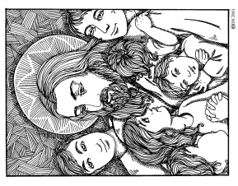

Let the little Children come to me.

(Matthew 19:4)

Let the little children come to me.

bd07798_**First Reconciliation and First Holy Communion**

**Prayer Support**

**Child’s Name: \_\_\_\_\_\_\_\_\_\_\_\_\_\_\_\_\_\_\_\_\_\_\_\_\_\_\_\_\_\_\_\_\_\_\_\_\_\_\_\_\_**

**Parent/Guardian Name(s): \_\_\_\_\_\_\_\_\_\_\_\_\_\_\_\_\_\_\_\_\_\_\_\_\_\_\_\_\_\_**

**\_\_\_\_\_\_\_\_\_\_\_\_\_\_\_\_\_\_\_\_\_\_\_\_\_\_\_\_\_\_\_**

Prayer support from all members of our Parish family is so necessary if we are to be guided by the Holy Spirit in following the directives and norms for catechetical and liturgical practices set down by the Church for the reception of the Sacraments of Reconciliation and Eucharist. Therefore, we are asking each child to secure the promise of prayer and sacrifice from *at least* five (5) confirmed Catholics. When they agree to support you by remembrance in their prayers, ask them to sign this paper for you**.** If someone is from out of town, you may fill in the information yourself.

I, \_\_\_\_\_\_\_\_\_\_\_\_\_\_\_\_\_\_\_\_\_\_\_\_\_\_\_\_\_\_\_\_\_\_\_\_\_\_, promise to support\_\_\_\_\_\_\_\_\_\_\_\_\_\_\_\_\_\_\_\_\_\_\_\_\_\_\_\_\_ by prayer and sacrifice during her/his preparation period for First Reconciliation and First Holy Communion.

I, \_\_\_\_\_\_\_\_\_\_\_\_\_\_\_\_\_\_\_\_\_\_\_\_\_\_\_\_\_\_\_\_\_\_\_\_\_\_, promise to support\_\_\_\_\_\_\_\_\_\_\_\_\_\_\_\_\_\_\_\_\_\_\_\_\_\_\_\_\_ by prayer and sacrifice during her/his preparation period for First Reconciliation and First Holy Communion.

I, \_\_\_\_\_\_\_\_\_\_\_\_\_\_\_\_\_\_\_\_\_\_\_\_\_\_\_\_\_\_\_\_\_\_\_\_\_\_, promise to support\_\_\_\_\_\_\_\_\_\_\_\_\_\_\_\_\_\_\_\_\_\_\_\_\_\_\_\_\_ by prayer and sacrifice during her/his preparation period for First Reconciliation and First Holy Communion.

I, \_\_\_\_\_\_\_\_\_\_\_\_\_\_\_\_\_\_\_\_\_\_\_\_\_\_\_\_\_\_\_\_\_\_\_\_\_\_, promise to support\_\_\_\_\_\_\_\_\_\_\_\_\_\_\_\_\_\_\_\_\_\_\_\_\_\_\_\_\_ by prayer and sacrifice during her/his preparation period for First Reconciliation and First Holy Communion.

I, \_\_\_\_\_\_\_\_\_\_\_\_\_\_\_\_\_\_\_\_\_\_\_\_\_\_\_\_\_\_\_\_\_\_\_\_\_\_, promise to support\_\_\_\_\_\_\_\_\_\_\_\_\_\_\_\_\_\_\_\_\_\_\_\_\_\_\_\_\_ by prayer and sacrifice during her/his preparation period for First Reconciliation and First Holy Communion.

Thank you,

Mrs. Kathleen Greco, DRE

**Guidelines for Photographs and Videos**

The reception of a sacrament is a precious and holy moment in the life of your child. In order to safeguard a sacred atmosphere in the Church during the First Holy Communion liturgy, the parish has hired *Bradley Digital* to videotape the entire liturgy. There is **NO** picture taking or videotaping during the liturgy. **The family of each First Communicant receives a video download**.

*Bradley Digital* will also photograph the actual moment of your child’s first reception of Jesus. In addition to this keepsake, *Bradley Digital* offers professional still portraits at a sitting prior to First Communion. Families are able to review this photograph as well as other candid photographs of the liturgy within 48-72 hours. For your convenience, *Bradley Digital* provides a secure, password protected photo gallery website to view these photographs. There is no obligation to purchase the photograph(s). Bradley Digital will provide a flyer with complete information.

Please read and sign the information below. Return this form with the paperwork for First Holy Communion to your child’s teacher or the Religious Education Office by the week of December 1, 2026.

**            **

MCj04242260000[1]

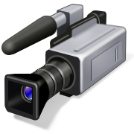**Photo/Video Policy during First Holy Communion Mass**

**May 9, 2026**

**St. Joseph**

**460 Manor Ave., Downingtown, PA 19335**

I understand that photographs and videos during the First Communion liturgy may not be taken. At no time am I or any family member permitted to leave our seats to take photos or record videos.

I give *Bradley Digital* permission to photograph and videotape my child during the First Communion liturgy. I understand that the photograph(s) of my child will be posted at a secure website provided by *Bradley Digital* and there is no obligation to purchase this photograph(s).

Name of Child \_\_\_\_\_\_\_\_\_\_\_\_\_\_\_\_\_\_\_\_\_\_\_\_\_\_\_\_\_\_\_\_\_\_\_\_\_\_\_\_\_\_\_\_\_\_\_\_\_\_\_\_\_\_\_\_\_

(Please Print)

Name of Parent(s)/Guardian(s)\_\_\_\_\_\_\_\_\_\_\_\_\_\_\_\_\_\_\_\_\_\_\_\_\_\_\_\_\_\_\_\_\_\_\_\_\_\_\_\_\_\_

(Please Print)

Signature of Parent(s)/Guardian(s)\_\_\_\_\_\_\_\_\_\_\_\_\_\_\_\_\_\_\_\_\_\_\_\_\_\_\_\_\_\_\_\_\_\_\_\_\_\_\_\_\_

Date\_\_\_\_\_\_\_\_\_\_\_\_\_\_\_\_\_\_\_\_\_\_\_\_\_

**First Holy Communion Mass Volunteer Form**

May 9, 2026

Volunteer’s Name:\_\_\_\_\_\_\_\_\_\_\_\_\_\_\_\_\_\_\_\_\_\_\_\_\_\_\_\_\_\_\_\_

1st Communicant’s Name: \_\_\_\_\_\_\_\_\_\_\_\_\_\_\_\_\_\_\_\_\_\_\_\_\_\_\_\_\_\_

Volunteer’s Phone Number: \_\_\_\_\_\_\_ \_\_\_\_\_\_\_\_\_\_\_\_\_\_\_\_\_\_\_\_\_\_\_

****

* **Parents are needed to be greeters at the Communion liturgies. If you can help, please check off one:**

(Greeter’s will arrive early and have a family member reserve a seat for them, and then they will go to the doors of the Church and distribute Mass booklets)

\_\_\_ 9:30 a.m. Mass \_\_\_ 12:00 noon Mass

****

* **If you are currently a lector at St. Joseph Parish and would like to volunteer at your child’ s Mass, please check off one :**

(Lector’s have ½ pew of reserved seating)

\_\_\_ 9:30 a.m. Mass \_\_\_ 12:00 noon Mass

* **If you are currently an Extraordinary Minister of the Eucharist at St. Joseph Parish and would like to volunteer at your child’ s Mass, please check off one :**

(Please understand, EMs are only used to help with distribution to the congregation if there are not enough clergy at the Mass, you will be contacted if you are needed.)

\_\_\_ 9:30 a.m. Mass \_\_\_ 12:00 noon Mass

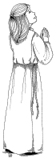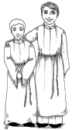**Altar Server – First Holy Communion Mass**

**May 9, 2026**

**If your child has a sibling who is an altar server and would like to volunteer at your child’s Mass, please check off one:**

\_\_\_ 9:30 a.m. Mass \_\_\_ 12:00 noon Mass

Server’s Name: \_\_\_\_\_\_\_\_\_\_\_\_\_\_\_\_\_\_\_\_\_\_\_\_\_\_\_\_\_\_\_\_\_\_\_\_\_

1st Communicant’s Name: \_\_\_\_\_\_\_\_\_\_\_\_\_\_\_\_\_\_\_\_\_\_\_\_\_\_\_\_\_\_

Server’s Phone Number:\_\_\_\_\_\_\_ \_\_\_\_\_\_\_\_\_\_\_\_\_\_\_\_\_\_\_\_\_\_\_

*Please understand this only a request to serve. You will be contacted if you services are needed. Thank you for volunteering.*

**Visiting Clergy**

**(Priests and Deacons)**

**May 9, 2026**

If a family member or friend will be participating in the liturgy, may we please have:

**Clergy’s Name:\_\_\_\_\_\_\_\_\_\_\_\_\_\_\_\_\_\_\_\_\_\_\_\_\_\_\_\_\_\_**

**Clergy’s Address:\_\_\_\_\_\_\_\_\_\_\_\_\_\_\_\_\_\_\_\_\_\_\_\_\_\_\_\_**

**\_\_\_\_\_\_\_\_\_\_\_\_\_\_\_\_\_\_\_\_\_\_\_\_\_\_\_\_\_\_\_\_\_\_\_**

**Clergy’s Phone #:\_\_\_\_\_\_\_\_\_\_\_\_\_\_\_\_\_\_\_\_\_\_\_\_\_\_\_\_**

**Clergy’s email address: \_\_\_\_\_\_\_\_\_\_\_\_\_\_\_\_\_\_\_\_\_\_\_\_**

\_\_\_ 9:30 a.m. Mass \_\_\_ 12:00 noon Mass

1st Communicant’s Name: \_\_\_\_\_\_\_\_\_\_\_\_\_\_\_\_\_\_\_\_\_\_\_\_\_\_\_\_\_\_

First Penance

Basic Prayer & Knowledge Checklist

This form is to be filled out by a parent/guardian and returned to the child’s teacher, or the PREP Office or emailed to the child’s teacher, the week of January 7, 2025.

\_\_\_\_\_\_\_\_\_\_\_\_\_\_\_\_\_\_\_\_\_\_\_\_\_\_\_\_\_\_\_\_\_has prepared for the Sacrament of Reconciliation (name)

by studying basic elements of our Faith and the sacrament itself. My child has also learned some basic prayers and is familiar with the form for confession.

**Basic Prayers Steps for Confession**

\_\_\_\_\_ Sign of the Cross \_\_\_\_\_ Examine conscience

\_\_\_\_\_ Our Father \_\_\_\_\_ Confess sins

\_\_\_\_\_ Hail Mary \_\_\_\_\_ Penance given

\_\_\_\_\_ Glory Be to the Father \_\_\_\_\_ Act of Contrition

\_\_\_\_\_ Act of Contrition \_\_\_\_\_ Absolution

\_\_\_\_\_ Do penance given

**Form for Confession**

**\_\_\_\_\_** Greeting the priest

\_\_\_\_\_ Make Sign of the Cross

\_\_\_\_\_ “Forgive me, Father, for I have sinned. This is my first confession.”

\_\_\_\_\_ Confess sins

\_\_\_\_\_ “I am sorry for all my sins.”

\_\_\_\_\_ Penance and Absolution given

\_\_\_\_\_ Thank the priest; pray your penance

Signature of Parent/Guardian: \_\_\_\_\_\_\_\_\_\_\_\_\_\_\_\_\_\_\_\_\_\_\_\_\_\_\_\_\_\_\_\_\_\_\_\_\_\_\_\_\_\_\_\_\_\_\_

Date: \_\_\_\_\_\_\_\_\_\_\_\_\_\_\_\_\_\_\_

**Handicap Seating**

**May 9, 2026 First Holy Communion Mass**

If you would like to reserve handicap seating, please know that only two seats will be reserved for each individual requesting this (one for the person needing handicap seating and the second for a person helping them). Please fill out the form below and return it in your child’s sacrament packet envelope.

On the day of your child(ren)’s First Holy Communion, an usher will be near the Baptismal font to help seat those with handicapped seating reservations.

Thank you for your consideration and understanding.



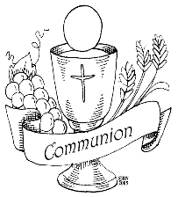

**Handicap Seating**

**May 9, 2026 First Holy Communion Mass**

Person Requiring Seating: \_\_\_\_\_\_\_\_\_\_\_\_\_\_\_\_\_\_\_\_\_\_\_\_\_\_\_\_\_\_\_\_

Does this person?

* Walk with assistance
* Using cane
* Using walker
* Using wheelchair
* Using motorized cart
* Other \_\_\_\_\_\_\_\_\_\_\_\_\_\_\_\_\_\_\_\_\_\_\_\_\_\_\_\_\_\_\_\_\_\_\_\_\_\_\_\_\_

Does this person need to have the Host brought to them at Communion time? YES NO

(please circle one)

Parent(s)/Guardian(s) name: \_\_\_\_\_\_\_\_\_\_\_\_\_\_\_\_\_\_\_\_\_\_\_\_\_

Phone Number: \_\_\_\_\_\_\_ \_\_\_\_\_\_\_\_ - \_\_\_\_\_\_\_\_\_\_\_\_\_\_\_\_\_\_\_\_\_

Email address: \_\_\_\_\_\_\_\_\_\_\_\_\_\_\_\_\_\_\_\_\_\_\_\_\_\_\_\_\_\_\_\_\_\_\_\_\_\_\_\_

First Communicant’s Name: \_\_\_\_\_\_\_\_\_\_\_\_\_\_\_\_\_\_\_\_\_\_\_\_\_\_\_\_\_\_\_\_

\_\_\_ 9:30 a.m. Mass \_\_\_ 12:00 noon Mass

A through L last name M through Z last name

\_\_\_\_\_\_\_\_\_\_\_\_\_\_\_\_\_\_\_\_\_\_\_\_\_\_\_\_\_\_\_\_\_\_\_\_\_\_\_\_\_

(Teacher’s name)