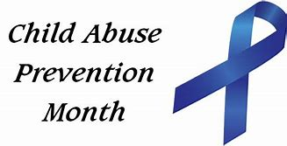

During the month of April, I invite you to wear the symbol of child abuse prevention. In the spring of 1989, a grandmother named Bonnie Finney took a stand against child abuse. She tied a blue ribbon on the antenna of her minivan in remembrance of her late grandson and as a signal to her community that child abuse was a devastating social plague. The symbol has since expanded across the country, and many wear blue ribbons each April in memory of those who have been the victim of child abuse. Please consider accepting this gift and wearing it as a sign of support for those who have been victims and to take a stand against this great sadness.

