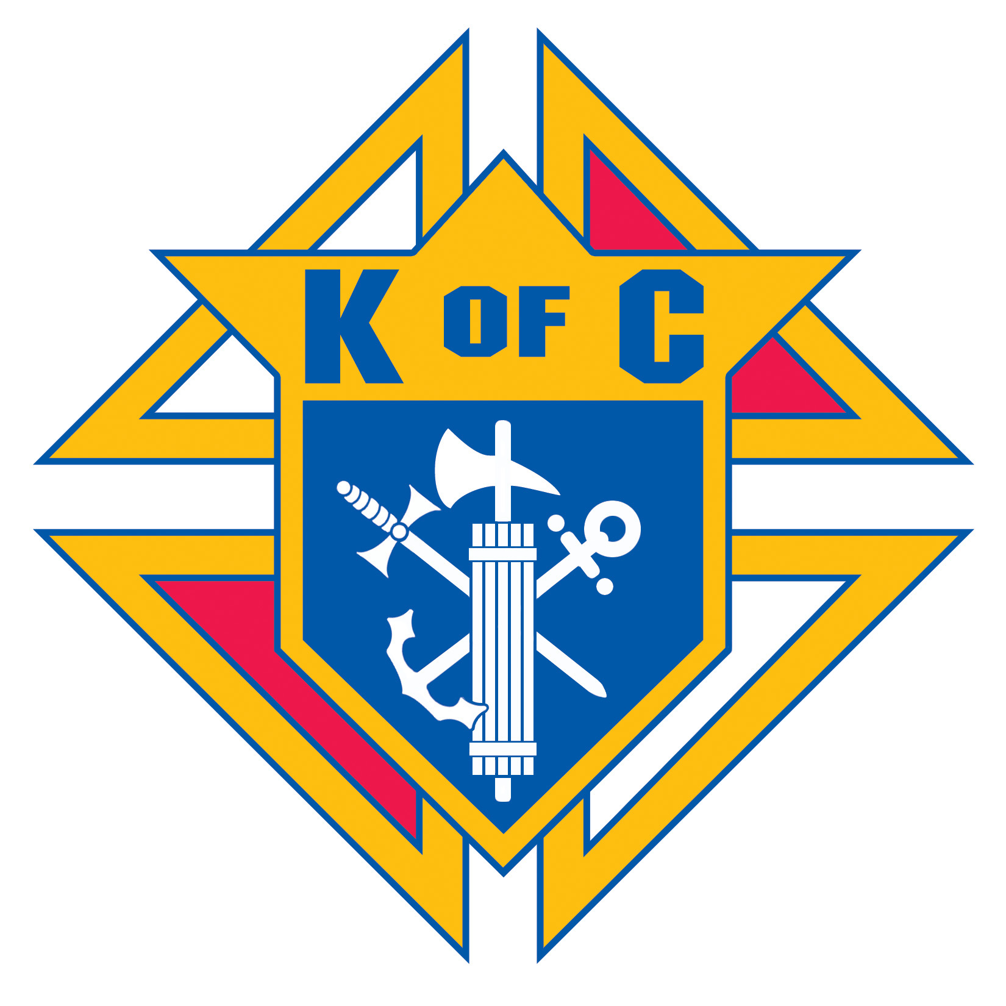

The Simeon Yap Scholarship

A. General information

Our Lady of the Prairie, Knights of Columbus Council #5264 offers an annual scholarship of $1000.00 awarded to a student entering an accredited post secondary educational / training institution (university, college, trade or technical school, etc.) and which leads to a degree or certificate in his/her chosen field.

B. Eligibility

The scholarship is open to a student who is registered, or whose family is registered, as a member of Mary Mother of the Church Parish or who is a son, daughter, or grandchild of a member of The Knights of Columbus, Our Lady of the Prairie Council #5264.

C. Criteria on which the award shall be based

The scholarship shall be based upon academic achievement in grade 12 and extracurricular activities and volunteerism in grades 11 and 12. Faith based activities at Mary, Mother of the Church or the Knights of Columbus shall be taken into account in assessing candidates for the award.

D. Application requirements

- A completed Simeon Yap Scholarship application form.
- High school transcript of courses completed in grade 12.
- Letter of reference from a grade 12 teacher.
- Proof of payment of tuition from the institution you are attending
E. Application Deadline

All applications must be received by the Grand Knight, Our Lady of the Prairie KC Council #5264 by October 1 for the academic year beginning in September.
Our Lady of the Prairie Knights of Columbus Council #5263
Simeon Yap Scholarship
Application Form

1. Personal Information

Name:__________________________________________________________________
Surname Given names

Address:________________________________________________________________
Street

________________________________________________________________
City Province Postal Code

Telephone:__________________________ e-mail___________________________________

2. How do you meet the eligibility requirements as per item “B”?

________________________________________________________________________

3. Extracurricular and volunteer activities. List the extracurricular activities in which you participated in school, in the community or in your church during the past two years. Discuss your specific involvement in these activities.
________________________________________________________________________________________________________________________________________________________________________________________________________________________________________________________________________________________________________________________________________________________________________________________________________________________________________________________________________________________________________________________________________________________________________________________________________________________________________________________________________

4. Faith Based Activities As a practicing Catholic, describe your participation in faith-based activities at Mary, Mother of the Church or other organization.

________________________________________________________________________________________________________________________________________________________________________________________________________________________________________________________________________________________________________________________________________________________________________________________________________________________________________________

5. Enclose a copy of your grade 12 transcript

6. Enclose a letter of reference from a teacher in grade 12. Overview content to include such attributes as participation in class discussions, nature of involvement in extracurricular activities, leadership qualities, work ethics,s consideration for others, etc. Have the teacher enclose the letter in a sealed envelope with her/his signature across the sealing flap.

7. Enclose a copy of letter of acceptance to the post secondary institution you will be attending in September.

8. Enclose a letter explaining why you feel you should receive this scholarship. Discuss your personal qualities that have helped colleagues with whom you have interacted to make your school, parish, or community a better place.

9. Declaration

I certify that the information I have provided on this application is true and complete

_______________________________________________________________________
Signature of Applicant Date

10. Mail to:
Grand Knight, Our Lady of the Prairie KC Council #5264,
Mary, Mother of the Church,
85 Kirkbridge Drive
Winnipeg, MB R3T 5S7

OR
Deliver to the Parish Office at Mary, Mother of the Church.

