GENERAL INTERCESSIONS FOR VOCATION AWARENESS
From the Syracuse Diocese Office of Vocation Promotion
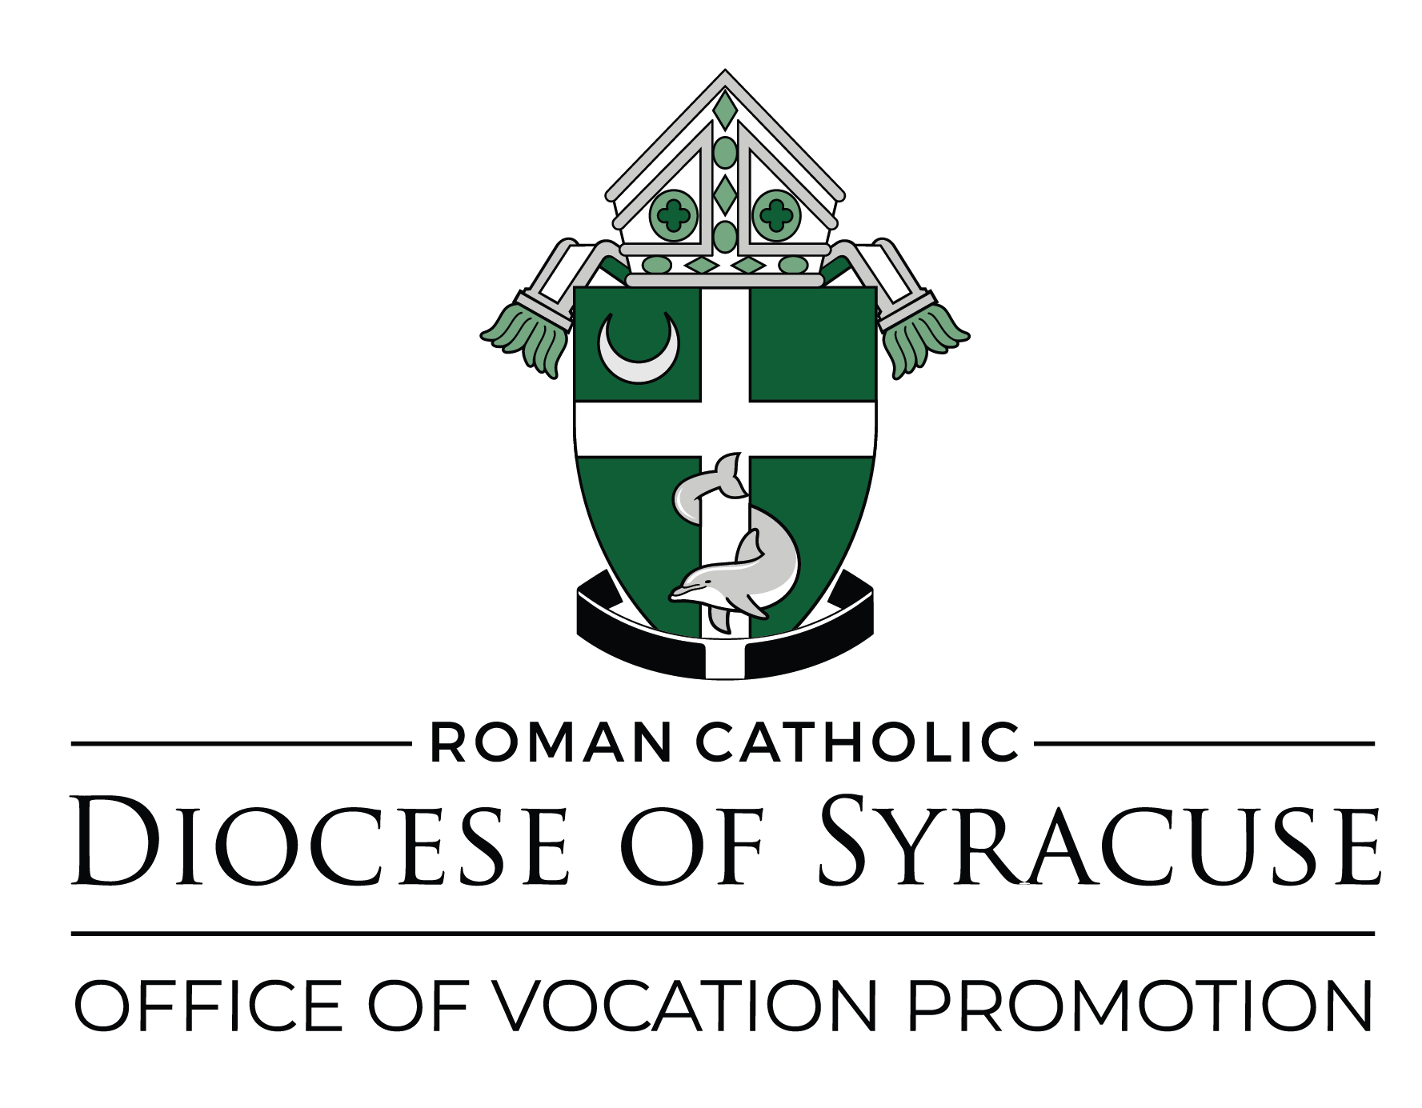

- For all young people of our parish who are making lifetime choices at this time, we pray to the LORD.
- For all families, that they may have a positive regard for vocations to the priesthood and religious life, we pray to the LORD.
- For all seminarians, especially those of our diocese, as they prepare for a lifetime of service in the Church, we pray to the LORD.
- For an increase of vocations to the priesthood and the religious life, especially within our diocese, we pray to the LORD.
- For all priests, especially those of our diocese, that they may provide an example and guidance to all youth, we pray to the LORD.
- For all who work with youth, we pray to the LORD.
- For the members of the parish vocations committees, that they may see fruit of their efforts in a rich harvest of vocations to the priesthood and religious life, we pray to the LORD.
- For all altar servers, that they may find joy in service at the altar of God, we pray to the LORD.
- For the clergy and religious of our diocese, that their example may be an encouragement for young people to consider a Church vocation, we pray to the LORD.
- For the immigrant clergy who serve the Church within our diocese, that they may be blessed for their generosity and that we may be enriched by their missionary spirit, we pray to the LORD.
- For all religious serving the needs of the sick and elderly in our diocese, that they may be blessed for their efforts and supported by our prayer, we pray to the LORD.
- For our holy father Pope Leo, and his efforts to call youth to their Christian calling, we pray to the LORD.
- For all teachers in the Church, and for their students who are growing in knowledge and love of the Word of God, we pray to the LORD.
- For all who support the work of vocation promotion through their prayers, sufferings, and good works, we pray to the LORD.
- For all children of the world, that they may all know the love of Jesus in their lifetime, we pray to the LORD.
- For all parents who by prayer and example nourish the call of God in each of their children, we pray to the LORD.
- For all the people who work for the upbuilding of the Church in our diocese, we pray to the LORD.
- For all religious congregations serving the Church in our diocese, we pray to the LORD.
- For our newly ordained priests, in thanksgiving for their ordination and that their first year of service in our diocese will be fruitful, we pray to the LORD.
- For those who will be ordained this year to the priesthood, that God’s grace and blessings be generously poured out upon them, we pray to the LORD.
- That all Christians recognize, accept, and follow their Baptismal call to holiness, we pray to the LORD.
- That those who have renounced the marriage state through celibacy may witness their love of Christ in availability to His people, we pray to the LORD.
- That monks and nuns, whose lives are governed by the spirit and practice of contemplation, and who profess solemn vows in religious life, will be sustained in their life of prayer by the support of God’s grace and our faith, we pray to the LORD.
- For all parents of our parish, that they may instill a positive regard for the priesthood and religious life as lifetime paths for their sons and daughters, we pray to the LORD.
- For those called to a Church Vocation by power of the Holy Spirit, that they will be filled with the courage and faith to respond to a life of service, we pray to the LORD.
- For priests, that they will invite young men to join them in the priesthood, we pray to the LORD.
- For all our seminarians preparing for priestly service in our diocese, that they may persevere in their studies and preparation for ministry, and that their families will be blessed, we pray to the LORD.
- For altar servers , that they will be blessed for their service to our parishes, and that they will develop a life of prayer based on their familiarity with “the things of God” they know from this service, we pray to the LORD.
- For the clergy of our diocese—the infirm, elderly and retired priests, the parish priests, the deacons, and our bishops—we pray to the LORD.
- For the religious of our diocese—sisters, brother, priests—that they may be blessed in their life of consecration to the Lord and to his Church, we pray to the LORD.
- That the Lord of the harvest, who told us the harvest is ready and that there is so much more work to be done, will send laborers into his vineyard, the Church, we pray to the LORD.
- For those entrusted with the formation of the clergy, we pray to the LORD.
- For greater devotion to Mary, and that young people will look to her as a model of persons chosen by God for special work on behalf of the Kingdom of God on earth, we pray to the LORD.
- For greater devotion to the Sacred Heart of Jesus, especially in homes and families, for the extension of the Kingdom of God on earth, we pray to the LORD.
- For all priests and religious who celebrate jubilees this year, that God will bless them graciously, we pray to the LORD.
- For those who will receive the Holy Eucharist for the first time, that they will always know the companionship of Jesus and Mary in their lives, we pray to the LORD.
- For those who work in the Sacred Heart Apostolate within our diocese, encouraging family prayer through devotion at home, we pray to the LORD.
- For those who work to promote vocation awareness in our diocese, we pray to the LORD.
- That men and women may find joy in sacrificing personal gain for the service of others in a Church vocation, we pray to the LORD.
- That the LORD of the Harvest may open the hearts of our young people to the possibility of a life in priesthood or religious life, we pray to the LORD.
- That parents, by their lives and example, may encourage Church vocations among their children, we pray to the LORD.
- For all men and women who wish to follow Christ, that they may respond generously to God’s graces, trusting His leading them into His service as priests or religious, we pray to the LORD.
- For Christian families, the source of religious vocations, that they may be prompted to encourage young people to rejoice in doing God’s will, we pray to the LORD.
- That today’s youth may show generosity to Jesus’ call and make wise decisions in choosing their vocation in life, we pray to the LORD.
- For all young men of our parish who are making lifetime choices at this time, that they will include service to the People of God as a diocesan priest among their other options, we pray to the LORD.
- For all parents of our parish, that they may instill a positive regard for the priesthood as a lifetime path their sons might consider, we pray to the LORD.
- For our young people, that they may find a joyful faith in their families, and encouragement to respond to a life of ministry and service, we pray to the LORD.
- For our diocese, that God will abundantly bless our bishops, priests, deacons and religious, we pray to the LORD.
- For the Knights of Columbus within our diocese, that they may be blessed for the assistance they give our bishops, seminarians, and vocation promotion efforts, we pray to the LORD.
- For all parishioners who have made a commitment to pray intensely for vocations, that their intercessory prayer for an increase of candidates for priesthood in our diocese will be fruitful for the Church and they will be blessed for their efforts, we pray to the LORD.
- For Bishop Lucia, for good health and fruitful ministry on behalf of the Church of Syracuse, we pray to the LORD.
- For the Parish Vocations Committees of our diocese, that they will grow in appreciation of the task entrusted to them, and that the seeds of awareness they plant will grow to maturity through prayer and care, we pray to the LORD.

