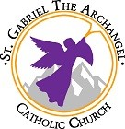

Youth Confirmation
Information Guide
2022 - 2023
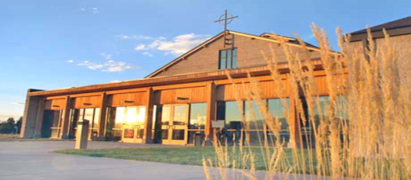
St. Gabriel the Archangel Catholic Parish
8755 Scarborough Drive Colorado Springs, CO 80920
Phone: 719-528-8407 Fax: 719-598-1696
www.saintgabriel.net
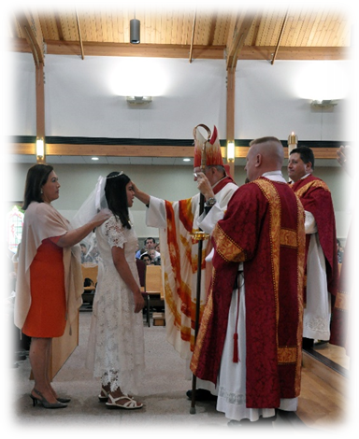
The sacrament of Confirmation strengthens the baptized and obliges them more firmly to be witnesses of Christ by word and deed and to spread and defend the faith. It imprints a character, enriches by the gifts of the Holy Spirit the baptized continuing on the path of Christian initiation, and binds them more perfectly to the Church. (CCL #879)
Confirmation is not an optional sacrament. This sacrament is necessary for the completion of baptismal grace. Every effort should be made in order for every child of appropriate age to receive this sacrament and complete initiation. It is an important step in a Christian’s faith journey that stresses commitment, knowledge, freedom, and active participation. Through Baptism a person is incorporated into Christ and the Church. The baptized is configured to Christ and given an indelible spiritual character of his or her belonging to Christ. This character, or mark, can never be erased. Baptism makes a person a member of the Church and enables and commits them to serve God by participating in the Church, especially in the liturgy.
Confirmation is a sacrament that gives a new and special outpouring of the Holy Spirit on the baptized, in the same way that the Spirit once came to the apostles at Pentecost. Confirmation “completes” Baptism in that it, too, imprints an indelible mark on the soul. Confirmation brings about an increase and deepening of baptismal grace.
Youth Confirmation preparation is a two-year program utilizing the Chosen curriculum from Ascension Press. Preparation for the sacrament normally begins in seventh grade and the student receives the Sacrament of Confirmation at the end of the eight grade year. As part of their preparation for the sacrament, Middle School students will participate in EPIC Large group events and High School students will participate in YDisciple. All students will be expected to complete works of charity, attend a Confirmation retreat and all scheduled events. Parent involvement and attendance of parent classes is required.
Confirmation Year I classes are on Sunday, 2:15-3:45pm
Confirmation Year II classes are on Sunday, 2:15-3:45pm
*Schedules for both years will be provided.
Confirmation Candidates must register for class no later than October 1, 2023.
All Candidates must choose a Sponsor
Candidates must choose a suitable sponsor who will accompany them and meet the following requirements:
- Have been chosen by the candidate personally and have a significant relationship with the candidate
- Have attained the age of sixteen (16) unless special circumstances are approved by clergy
- Be a fully initiated, confirmed, practicing Catholic participating in Sunday liturgy, leading a life of strong moral character and faith and not bound by any canonical penalty
- Is not the mother or father of the candidate
- Canon law states that it is preferable that the Confirmation sponsor be the baptismal sponsor so the link between Baptism and Confirmation is clearly defined.
Sponsor selection forms can be found at the Saint Gabriel Youth Confirmation webpage:
https://www.saintgabriel.net/faith-formation/sacramental-preparation/youth-confirmation

Additional requirements for Confirmation Year II Candidates
Works of Charity
Candidates will complete 21 hours of service in 3 categories: world, community, and parish service. Candidates will attempt to have hours in each category and may not have more than 10 hours in any single category. Specific details and due date regarding the completion of Works of Charity can be found on the Saint Gabriel Youth Confirmation webpage.https://www.saintgabriel.net/faith-formation/sacramental-preparation/youth-confirmation
Candidates are encouraged to begin completing their Works of Charity in Confirmation Year I.
Saint Project
Candidates will research the lives of the saints and select one that inspires them. Once the selection is made, the candidate will complete a report on the character traits and qualities this saint possessed that can help the candidate on their life-long faith journey. Specific details and due date regarding the saint project can be found on the Youth Confirmation webpage.
Letter to Bishop
Candidates will write a letter to the Bishop detailing why they are asking to receive the Sacrament of Confirmation. More information and due date regarding can be found on Confirmation webpage.
Confirmation Retreat
Candidates are expected to attend one retreat prior to receiving the Confirmation. The Saint Gabriel retreat begins on Friday April 21 and ends Saturday April 22, 5pm. Attendance is required for the entire duration of the retreat. Transportation is on your own. Location to be announced.
If the candidate cannot attend the Saint Gabriel retreat, they may attend an alternative Confirmation retreat at another parish with Confirmation Coordinator’s approval. Parents must be involved in locating an alternative retreat and providing proof of attendance.
Mass Attendance 2022-2023
Candidates are expected to participate in Sunday Mass and regularly receive the Sacrament of Reconciliation in order to manifest the desire to live a Catholic life. Mass attendance every Sunday and on Holy Days of Obligation is a basic precept of our Catholic Faith and attendance fulfills the 3rd Commandment.
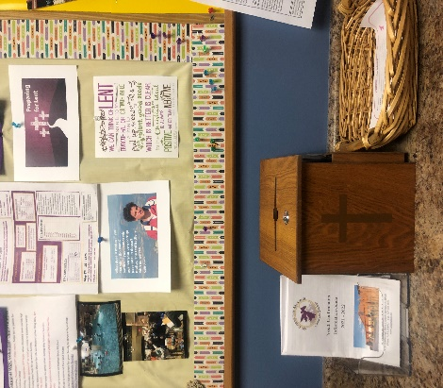
In an effort to inspire candidates to be more present at the Mass, they will be required to complete Mass reflections for Sunday Masses and Holy Days of Obligation.
Mass reflection sheets will be available to the candidates at the first day of class. The sheets will be completed after Mass and placed in a collection box on the Faith Formation table in the Narthex.
Please see our bulletin or website (www.saintgabriel.net) for Mass times.
If traveling or in another location, feel free to attend a Roman Catholic Church near your location. Roman Catholic Church Mass times can be found at www.masstimes.org. It might be helpful if the candidate takes a bulletin or some other brochure or handout from the parish visited. The candidate can simply write their name on it and place it in the Mass reflection box at Saint Gabriel.

Parent Responsibility
As the primary educator of their child, the parent/guardian has the first and most important influence on the faith development of their child. It is very important that the parent/guardian meet the parishes’ requirement for involvement in this process of preparation. They are expected to participate in those catechetical programs offered by the parish to help them grow in their own understanding and appreciation of the sacrament of Confirmation so they can guide their child into fuller participation in the life and worship of the Christian community.
At least one parent/guardian should be a Catholic who practices the faith in the parish where he/she resides or is registered and attend Sunday Mass each week.
Parent/Guardian must provide a copy of the candidate’s Baptismal certificate if baptized in a Parish other than the one in which he/she will receive the Sacrament of Confirmation.
Parents are expected to foster the child’s desire and readiness to receive the sacrament of Confirmation.
Parents will attend parent classes and meetings.
Parents will volunteer to assist in the classroom twice per year.
Parents are responsible for ensuring their teen attends all classes and preparation activities; 75% attendance is required for completion of sacramental preparation.
-If attendance falls below the threshold, the candidate and their parent will meet with the Confirmation Coordinator and/or Director of Faith Formation to assess progress and develop a plan of action to ensure completion of sacramental preparation.
-Homeschooling may be required for a candidate to complete missing assignments.
-The reception of the Sacrament of Confirmation is the candidate’s decision
Confirmation Mass
The Sacrament of Confirmation is officiated by the Bishop during a Mass celebrated at Saint Gabriel. The date and time of the Mass is determined by the office of the Bishop, it will be after Easter.
Dress Code
The following guidelines for appropriate attire come from the document of Sacramental and Liturgical planning from the Diocese of Colorado Spring. While the church greatly respects the uniqueness and individuality in each of its members, it holds that modesty is a fruit of the Holy Spirit and that teaching modesty to children and adolescents means awakening in them respect for the human person. (Catechism of the Catholic Church 25234)
Dress in good taste. Attire should be appropriate for the important life occasion. (Church, banquets, and special occasions but not formal) Jeans, shorts, tennis shoes and flip flops are never appropriate.
Ladies:
- Dress should be White
- Girls’ shoulders should be covered. If they wear sleeveless, strapless, or spaghetti strap dresses, they are required to wear a sweater or shawl to cover their shoulders.
- No plunging or revealing necklines, no bare midriffs.
- Skirts should fall at knee length and not be tight or suggestive. Pant suits or full-length pants with appropriate white top are acceptable. Please no shorts, capris or flip flops.
Gentlemen:
- White shirt with collar and tie (sport coat or suit jacket is optional)
- Shirts should be tucked in
- Pants fitted at waist with belt.
- Shoes should be appropriate for outfit and church (no tennis shoes or flip flops)
Confirmation Preparation Commitment
“A Candidate for Confirmation … Must profess the faith, be in the state of grace, have the intention of receiving the sacrament, and be prepared to assume the role of disciple and witness to Christ, both within the {church} and in the [everyday life}.”
As a candidate for Confirmation, I acknowledge the following requirements:
- I will attend Mass every Sunday and on Holy Days of Obligation.
- I will attend all confirmation sessions and turn in all required work on time.
- I will live my life in service to others by living the corporal and spiritual works of mercy.
- I will memorize the required common Catholic Prayers.
- I will attend a confirmation retreat.
- I will celebrate the Sacrament of Reconciliation before receiving Confirmation.
- I will commit myself to daily personal prayer.
- I will continue to live my life as a witness to Jesus Christ through prayer, service, and worship long after my Confirmation.

I understand that these requirements help me to accept the role of “disciple and witness to Christ” I understand the Sacrament of Confirmation is a GIFT from God, rather than a requirement to get done. Therefore, I take this step freely and without reservation.
X__________________________
Candidate

As the primary educator of my child, I pledge to make my best effort to prayerfully support my child in this endeavor, and I will work with my child to successfully meet these requirements in preparation for his/her confirmation.
X__________________________
Parent/Guardian

Sign and return this page no later than Aug. 27th at check in.

For more information contact:
Christina Thornbery
Youth Confirmation Coordinator
528-8407 or cthornbery@saintgabriel.net

Sign up for

Like us on

