February | ACCW VOCATIONS CALENDAR
2023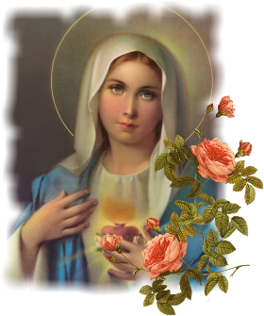 | Vocation Prayer for those on their journey to ordination/final vows.  Loving God, we ask you to guide the men and women of this Archdiocese who are considering religious life and those already on their journey towards ordination or final vows. Bless them in their decisions; strengthen them in their love for you and their desire to serve you in this special way. Hold them all close to your heart, especially during difficultly or troubled times. Shower them with your love and fill them with courage and joy as they study and prepare themselves for your work. We pray for all on their journey to religious life. May they feel our loving and prayerful support. We ask this in the name of Jesus, Your Son. Amen. www.accwarchspm.org

Sunday | Monday | Tuesday | Wednesday | Thursday | Friday | Saturday
 |  |  | 1 | 2 | 3 | 4
 |  |  | Matthew Sell | Nicholas Deutsch | Joseph Etnier | Pope Francis
5 | 6 | 7 | 8 | 9 | 10 | 11
Archbishop Hebda | John Kleis | Dominic Romporti | Brennan Crow | Edmund Havlicek | Patrick Hess | Bishop Williams
 |  | 14 | 15 | 16 | 17 | 18
Deacons | Ashton Lacko | Andrew Lehnen | Levi Meyer | Trevor Thorp | Deacon Kyle Etzel | Religious Sisters
19 | 20 | 21 | 22 | 23 | 24 | 25
U. S. Cardinals | Ryan Glaser | Deacon William Kratt | Deacon John Rumpza | Hjalmar Blondal | Brent Bowman | Those in Discernment
26 | 27 | 28
Spiritual Advisors | Philip Conklin | Francis Floeder

