Butler Catholic School Jump Night
Wednesday, March 22nd, 6:00PM - 8:00PM
$13.99 for 2 hours of Jump Time When You Mention Your School at the Register!
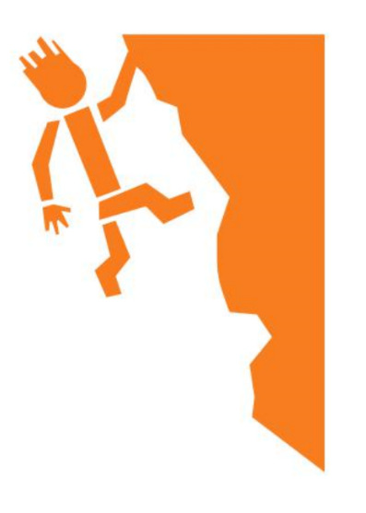
Located at 101 Clearview Circle Butler, PA 16001
Friday Night Frenzy & Saturday Night Teen Night
7-10pm only $15!
Black Lights and Party Music!

Attractions
- Main Court & Kid’s Court
- High 9 Reaction Wall
- Trapeze Bar
- Extreme Dodgeball
- Trampoline Basketball
- Gymnastics Tumble Tracks
- High Jump
- Battle Beam
- Monkey Bars Wipeout
- 3 Foam Pits
Monday-Thursday
11:00 am – 8:00 pm
Friday-Saturday
11:00 am – 10:00 pm
Sunday
11:00 am – 7:00 pm

Toddler Time 6 and Under
11am-1pm Weekdays $8.99
2 Hours of Jump and a Less Crowded Park!

