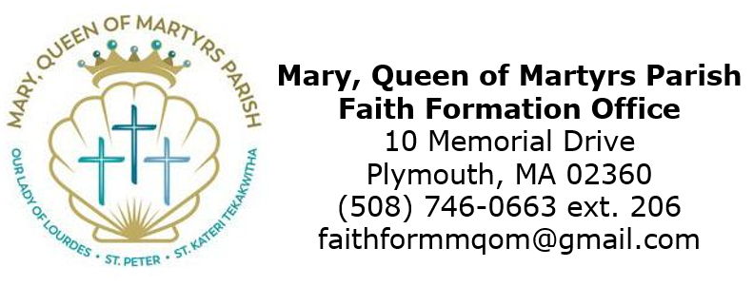

Parish Service Log: Due May 1, 2026

Candidate Name: _______________________________

Any service that reflects Jesus’ love is “Christian Service.” The world is in desperate need of Christians willing to show the love of Christ through their actions. Jesus said the second greatest commandment is to love others - wanting the best for them and helping them to receive what they need. Every action performed out of kindness, powered by the understanding of Christ and His love, is Christian service.
Confirmation I - 5 hours
Confirmation II - 8 hours

The following service was completed:
Date: | Description of Service: | # of Hours: | Signature of Supervisor

