

Instructions on Completing 2025 MA Health Insurance Responsibility Disclosure (HIRD) Filing

The Health Insurance Responsibility Disclosure (HIRD) form must be completed electronically from November 15 to December 15 each year. The HIRD reporting is administered by MassHealth and the Department of Revenue (DOR) through the MassTaxConnect web portal.

This annual filing is required by state law for all Massachusetts employers with 6 or more employees.
This includes all parishes, regardless of size.

The HIRD form collects information about your employer-sponsored health insurance offerings and will be used to assist MassHealth in identifying its members with access to qualifying insurance who may be eligible for the MassHealth Premium Assistance Program. The Premium Assistance Program helps eligible working individuals and families pay for qualifying employer-sponsored insurance. For more information, please reference the HIRD FAQs.

Instruction documents for all of the processes noted below along with a recorded presentation are available on the Administrator Toolkit page of the Benefits Department website:
catholicbenefits.org/administrators
- First-time user, need to set up online access
- Already have set up online access but need help retrieving your Username or Password

Important Note! Before you begin, find the cost sharing for your location for the Enhanced, Basic and High-Deductible Plans, even if you have no employees enrolled in those plans. The HIRD filing process should take approximately 15 minutes once you have that information. You can copy/paste responses from this document into the HIRD form. The module does allow you to save once you start. You should see a link for “continue editing” on the Summary page where you started the Disclosure if you need to log in later to finish a partially completed HIRD filing.
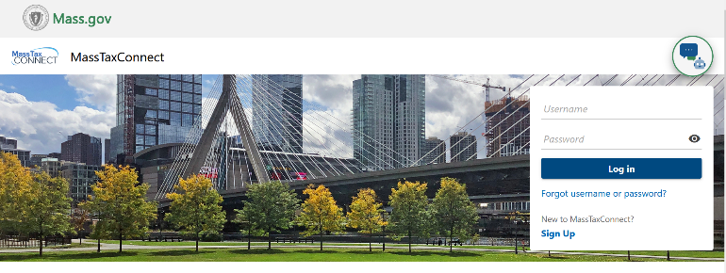
- Log into your MassTaxConnect Account
at https://mtc.dor.state.ma.us/mtc/_/

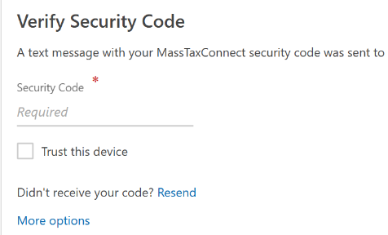

You may be asked to verify your account with a Security Code.

- Scroll down to the Withholding Tax section of the Summary page and select the “File a Health Insurance
Responsibility Disclosure” link under the HIRD subsection.

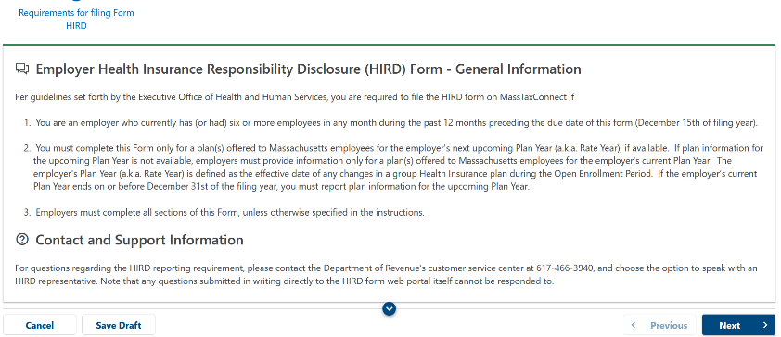

- Review general information and click “Next.”

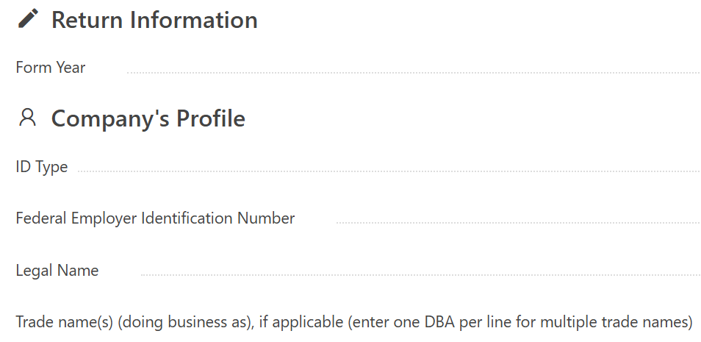

- Confirm the Company’s Profile information is
correct and click “Next.”

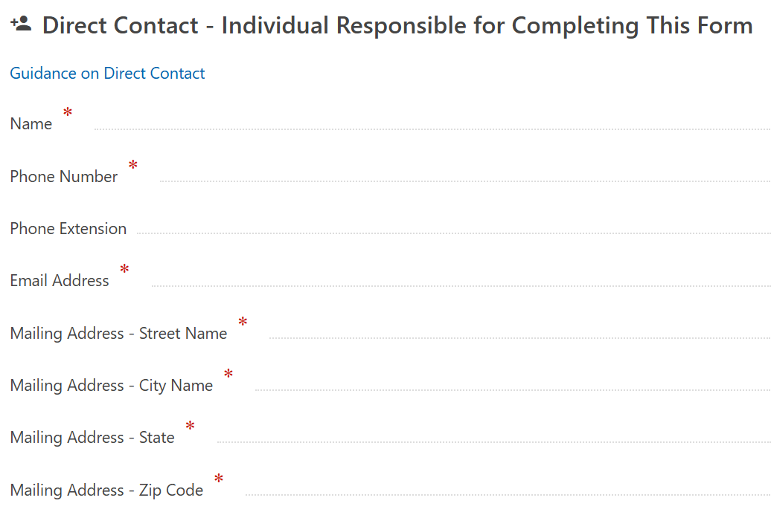
- Enter your contact information as the person
completing the form. Click “Next.”

- Complete the Company’s Insurance Profile – Health Plan Eligibility page.
Suggested responses are outlined below.

Question | Suggested Response
Does the employer offer group health insurance? | Yes
What is the minimum number of scheduled hours per week that the employer requires an employee to work to be considered eligible for health plan benefits? | 20 for RCAB parish locations; 24 for parish schools; or a higher number (up to 30 per week) if your separately-incorporated location requires more hours to be worked for benefit eligibility.
What is the time period (in months) that a new employee must work before he or she is eligible for health plan benefits? | Enter 1 for any RCAB location; if your separately- incorporated location has a longer waiting period, enter the correct number of months.
Does employer determine employee eligibility for health plan benefits according to employment-based categories for different groups of employees? | No
Does employer offer different health plan benefits / rates for health plan benefits according to employment-based categories for different groups of employees? | No, unless your location has different cost sharing for current and newly eligible employees (more on that topic below, if applicable).
Does employer offer health plan(s) which use Massachusetts Health Connector Employee Choice Models? | No
Select the employment-based categories that the employer utilizes. | No, unless your location has different cost sharing for current and newly eligible employees (more on that topic below, if applicable).
Select the employment-based categories that the employer utilizes. (Select as many employment-based categories as necessary). | Click No for all unless your location has multiple cost shares. See additional information below.*
Does the employer employ any union members who receive Group Health Insurance through a union rather than through the employer? | No. Then leave next box blank. Click “Next.”

*If your location has multiple cost shares for groups of employees, choose “YES” under “Other” and then add text to describe the categories. For example, if your location has employees who pay less for health coverage based on date of hire, choose “YES” under “Other” and then add the following under both boxes:
“The employer offers less expensive health insurance to employees who were hired on or before ________[date]. All employees are eligible for the RCAB Health Plans through Blue Cross if they are scheduled to work at least 1,000 [for separately-incorporated locations requiring more hours, insert correct data here] hours/year.”
Alternatively, if you have an employee who is offered coverage with lower cost-sharing than other employees as an exception (i.e., on a “grandfathered” basis), and no other employees would be offered this cost-sharing in the future, this cost share does not need to be reported through HIRD. Thus, the “NO” answers above should be left as is.
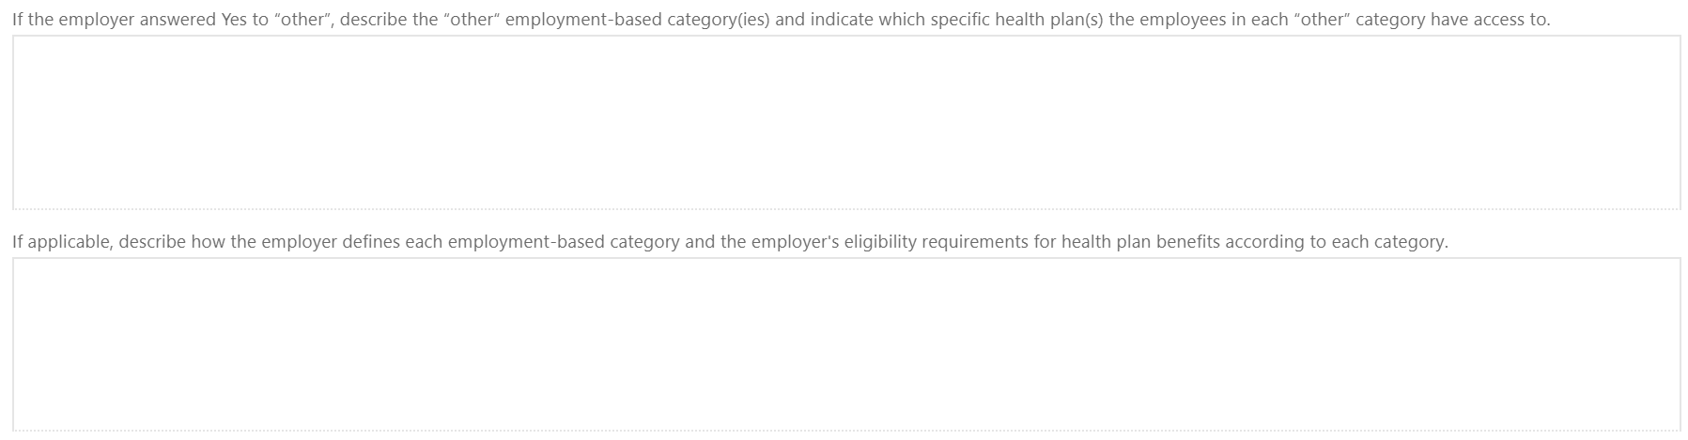

Click “Next.”

- Complete the Company’s Insurance Profile – Open Enrollment and Plan Year Dates page.
Suggested responses are outlined below.

Open Enrollment period: Start Date  Open Enrollment period: End Date | 05/12/2025  06/16/2025
Plan year’s (a.k.a. rate year) Start date  Plan year’s (a.k.a. rate year) End date | 07/01/2025  06/30/2026

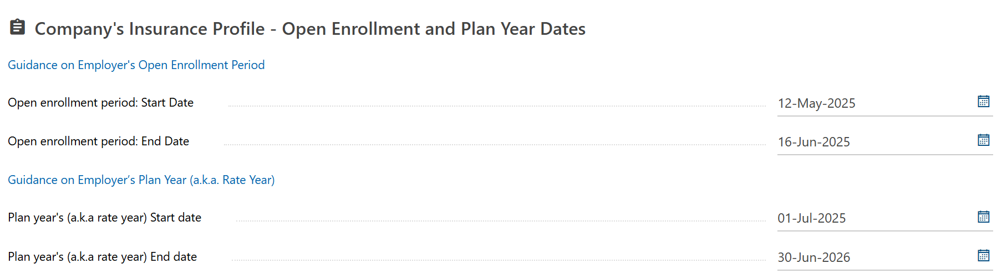

Click “Next.”

- The following page will ask you to enter the Plan and cost share information for each of the three Health Plan options offered by RCAB; Enhanced, Basic and High-Deductible.
You must enter all three even if you do not have anyone currently enrolled in any one plan.

To begin, click “+ Add a Plan”
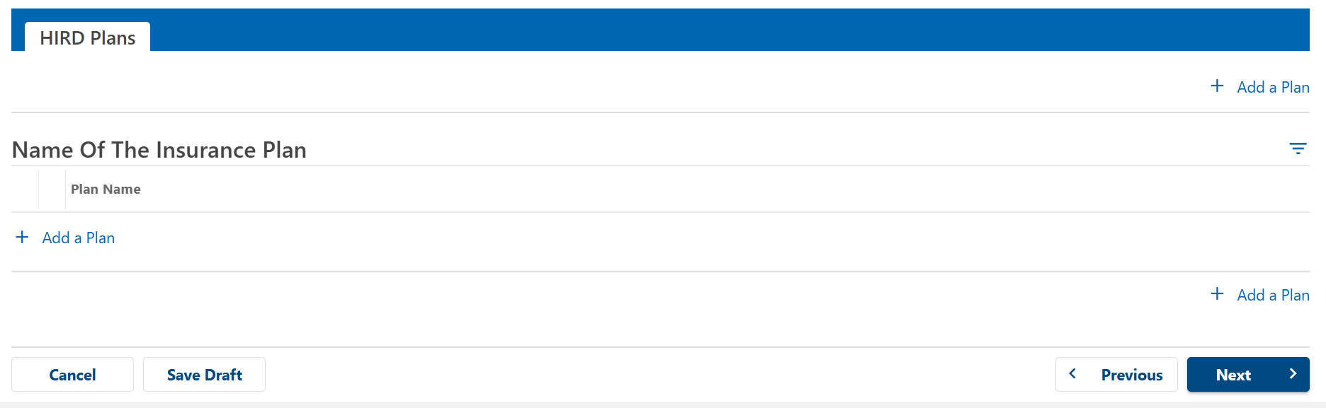

Enter the below for the Enhanced PPO Health Plan:

Name of the Health Insurer | Blue Cross Blue Shield of MA
Name of Health Plan | Enhanced PPO Health Plan
Plan group numbers (these can be copy and pasted): | 002370423 002370425  002370427 002370428  002370429 002370430
Do the benefits provided under the health insurance plan satisfy the minimum creditable coverage requirements of 956 CMR 5.03(1)(a)? | Yes
Does the employer offer its employees wellness credits that may reduce the employee contribution to the premium for this plan? | No
Enter the date on which the following costs and coverage information became or will become effective for this plan. | 07/01/2025

If you answered YES to the question “Does employer offer different benefits / rates for health plan benefits, then the question “Indicate the employment-based categories that have access…” will appear, followed by the category which you selected. Answer YES, which will then require you to fill out two plan profiles for the Enhanced Plan—one for each of the different cost-sharing splits. These pages will be identical except for the dollar amounts for the cost-sharing.
If this question does not appear, continue to the next section.
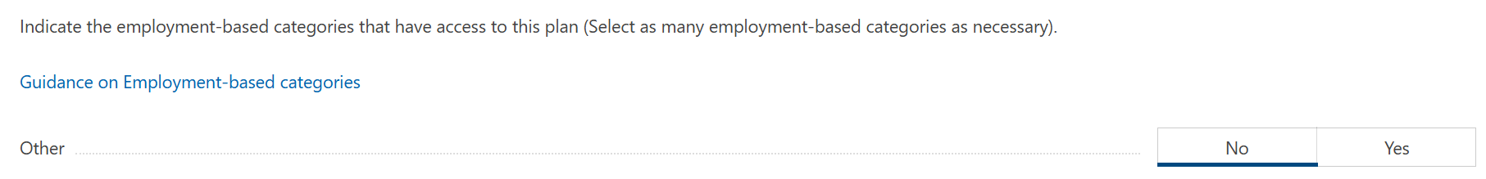
Under the Levels of Coverage section, select the following.
Individual = Yes
Employee Plus One = Yes
Employee Plus Children = No
Family = Yes
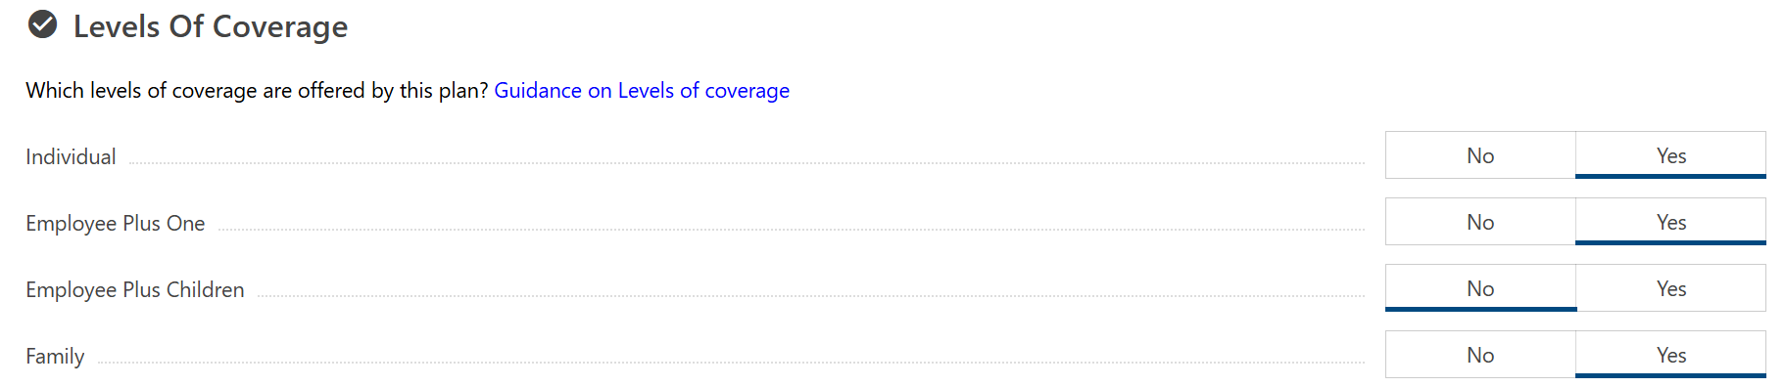
Next you will see three sections to input the Employee’s Monthly Contribution, Employer’s Monthly Contribution and the Plans Total Monthly Costs.

The recommended cost shares are included in the examples below however cost shares vary from location to location. The Health Plan Cost Share/Budget Calculator (7/1/2025-6/30/2026) found on catholicbenefits.org/administrators can assist with these calculations.

Complete this section based on your locations cost sharing for the Enhanced PPO Health Plan.

Example: If your cost sharing is Enhanced (25% Individual/40% Ind +1/Family) Basic (15% Individual/35% Ind+1/Family) (recommended cost-sharing):

Enhanced Plan | Monthly Employee |  | Monthly Employer |  | Monthly Rate/Total Monthly Premium
 | Cost | % | Cost | % | Monthly Rate/Total Monthly Premium
Individual | $249.01 | 25% | $747.02 | 75% | $996.02
Individual + 1  (spouse or child) | $896.12 | 40% | $1,344.19 | 60% | $2,240.31
Family | $1,115.16 | 40% | $1,672.75 | 60% | $2,787.91

You may need to round the contributions up/down by a penny if the total monthly costs do not match the employee plus employer contribution amounts. A red message will appear if this is needed.

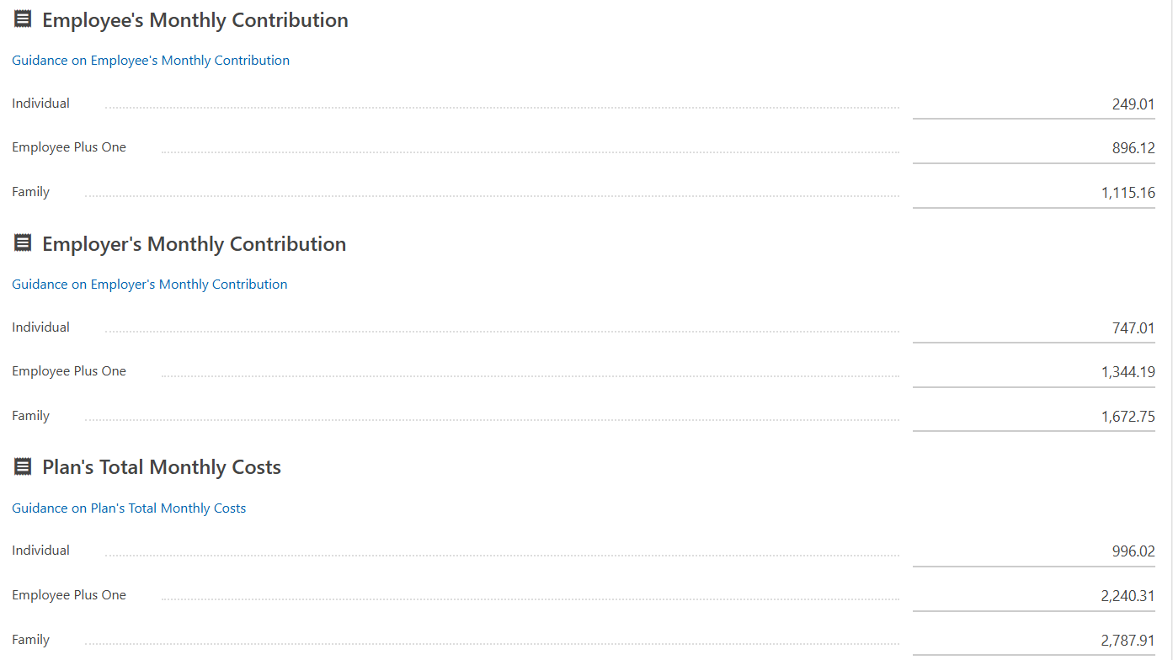

Enter the following for the In-Network Annual Deductibles and Annual Out-of-Pocket Max Expenses fields for the Enhanced PPO Health Plan

 | In-Network Annual Deductible | Annual Out of Pocket Max Expense
Individual | $1,000 | $3,750
Employee Plus One | $2,000 | $7,500
Family | $2,000 | $7,500

Click “Add a Plan” to enter information for the Basic PPO Health Plan.
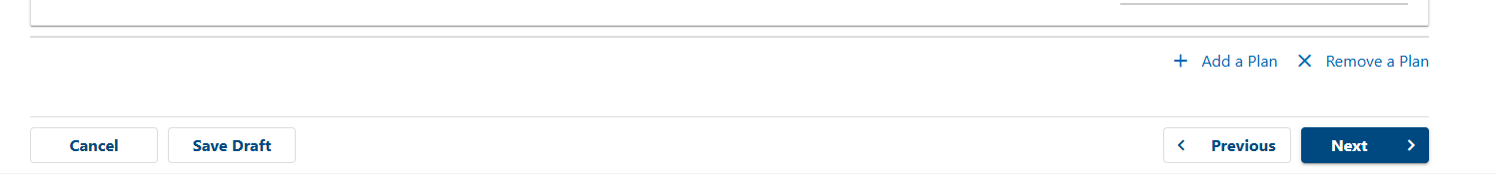

Follow the same steps for the Basic PPO under Plan’s Profile:

Name of the Health Insurer | Blue Cross Blue Shield of MA
Name of Health Plan | Basic PPO Health Plan
Group Numbers (these can be copy and pasted): | 002370431 002370433  002370435 002370436  002370437 002370438
Do the benefits provided under the health insurance plan satisfy the minimum creditable coverage requirements of 956 CMR 5.03(1)(a)? | Yes
Does the employer offer its employees wellness credits that may reduce the employee contribution to the premium for this plan? | No
Enter the date on which the following costs and coverage information became or will become effective for this plan. | 07/01/2025

If you answered YES to the question “Does employer offer different benefits / rates for health plan benefits, then the question “Indicate the employment-based categories that have access…” will appear, followed by the category which you selected. Answer YES, which will then require you to fill out two plan profiles for the Enhanced Plan—one for each of the different cost-sharing splits. These pages will be identical except for the dollar amounts for the cost-sharing.
If this question does not appear, continue to the next section.
Under the Levels of Coverage section, select the following.
Individual = Yes
Employee Plus One = Yes
Employee Plus Children = No
Family = Yes

Enter your locations Employee’s Monthly Contribution, Employer’s Monthly Contribution and the Plans Total Monthly Costs for the Basic PPO Health Plan. These vary from location to location.

Example: If your cost sharing is Enhanced (25% Individual/40% Ind +1/Family) Basic (15% Individual/35% Ind + 1/Family) (recommended cost-sharing)

Basic Plan | Monthly Employee |  | Monthly Employer |  | Monthly Rate/Total Monthly Premium
 | Cost | % | Cost | % | Monthly Rate/Total Monthly Premium
Individual | $127.02 | 15% | $719.77 | 85% | $846.79
Individual + 1  (spouse or child) | $666.63 | 35% | $1,238.02 | 65% | $1,904.65
Family | $829.58 | 35% | $1,540.66 | 65% | $2,370.24

You may need to round the contributions up/down by a penny if the total monthly costs do not match the employee plus employer contribution amounts. A red message will appear if this is needed.

Enter the following for the In-Network Annual Deductibles and Annual Out-of-Pocket Max Expenses fields for the Basic PPO Health Plan.

 | In-Network Annual Deductible | Annual Out of Pocket Max Expense
Individual | $3,000 | $5,500
Employee Plus One | $6,000 | $11,000
Family | $6,000 | $11,000
Click “Add a Plan” to enter information for the Blue Cross High Deductible Health Plan (HDHP).

Follow the same steps for the High Deductible Health Plan (HDHP) under Plan’s Profile:

Name of the Health Insurer | Blue Cross Blue Shield of MA
Name of Health Plan | High Deductible Health Plan
Group Number (this can be copy and pasted): | 002374258
Do the benefits provided under the health insurance plan satisfy the minimum creditable coverage requirements of 956 CMR 5.03(1)(a)? | Yes
Does the employer offer its employees wellness credits that may reduce the employee contribution to the premium for this plan? | No
Enter the date on which the following costs and coverage information became or will become effective for this plan. | 07/01/2025

If you answered YES to the question “Does employer offer different benefits / rates for health plan benefits, then the question “Indicate the employment-based categories that have access…” will appear, followed by the category which you selected. Answer YES, which will then require you to fill out two plan profiles for the Enhanced Plan—one for each of the different cost-sharing splits. These pages will be identical except for the dollar amounts for the cost-sharing.
If this question does not appear, continue to the next section.
Under the Levels of Coverage section, select the following.
Individual = Yes
Employee Plus One = Yes
Employee Plus Children = No
Family = Yes

Enter the Employee’s Monthly Contribution, Employer’s Monthly Contribution and the Plans Total Monthly Costs for the High Deductible Health Plan.
All locations use the following cost-sharing for the HDHP: 5% for individual and 25% for family (unless you do not charge employees for any Plan, in which case the employee cost share would be 0%).

High Deductible Health Plan | Monthly Employee |  | Monthly Employer |  | Monthly Rate/Total Monthly Premium
 | Cost | % | Cost | % | Monthly Rate/Total Monthly Premium
Individual | $36.35 | 5% | $690.74 | 95% | $727.09
Individual + 1  (spouse or child) | $408.85 | 25% | $1,226.56 | 75% | $1,635.41
Family | $508.80 | 25% | $1,526.39 | 75% | $2,035.18

Enter the following for the In-Network Annual Deductibles and Annual Out-of-Pocket Max Expenses fields for the High Deductible Health Plan.

 | In-Network Annual Deductible | Annual Out of Pocket Max Expense
Individual | $4,000 | $7,000
Employee Plus One | $8,000 | $14,000
Family | $8,000 | $14,000
- Click “Next.”
- Review the Return Summary to ensure it is correct. If you need to go back to fix any data, click “Previous.” Note the tabs across the top for the three Plans. Click on the correct tab to edit data.

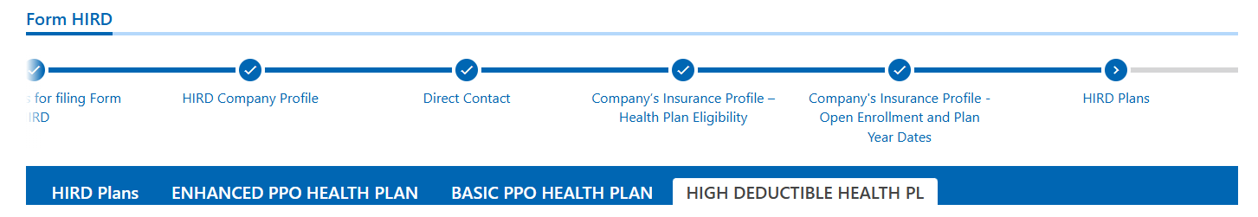

- Once ready, click the “Confirmation” box, then “Submit.” Then enter your password to certify that all information is true and complete, then click “OK.”
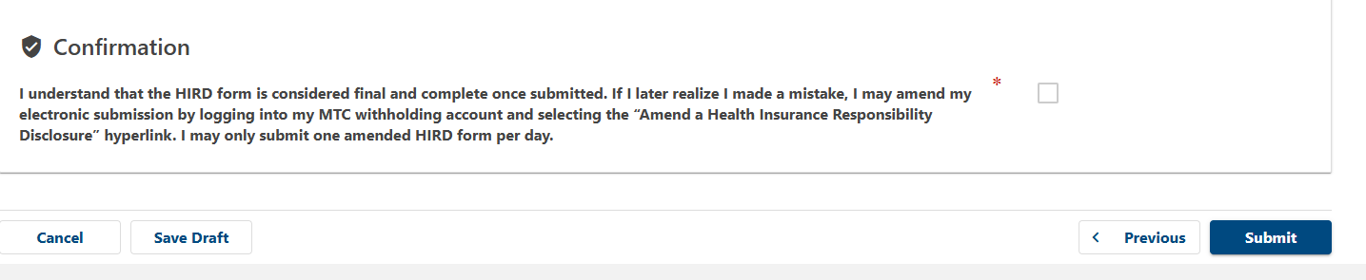
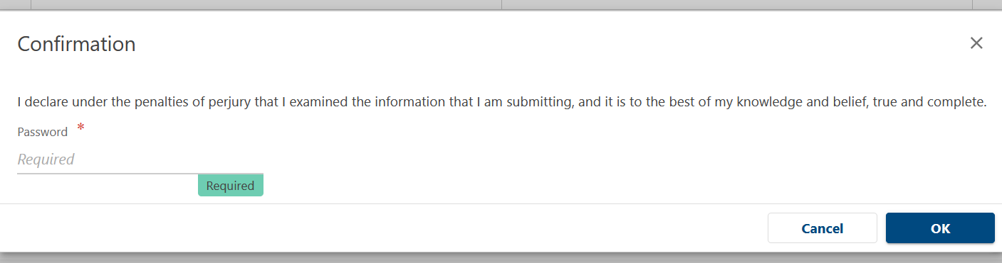

- Print the Submission page by clicking “Print Confirmation.” You should receive an email from the DOR confirming your submission. You can also return to the Home page and see that the HIRD filing shows as Submitted.
