**Preparation Classes**

**Location: Our Lady of Guadalupe Catholic**

**Church 13715 Riggs Rd - Helotes, TX 78023**

**Time: 6:30 PM - 8:00 PM** **Dates in 2025:**

# Thursday, January 16  Thursday, March 6  Thursday, May 1  Thursday, July 17

# Thursday, Sept 18 

Thursday, Nov 6

***IMPORTANT NOTES:***

* Classes are for parents and godparents
* Registration prior or and R.S.V.P. is NOT required, simply attend the session.
* Please arrive 10 minutes before the start of class to sign in and receive information.
* Participant must stay for the entire session in order to receive proof of partici-pation.
* Childcare is NOT available, please plan accordingly.
* Check our website for updates and information at www.olghelotes.org.

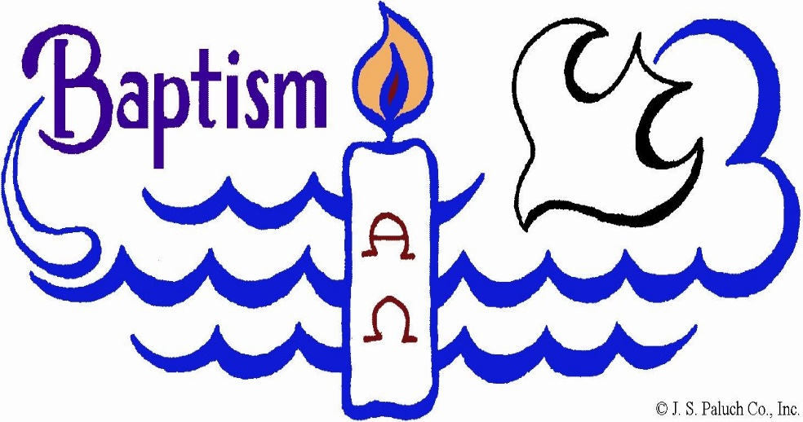

Age 0 - 6 years

# **Our Lady of Guadalupe Catholic Church**

13715 Riggs Rd - Helotes, TX 78023(210) 695-8791 Fax: (210) 695-9957 **www.olghelotes.org olgemail@olghelotes.org**

Catechism of the Catholic Church

**The Sacrament of Baptism**

Holy Baptism is the basis of the whole Christian life, the gateway to life in the Spirit (vitae spiritualis ianua), and the door which gives access to the other sacraments. Through Baptism we are freed from sin and reborn as sons of God; we become members of Christ, are incorporated into the Church and made sharers in her mission: "Baptism is the sacrament of regeneration through water in the word.” (1213)

**Who Can Receive Baptism?**

“Every person not yet baptized and only such a person is able to be baptized.” (1246)

**The Baptism of Infants**

The practice of infant Baptism is an immemorial tradition of the Church. There is explicit testimony to this practice from the second century on, and it is quite possible that, from the beginning of the apostolic preaching, when whole "households" received baptism, infants may also have been baptized. (1252)

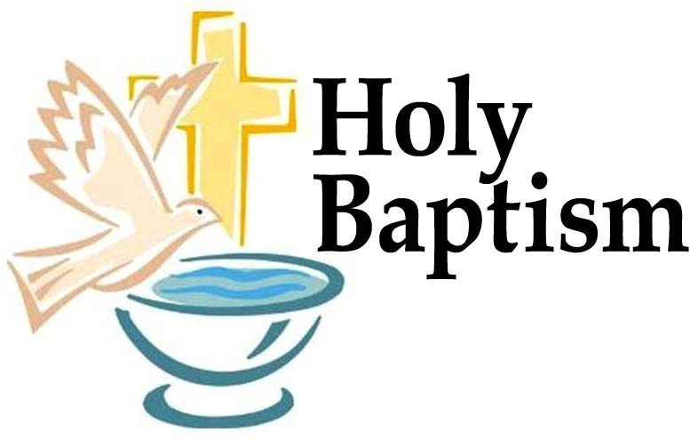

Infant Baptism at our Church

**Planning your Child’s Baptism**

We recommend that you begin the planning of your child’s baptism at least 3 months in advance. This gives parents enough time to select your child’s baptismal godparents, make contact with our parish office, complete the baptismal application, gather required documentations, and attend a baptismal preparation class.

**Application, Requirements & Baptismal Prep Class**

*Applications for the Sacrament of Baptism* are available at our parish office. A list of required documentation is printed on the back of the application for your convenience.

To download and print a copy of the application and for detailed information on requirements and class dates, please visit our parish website at **www.olghelotes.org**.

Completed applications should be turned in to the parish office during regular business hours M-F; 9 a.m.-12 p.m. & 1 p.m.-5 p.m

OR faxed (please include a cover page) to ATTN:

Anna Alvarado at (210) 695-8791 ext. 114 OR emailed (please send ***PDFs ONLY, no JPEGs***) to: [**aalvarado@olghelotes.org**](mailto:aalvarado@olghelotes.org)

**How Do I Schedule My Child’s Baptism?**

Parents MUST turn in an application AND all required documentation to our parish office in order to receive a list of available baptism dates. Dates WILL NOT be given to anyone who has not turned in a complete application.