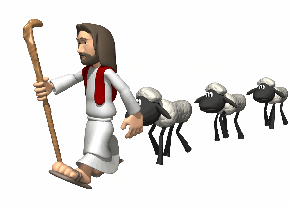

As we learn those things about Jesus by following him, we will see how Jesus leads us to and shows us how to live God’s better way.

* This is a repeat-after-me prayer.

**Dear God,   
Dear God,   
  
Thank you for Jesus…**

**Thank you for Jesus…**

**…who cares for us…**

**…who cares for us…**

**…and teaches us…  
…and teaches us…**

**…how to live your better way.  
…how to live your better way.**

**Thank you and Amen.**

How To Make the Lamb Mask

1. Cut a face-sized hole inside the paper plate. It may be easier to fold in half first.
2. Color the outside, if desired.
3. Glue cotton balls around the border of the plate.
4. Attach paper ears and ribbon, if you like.
5. Optionally, add a popsicle stick to hold up the mask.
6. Smile and say “baaaa”!

