**February 10/11, 2023 and February 17/18, 2024**

**Prayer of the Faithful**

**May we all join in prayer to support this year’s Annual Catholic Appeal and all the ministries it funds in the Diocese of Madison. Let us remember that through the Eucharist “We are One Body in Christ” united in both faith and mission… We pray to the Lord.**

**Bulletin Announcement**

You may wish to use the Annual Appeal logo to call attention to the bulletin announcement. If so, you can obtain a copy of the logo by going to: [www.madisondiocese.org/appeal-materials](http://www.madisondiocese.org/appeal-materials)

###### Diocese of Madison

###### Annual Catholic Appeal 2024

###### *“We are One Body in Christ”*

The theme for the 2024 Annual Catholic Appeal of the Diocese of Madison is **“We are One Body in Christ.”** Taken from Paul’s letter to the Romans 12:5, this simple phrase expresses our solidarity with Our Lord and with one another, united in both faith and mission.

Each pledge to the Annual Catholic Appeal supports the many programs, resources and services that the Diocese sponsors, offering hope, help and healing in countless ways. The Lord wants us to know the Eucharist as the source and summit of our unity in Him and as the flowing source of the graces we need to embrace the challenges we face.

This year we ask that you prayerfully consider making a pledge, payable over six months. Your gift will help enable our parish and the diocese to reach its goal and provide to the ministries supported by the appeal.

If you received your pledge form in the mail, please complete it and mail it back.

Thank you for your prayerful consideration and generous response.

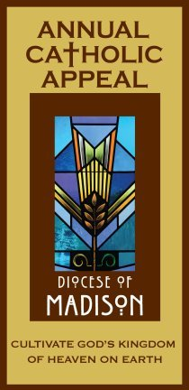

**Altar Announcement**

Please prepare an altar announcement encouraging a generous response to the Bishop’s letter through making a pledge for six monthly payments and asking people to read this bulletin announcement.