Completing Safe Environment Requirements for Diocesan Parishes and Schools

Please allow fo an hour and a half to complete, and complete within one sitting, if possible. Due to security on some smart phones/tablets, you may need to switch to a standard computer to complete the background.

- Please click on: www.madisondiocese.org/safe-enviornment (Or search for Diocese of Madison, click on the homepage, then at the top select: Offices & Apostolates, then Safe Environment). The screen shot should be similar to below. Click the bottom links to register as a first time user. Please Note: if logging back in, after exiting for any reason, you will click on the top links, or go to the main Virtus website: www.virtusonline.org

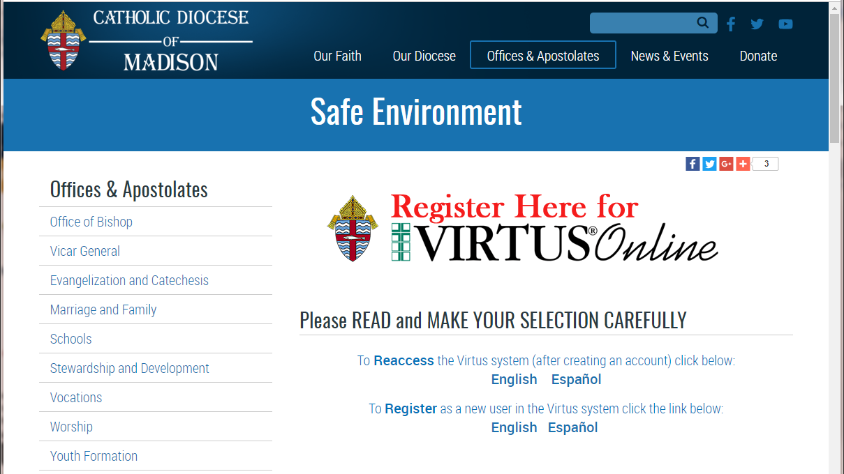

- New Users will create an account and select a location for your record.

Please select the Primary Location: __________________________________

Your role to select within the diocese is: Employee, Educator or Volunteer

You will complete the following requirements, in this order:
  - Read and Sign off on the Diocese of Madison Policy Regarding Sexual Abuse of Minors, Sexual Misconduct and Sexual Harassment
  - Complete Virtus’: Protecting God’s Children Online Awareness Session online training class and
  - Provide information for a Background check through the Fastrax website.

My parish/school please contact: ___________________
Diocese of Madison Office of Safe Environment, please call: 608-821-3133
Virtus Online help desk (M-F 8-5pm): 1-888-847-8870
Fastrax (Selection.com) helpdesk: 800-325-3609

