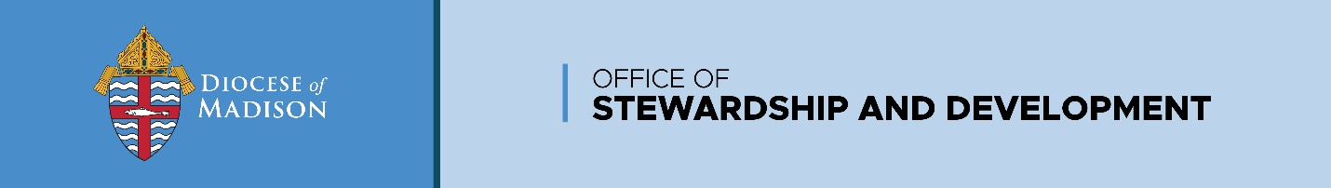

National Combined Collection
May 16-17, 2026

This shipment will contain the envelopes, brochures and posters ordered through the diocesan website. If any materials are missing, please let us know as soon as possible and we will mail additional materials to the parish. As part of the promotion, each parish is asked to do the following:
- Display the poster(s) immediately
- Insert the bulletin announcements in the bulletin
- Make altar announcements encouraging support of this collection
- Insert the brochure and envelope into each bulletin or make them available in a prominent location in the church(es) on May 16-17, 2026

Remittance of Funds:
As indicated on the envelopes, all checks are to be made out to your parish; the parish will be responsible for sending any acknowledgements or tax statements for these gifts. Within a month of the collection dates, the parish is to remit a check payable to the Diocese of Madison for all the gifts that have been made to the parish for this collection. Please be sure to break out the dollar amount designated to each of the following funds, based on what parishioners indicated on the envelopes.
- Black & Indian Missions
- Catholic Promotion of Authentic Human Development
- Catholic Communications Campaign
- Catholic Home Missions
- Catholic University of America
- Retirement Fund for Religious
- Archdiocese for the Military Services

A breakout of donors who contributed to this collection does not need to be provided.

Send all checks to:
Office of Stewardship and Development
Diocese of Madison
702 S High Point Rd, Ste. 225
Madison, WI 53719

Please note: A National Combined Collection envelope will be included in the Catholic Herald. The envelopes are pre–addressed to the Diocese of Madison, with checks being made payable to the Diocese of Madison. Please mail any envelopes with checks made out to the Diocese of Madison directly to the above address (both check and envelope). The diocese will process and acknowledge the gifts.

Questions – Contact our office at 608-821-3042 or stewardship@madisondiocese.org
Thank you!

