SMMA Bulletin Announcements

November 22-23 Weekend
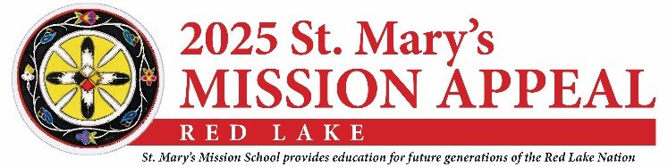

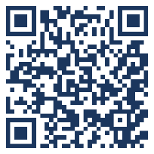
The St. Mary’s Mission Appeal collection is next weekend, November 29-30, 2025. Each year, churches and individuals across the diocese contribute significantly to the spiritual, educational, and physical needs of the children and families of St. Mary’s Mission on the Red Lake Reservation. Just this past Spring, 17 students were baptized! Your generous gift is transforming lives! You may support the work of St. Mary’s Mission through the mailing you have or will soon receive, the collection on November 29 & 30, or online at www.northlandccf.org/SMMA.

November 29-30 Weekend
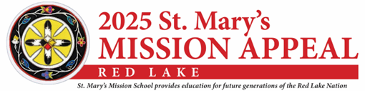

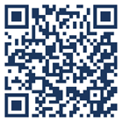
The St. Mary’s Mission Appeal collection is today. Thank you for your generous gift to the ministry and mission of St. Mary’s Mission on the Red Lake Reservation. Your gift helps students grow in wisdom, virtue, and faith. The lives of children and their families are meaningfully impacted through your prayers and support. You may continue to give through the parish, the mailing you received, or online at www.northlandccf.org/SMMA.

