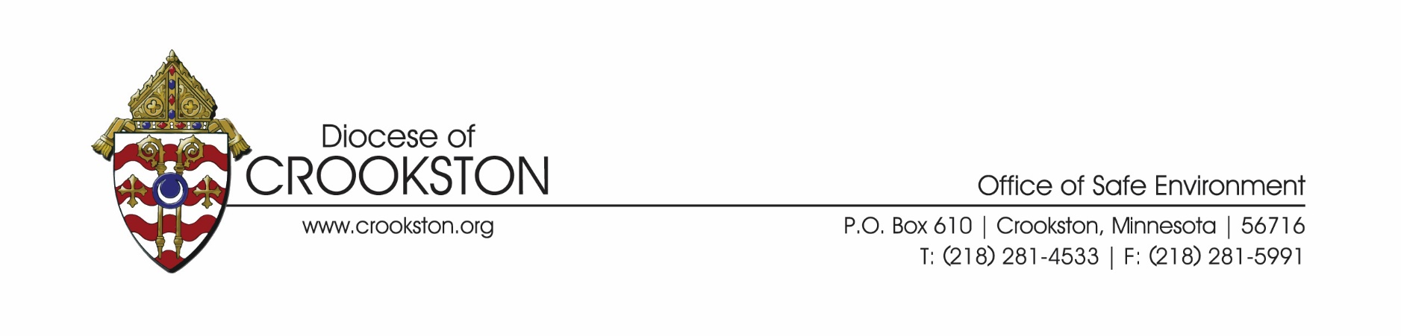

Intercessions for Child Abuse Prevention Month

We pray that God may grant those affected by abuse in any way the courage to tell their story and seek healing; that they may see a just and adequate response to the abuse they have experienced; and that they may encounter the presence of Christ in their dark moments as they deal with their trauma. We pray to the Lord…

We pray that all Catholics who are scandalized, and reconsidering their affiliation with the Church, will remain rooted in Christ and advocate for justice for the survivors of abuse. We pray to the Lord…

We pray for those with disabilities, that by our witness to God’s love and through our service to his people, we may use our gifts to help bring about the kingdom of mercy and justice. We pray to the Lord…

We pray for nations and government leaders, that they may be effective in achieving peace and defending the rights of all, especially children and the most vulnerable. We pray to the Lord…

We pray that bishops, church leaders, and the faithful will promote justice and healing for victims and survivors of abuse; that those who commit sexual abuse and abuse their power will be held accountable; and that we will commit to protect the most vulnerable in our communities. We pray to the Lord…

We pray for the pope and for the college of bishops around the world, at this time of crisis and conversion, that they may lead the church to a deeper faith in God and a stronger love of others. We pray to the Lord…