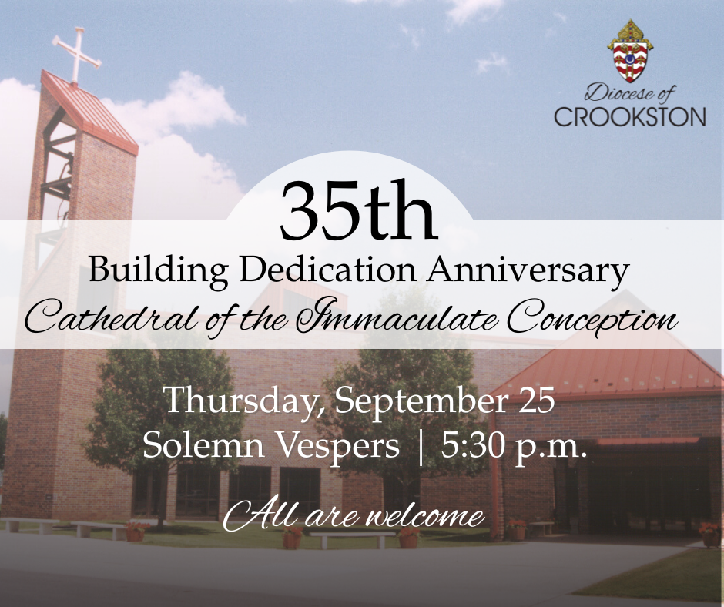
Join Us for Solemn Vespers – Cathedral of the Immaculate Conception’s 35th Building Dedication Anniversary
All are invited to attend Solemn Vespers with Bishop Andrew Cozzens in honor of the 35th anniversary of the building dedication of the Cathedral of the Immaculate Conception.
📅 Thursday, September 25
🕠 5:30 p.m.
📍 Cathedral of the Immaculate Conception
Come together in prayer and thanksgiving as we mark this special milestone in the life of our Cathedral.

